Volusia County Flood HAZARDS/ Threat Recognition System (FTR)

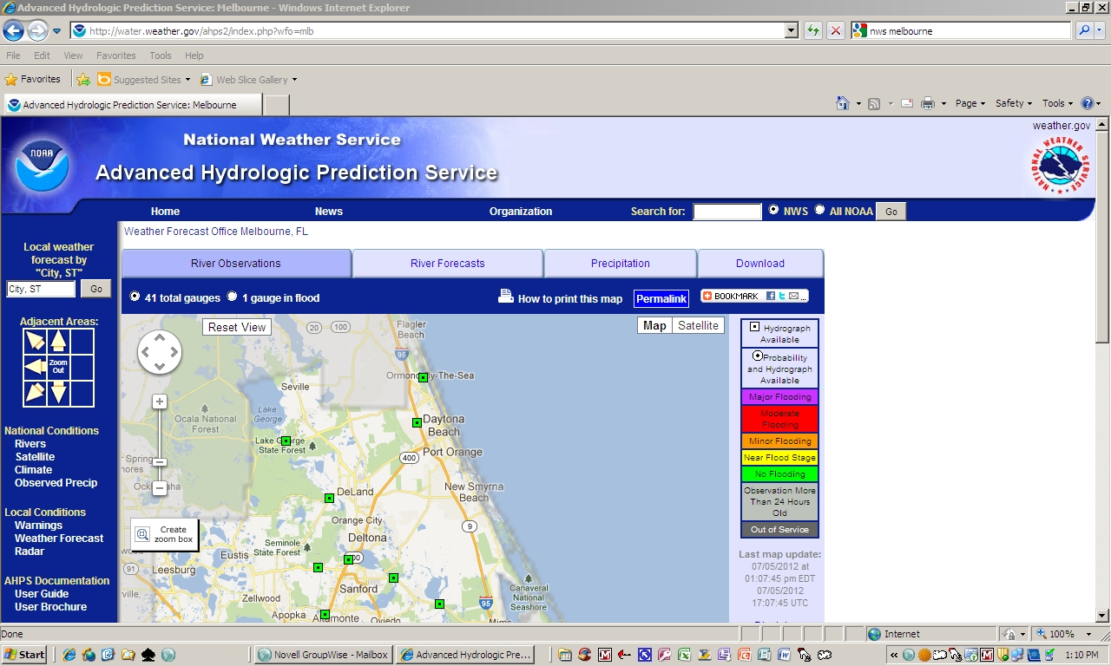
Volusia County Flood Hazards/ Flood Threat Recognition System

Volusia County Flood Hazards

1. Community information

Volusia County is located in the central portion of the Florida east coast. The land area of Volusia County is approximately 1,210 square miles, with 50 miles of Atlantic Ocean shoreline. Along the eastern side of the county, the Halifax River and Indian River/Mosquito Lagoon form long, narrow estuaries which separate the county’s mainland from its barrier island. Ponce DeLeon Inlet, located near the middle of the coastline, serves as the county’s only inlet through the barrier island and the major passage through which Atlantic Tides and storm surge propagate into the estuaries. The Tomoka River and St. Johns River are other major estuaries located in the county.

Volusia County has a subtropical climate, with long, warm, and humid summers and short, mild winters. The average annual participation is approximately 48 inches. Over half of this rainfall occurs from June 1 through November 30, the Atlantic hurricane season.

2. Types, causes, and sources of flooding

Flooding in Volusia County results from tidal surges associated with hurricanes, northeasters, and tropical storm activity and from overflow from streams and swamps associated with rainfall runoff. Major rainfall events occur from hurricanes, tropical storms, and thundershowers associated with frontal systems. During periods of intensive rainfall, smaller streams tend to reach peak flood flow concurrently due to a relatively short time of concentration, with elevated tailwater conditions associated with coastal storm surge. This greatly increases the likelihood of inundation of low-lying areas along the coast. Areas along the Halifax River, Tomoka River, Indian River, and Mosquito Lagoon are particularly vulnerable to this flooding. In the western part of the county, the St. Johns River periodically causing flooding from tidal surges and major rainfall events associated with hurricanes, tropical storms, and extended periods of heavy rainfall, such as during El Nino periods.

In eastern portions of the county, most of the flood prone areas feature relatively impermeable soil, a high water table, and flat terrain. These characteristics contribute significantly to flooding problems. Additionally, the flat slopes and heavily vegetated floodplains promote backwater effects and aggravate the flood problem by preventing the rapid drainage of floodwaters.

3. Depths and velocities

The USGS, NOAA, and the Florida Department of Transportation have installed discharge and stage gauges at several locations throughout the county. USGS stream gauges for the Tomoka River and B-19 canal provide significant historical flood data, and are useful for predicting future flood depths and velocities.

Storm surge associated with hurricanes and tropical storms can reach depths of up to 20+ feet, depending on the area of the county that is impacted and the category storm. Areas in and around the Indian River, Mosquito Lagoon, Ponce DeLeon Inlet, Spruce Creek, and the Tomoka River basin will experience the severest flooding associated with hurricanes and tropical storms. Other areas of the county can expect to experience flooding associated with stormwater runoff due to hurricane/tropical storm associated rainfall. This shallow fresh water flooding occurs primarily due to poor drainage, and develops gradually. Depths countywide will vary from several inches to several feet or more depending upon storm intensity, duration, previous rainfall events, and tidal conditions.

Velocities of floodwaters will vary according to location. Summaries of expected velocities for the various floodways located throughout the county are summarized in the following table:

Flooding Source | Mean Velocity (feet per second/max-min)
B-19 Canal | 11.1 – 0.3
Bulow Creek | 1.9 – 0.5
Groover Branch | 5.5 – 1.2
Misner Branch | 2.6 – 0.6
Spruce Creek | 4.2 – 0.9
Thompson Creek | 3.0 – 0.9
Tomoka River | 4.1 – 0.2

4. Warning times and special hazards

In all cases including storm surge, the amount of time necessary to notify the public that may be impacted by expected flooding is measured in relatively long amounts of time, from one to forty-eight hours, depending on the event. There are no dams in or near Volusia County, so any flooding that occurs is a gradual process, with the exception of hurricane-related storm surge. In the case of storm surge, there is adequate time to evacuate the population at risk (from 10 to 24 hours, depending on category storm and direction of travel) such that immediate notification is not necessary. Flash-flooding, that is, flooding that occurs within six hours of a rain event, does occur in Volusia County. However, the geography of the county is such that the flooding that occurs is generally of the “ponding” type in low-lying areas and is not associated with large “walls of water.”

Storm surge is the greatest potential special hazard threatening Volusia County. Sea water weights approximately 1,800 pounds per cubic yard, and possesses potentially catastrophic destructive capability. Volusia County has 50 miles of coastal high hazard area, and has incorporated several warning systems to notify those citizens (approximately 150,000) at risk to storm surge of the need to evacuate, should an approaching hurricane require evacuation of the storm surge areas.

Flood Threat Recognition System

1. System Description/Emergency Warning Dissemination

The Volusia County Flood Threat Recognition System, located at the Volusia County Emergency Operations Center, consists of the following elements:

    - Florida Emergency Warning and Information Network (EMWIN)
    - River stage gauges throughout the County of Volusia estuaries
    - State Warning Point satellite communications telephone system (EMNET)
    - Meterologix© Storm Sentry Weather Radar/WeatherWire© Alert System
    - National Weather Service telephone notification, provided to the EOC when a potential flood event may impact Volusia County
    - Audible notification/alert provided by county and municipal law enforcement officials in the form of public address system announcements from county/municipal patrol vehicles
    - On-line, real-time flood prediction and storm surge modeling provided by Hurrevac and HurrTrak© software systems
    - FirstCall “Reverse-911” System, which provides a recorded message which contains the specific information provided by the flood threat warning originating agency (able to reach 100% of Volusia County)
    - Brighthouse Cable “cable over-ride,” which permits the publishing, by the EOC, of flood alert messages to all households that subscribe to cable.
    - Twitter (@VolusiaEmergencyInfo) and Facebook real-time social media (search “Volusia County Emergency Management” on Facebook).

The river gauges placed by USGS, NOAA, and the Florida Department of Transportation provide adequate advance warning, usually days, before flooding can be expected to occur. Gauges have been placed in the Tomoka River at 11th Street, U.S. Highway 92, Canal B-19 at Willow Run and at State Road 415. Hydrologic data recorded by the gauges are reported to the Volusia County Emergency Operations Center on a daily basis, and are available “real time” 24/7 on-line from NOAA at the Advanced Hydrologic Prediction Center at http://www.srh.noaa.gov/alr/ These gauges enable a “real time” flood forecast to be promulgated in a timely manner, and provide accurate estimates of up-river arrival times and peak flows and elevations.

The gage information is utilized by the National Weather Service to forecast specific flooding conditions throughout the affected portion of Volusia County. The NWS promulgates the forecasted flooding through a variety of means: First notification is received over the EMWIN system, followed by an audible alert and hard-copy notification that is received via the Meteorologix© WeatherWire© Alert System. Finally, the Florida Department of Emergency Management notifies the Volusia County Emergency Operations Center via their satellite communications system. These systems are tested on at least an weekly basis; some systems, such as the State Warning Point satellite communications system and the 21st Century Communications “Reverse-911” system, are tested on a monthly basis. The flood warning system is tested on a year-round basis in the form of communications checks with the State and issuance of Twenty-First Century telephone notifications. Additionally, it is reviewed annually during the Statewide Hurricane Exercise every May prior to hurricane season.

The flood alert warnings provide explicit detail of the expected flooding, location(s) to be affected, time that the flooding is expected to begin, anticipated extent of the flooding in area and amount, and the time the flood alert expires. These alerts are provided for all anticipated flooding events, including storm surge, hurricane/tropical storm flooding from rainfall, and periods of brief, intense rainfall associated with localized weather events.

The HurrEvac©/HurrTrak© computerized storm surge prediction models also provide expected rain amounts, in inches, and areas expected to be most heavily impacted by the rain event.

Audible alerts are provided by county/municipal law enforcement agencies in the form of public announcements from their patrol vehicles. They are utilized extensively in the event an evacuation needs to ordered for a hurricane or intense, localized flooding occurs. This system provides a back-up benefit to those residents who do not have telephones and have not received telephonic notification via the “Reverse-911” system.

The Volusia County Flood Warning Dissemination System is described in the Flood Information Section of the “Bell South Complete Phonebook Covering Volusia/Flagler Counties.”

2. Local agency procedures

When a flood warning is received from the various notifying agencies, the information is immediately relayed by telephone to the communities/areas that are expected to be affected by the flooding, so that necessary precautions can be taken. The Duty Officer at the Volusia County Emergency Operations Center provides the flood warning data to the Volusia County Sheriff’s Office Dispatch Center; the Dispatch Center, in turn, provides the information/notification to the areas expected to be impacted by the flood event. After normal working hours, the Duty Officer at the Dispatch Center ("Central") becomes the primary notification source for all flood warnings. In the event a severe flood warning is issued, the Dispatch Duty Officer will notify the Emergency Operations Center Duty Officer, in the event other agencies need to be contacted to deal with the anticipated flooding (American Red Cross, Volusia County School District, etc.). These procedures are located in the Volusia County Emergency Operation Center’s Operations Manual and Emergency Response Plan. Training on the various flood notification systems is conducted on an annual basis, or whenever a new hire occurs. It should be noted that Volusia County has been designated by the National Weather Service as a “Storm Ready” community. Documentation can be reviewed on-line at http://www.stormready.noaa.gov/com-maps/fl-com.htm.

