Volusia County Government Activities
December 19-25, 2020

AVIATION
Daytona International Airport:
Operations: Decreased flight traffic is expected over the holidays as the Embry-Riddle Aeronautical University Flight Line is closed Dec. 22 through the New Year.

Facilities & Projects: Installation has begun on the new HVAC units for each of the airport’s six passenger boarding bridges. Each bridge will have a five ton roof top air conditioning unit which includes heating and air conditioning. Additionally, each unit will have UV-C lighting installed, which is capable of killing bacteria and viruses. Project cost is $131,146 and is being paid with Volusia County CARES Act funds.

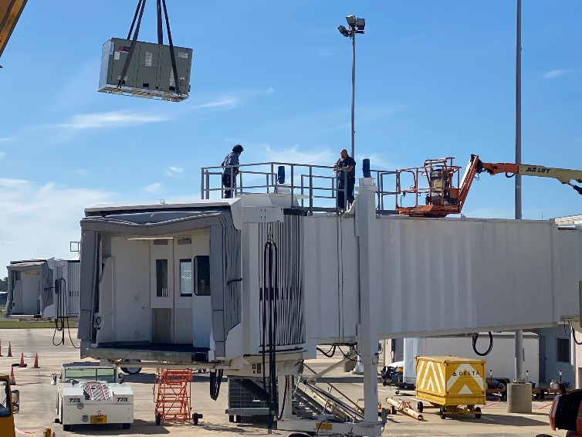

Economic Development: Staff worked with the county’s Purchasing division and issued a request for proposals for the purchase/development of the county's lot six property at DeLand Crossing Industrial Park. Staff met to discuss Industrial Development Authority bond financing. Staff met with city practitioners to strategize business assistance needs to respond to the new COVID-19 stimulus package. Staff continues to process the remaining small and home-based business grant applications. For more information, contact Joanne Magley at 386-248-8030 ext: 18309 or jmagley@volusia.org.

COMMUNITY SERVICES
Community Assistance: The City of New Smyrna Beach is partnering with the Volusia County Health Department to provide meals to 50 New Smyrna Beach households who are quarantined as a result of COVID-19. Meals will be delivered to each household twice a month for six months. Second Harvest Food Bank of Central Florida will be delivering a minimum of two food boxes per month for one year to a minimum of 75 seniors who are homebound as a result of COVID-19. For more information, contact Carmen Hall at CHall@volusia.org.

Library Services: The new addition to the Rachel Robinson Play Yard at the Daytona Beach Regional Library opened to children on Dec. 19. The additional playground equipment is for children two to five years of age. For more information, contact Lucinda Colee at LColee@volusia.org.

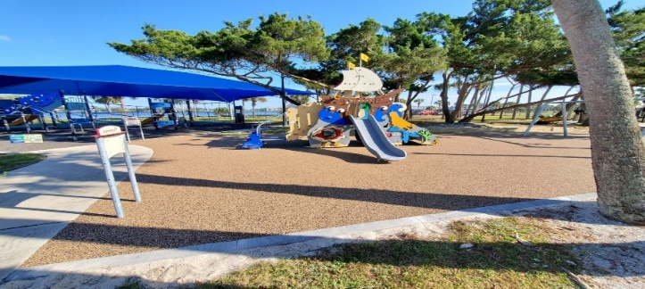

Parks, Recreation and Culture:
Recreation: DeBary Hall Historic Site participated in the City of DeBary’s First Reverse Christmas Parade at Gemini Springs Park on Dec13. DeBary Hall won 3rd place for Overall. For more information, contact Tim Baylie at TBaylie@volusia.org.

OCEAN CENTER
Events: This past weekend, the North American Wrestling Alliance (NAWA) presented Jingle Brawl on Saturday, December 19 at the Ocean Center. The event went off without any issues. This event was open to the public, masks were required and social distancing was enforced. We continue partnering with Halifax Urban Ministries for assembling and distribution of resources and food. For more information, contact Tim Riddle at TRiddle@volusia.org

PUBLIC PROTECTION
Beach Safety: Continue conducting the biannual swim requirements to stay in accordance with the United States Lifesaving Association standards. For more information, please contact Division Director Ray Manchester, 386-239-6414 ext. 20330.
Emergency Management: On Dec 21 and Dec 23, Emergency Management will participate in conference calls and GoToMeetings scheduled with the state and counties to update the counties of the COVID 19 issues and to further discuss vaccine planning with local EM partners. For more information, please contact Division Director Jim Judge, 386-316-1554.

Fire Services: On Dec 22 at 9:00 a.m., the Volusia County Fire Rescue Technical Rescue Team will be rigging static rope lines from Halifax Health Medical Center and rappel in front of the pediatric unit windows, in a Santa suit, to bring holiday cheer to the children. For more information, please contact Division Director/Fire Chief Howard J. Bailey, 386-736-5940, ext. 12918.

