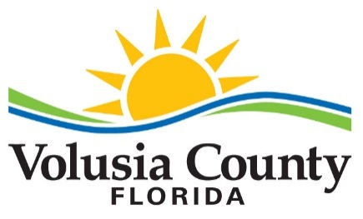

Credit Statement
for
County of Volusia, Florida

FEIN 59-6000885 DUNS # 06-784-9901

A county government, political sub-division of the State of Florida.

James T. Dinneen County Manager
Donna de Peyster Deputy County Manager, CFO
George Recktenwald Deputy County Manager
Ryan Ossowski Accounting Director
Jeaniene Jennings Purchasing and Contracts Director

Administrative Mailing Address: 123 W. Indiana Avenue, DeLand, FL 32720
Shipping Address: See PURCHASE ORDER
Billing Address: See PURCHASE ORDER

Bank (Checking): Wells Fargo Bank, N.A.

Trade References:

Brown & Brown of Florida, Inc.  220 S. Ridgewood Avenue  Daytona Beach, FL 32114  386-239-7233 | Communications International  4450 U.S. Highway 1  Vero Beach, FL 32967  888-275-4244
Ring Power Corporation  500 World Commerce Parkway  St. Augustine, FL 32092  904-737-7730 | Staples  500 Staples Drive  Framingham, MA 01702  888-753-4103

Purchase Order Required
The County of Volusia, FL, requires a purchase order for all purchases unless payment is made by County VISA card.

Payment Terms: NET 45 DAYS
The County will remit full payment on all undisputed invoices within 45 (forty-five) days from receipt by the appropriate person(s) (to be designated at time of contract) of the invoice(s) or receipt of all products or services ordered. The County does not make partial payments on partial deliveries.

Pursuant to Chapter 218, Florida Statutes, the County will pay interest not to exceed one percent (1%) per month on all undisputed invoices not paid within 45 (forty-five) days after receipt of the entire order of the commodity or service, and a properly completed invoice, whichever is later.

The County of Volusia, FL, is exempt from payment of Florida Sales and Use Taxes and generally all other taxes per Exemption Certificate No. 85-8012622393C-9 (expires 10/31/2022).

