LID Best Management Practices (BMPs) Table – Site Design
Section | Site Design BMP | Examples | Description | Incentive | Requirements to gain Incentives | Reviewing Entity
4.2.1.A. | Maintain Natural Topography | 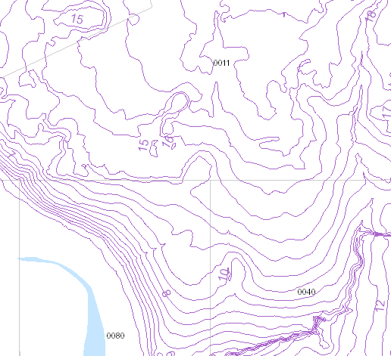  Figure 11 | Design buildings and infrastructure around existing topography, rather than re-contouring the land to fit the building design. | Option A:  - All incentives for Option B  - Increased Density (Section 2.2.1.C.)  - Increased Floor Area Ratio (Section 2.2.1.D.)  - Increased Lot Coverage (Section 2.2.2.G.)  Option B:  - Flexible Lot Sizes (Section 2.2.1.A.)  - Flexible Building Setbacks (Section 2.2.1.B.)  - Increased Maximum Height (Section 2.2.2.A.)  - Off-Street Parking Flexibility (Section 2.2.2.F.)  - Reduced Building Permit Fees (Section 2.2.4.A.)  - Reduced Land Development Fees (Section 2.2.4.B.)  - Variance and/or Waiver Not Required (Section 2.2.5.A.) | Option A: Maintain natural topography for 30% of the site. The area must be contiguous and preserved with a conservation easement dedicated to Volusia County, severing all development rights. The submitted Final Site Plan or Overall Development Plan and Preliminary Plat must identify the square-footage/acreage of these areas.  Option B: The notes on a Final Plat or Final Site Plan must state stem-wall construction is required for all primary structures. If a subdivision, this must also be stated within the Declaration of Covenants, Conditions and Restrictions (DCCRs).  Fill/grading is limited to the footprint of and a 15-foot perimeter around the building to facilitate stormwater conveyance. This must be depicted within the engineered drawings on the Final Site Plan or Preliminary Plat application.  Pairs well with: Preserving Floodplain (Section 4.2.1.B.), Retaining Tree Canopy and Native Vegetation (Section 4.2.2.A.), Retaining Large Riparian or Vegetated Natural Buffers (Section 4.2.2.B.), Cluster Subdivisions (Section 4.2.2.C.), Conservation Subdivisions (Section 4.2.2.D.), Common Open Space (Section 4.2.3.A.), Corridor Protection (Section 4.2.3.B.), Habitat Restoration or Habitat Management (Section 4.2.4.B.), Minimize Building Construction Footprint (Section 4.2.6.A.), and Minimize Total Impervious Area (Section 4.2.6.B.) | Option A: Development Engineering  Option B: Land Development
4.2.1.B. | Preserving Floodplain | 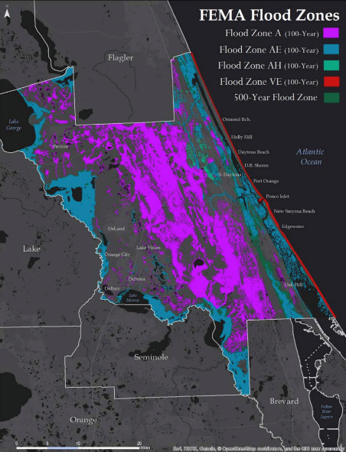  Figure 14 | Preserving floodplains is crucial for mitigating flood damage and maintaining ecological balance. Floodplains store excess water, reducing flood peaks and velocities, particularly vital in urban areas. Floodplains slow runoff, promoting water infiltration and groundwater recharge, essential for local water sources. During non-flood periods, they regulate flow through groundwater discharge, mitigating flood peaks and low flows. Protecting floodplains not only safeguards communities from disasters but also sustains the health of riverine environments. | - Flexible Lot Sizes (Section 2.2.1.A.)  - Flexible Building Setbacks (Section 2.2.1.B.)  - Increased Density (Section 2.2.1.C.)  - Increased Floor Area Ratio (Section 2.2.1.D.)  - Increased Maximum Height (Section 2.2.2.A.)  - Increased Lot Coverage (Section 2.2.2.G.)  - Reduction in Tree Replacement Requirements (Section 2.2.3.A.)  - Reduced Building Permit Fees (Section 2.2.4.A.)  - Reduced Land Development Fees (Section 2.2.4.B.)  - Variance and/or Waiver Not Required (Section 2.2.5.A.) | 100% of the FEMA Flood Hazard Areas identified at the time of application are protected through a conservation easement dedicated to Volusia County, severing all development rights, when they encompass 30% or more of the site.  This can include the tree preservation area required by Section 72-837, of the LDC.  Pairs well with: Maintaining Natural Topography (Section 4.2.1.A.), Retaining Tree Canopy and Native Vegetation (Section 4.2.2.A.), Retaining Large Riparian or Vegetated Natural Buffers (Section 4.2.2.B.), Cluster Subdivisions (Section 4.2.2.C.), Conservation Subdivisions (Section 4.2.2.D.), Common Open Space (Section 4.2.3.A.), Corridor Protection (Section 4.2.3.B.), Habitat Restoration or Habitat Management (Section 4.2.4.B.), Minimize Building Construction Footprint (Section 4.2.6.A.), and Minimize Total Impervious Area (Section 4.2.6.B.) | Development Engineering & Land Development
4.2.2.A. | Retaining Tree Canopy and Native Vegetation | 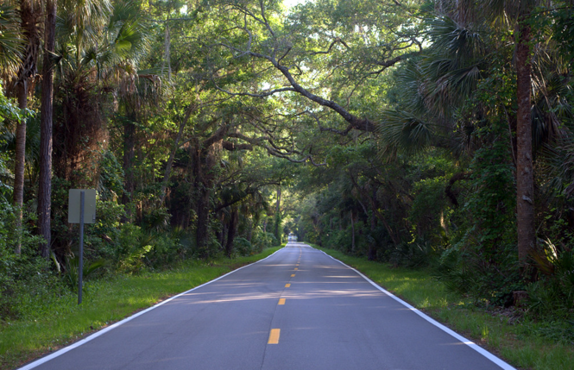  Figure 15: Large tree canopies in Ormond Beach, Florida. | This refers to the intentional preservation and incorporation of existing natural vegetation, including trees, shrubs, and ground cover. This approach aims to minimize disturbance to natural ecosystems and preserve biodiversity. | - Reduction in Tree Replacement Requirements (Section 2.2.3.A.)  - Reduced Building Permit Fees (Section 2.2.4.A.)  - Reduced Land Development Fees (Section 2.2.4.B.)  - Variance and/or Waiver Not Required (Section 2.2.5.A.) | Retain an additional 5% of the square footage of any development for the preservation of existing trees beyond the minimum requirements of Section 72-837, of the LDC. A conservation easement dedicated to Volusia County, severing all development rights, is required.  Pairs well with: Maintaining Natural Topography (Section 4.2.1.A.), Preserving Floodplain (Section 4.2.1.B.), Retaining Large Riparian or Vegetated Natural Buffers (Section 4.2.2.B.), Cluster Subdivisions (Section 4.2.2.C.), Conservation Subdivisions (Section 4.2.2.D.), Common Open Space (Section 4.2.3.A.), Corridor Protection (Section 4.2.3.B.), Habitat Restoration or Habitat Management (Section 4.2.4.B.), Minimize Building Construction Footprint (Section 4.2.6.A.), and Minimize Total Impervious Area (Section 4.2.6.B.) | Environmental Management
4.2.2.B. | Retaining Large Riparian or Vegetated Natural Buffers | 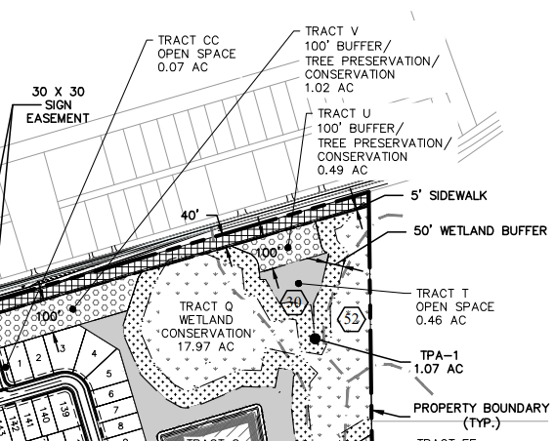  Figure 17: Excerpt of subdivision construction plan | This refers to strips or areas of vegetation strategically located along the edges of water bodies, drainage channels, or developed areas to mitigate the impacts of stormwater runoff and protect water quality. These buffers help to slow down, filter, and absorb stormwater before it enters water bodies. | - Flexible Building Setbacks (Section 2.2.1.B.)  - BMP Permitted within Landscape Buffers and Building Setbacks (Section 2.2.2.B.)  - BMP Credited as Landscaping (Section 2.2.2.D)  - Increased Lot Coverage (Section 2.2.2.G.)  - Reduced Building Permit Fees (Section 2.2.4.A.)  - Reduced Land Development Fees (Section 2.2.4.B.)  - Variance and/or Waiver Not Required (Section 2.2.5.A.) | Option A: Retain a 20% greater buffer than the minimum required by Division 11, of the LDC, adjacent to all wetland/surface waters on 100% of the site.  Option B: Retain a 20% greater natural landscape buffer than the minimum required by Section 72-284, or the Zoning Ordinance, along all property boundaries.  Pairs well with: Maintaining Natural Topography (Section 4.2.1.A.), Preserving Floodplain (Section 4.2.1.B.), Retaining Tree Canopy and Native Vegetation (Section 4.2.2.A.), Cluster Subdivisions (Section 4.2.2.C.), Conservation Subdivisions (Section 4.2.2.D.), Common Open Space (Section 4.2.3.A.), Corridor Protection (Section 4.2.3.B.), Habitat Restoration or Habitat Management (Section 4.2.4.B.), Minimize Building Construction Footprint (Section 4.2.6.A.), and Minimize Total Impervious Area (Section 4.2.6.B.) | Option A: Environmental Management  Option B: Zoning
4.2.2.C. | Cluster Subdivisions | 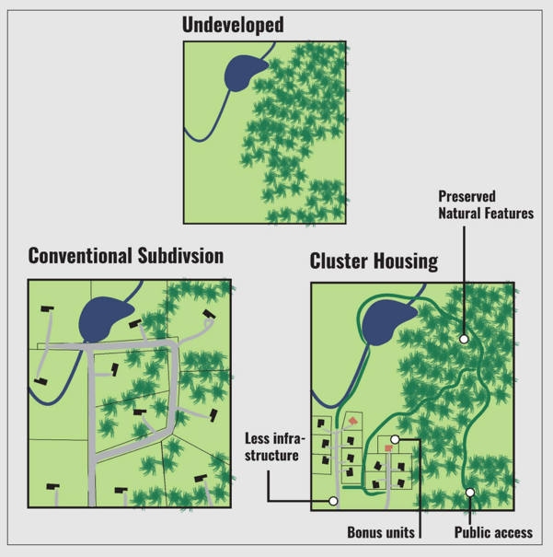  Figure 18 | Development design technique that permits a reduction in lot area by concentrating building in a specific area to allow the remaining land to be used for recreation, open space, or preservation of environmentally sensitive areas. | Incentives currently within Section 72-304, of the ZO:  - Flexible Lot Sizes (Section 72-304(b)(2), of the ZO)  - Flexible Building Setbacks (Section 72-304(b)(4), of the ZO)  Additional Incentives:  - Increased Lot Coverage (Section 2.2.2.G.)  - Reduction in Tree Replacement Requirements (Section 2.2.3.A.)  - Reduced Building Permit Fees (Section 2.2.4.A.)  - Reduced Land Development Fees (Section 2.2.4.B.)  - Variance and/or Waiver Not Required (Section 2.2.5.A.) | Must follow the provisions of Section 72-304, of the Zoning Ordinance.  Pairs well with: Maintaining Natural Topography (Section 4.2.1.A.), Preserving Floodplain (Section 4.2.1.B.), Retaining Tree Canopy and Native Vegetation (Section 4.2.2.A.), Retaining Large Riparian or Vegetated Natural Buffers (Section 4.2.2.B.), Common Open Space (Section 4.2.3.A.), Corridor Protection (Section 4.2.3.B.), Habitat Restoration or Habitat Management (Section 4.2.4.B.), Minimize Building Construction Footprint (Section 4.2.6.A.), Minimize Total Impervious Area (Section 4.2.6.B.), and Stormwater Treatment Park (Section 4.3.1.A.) | Zoning
4.2.2.D. | Conservation Subdivisions | 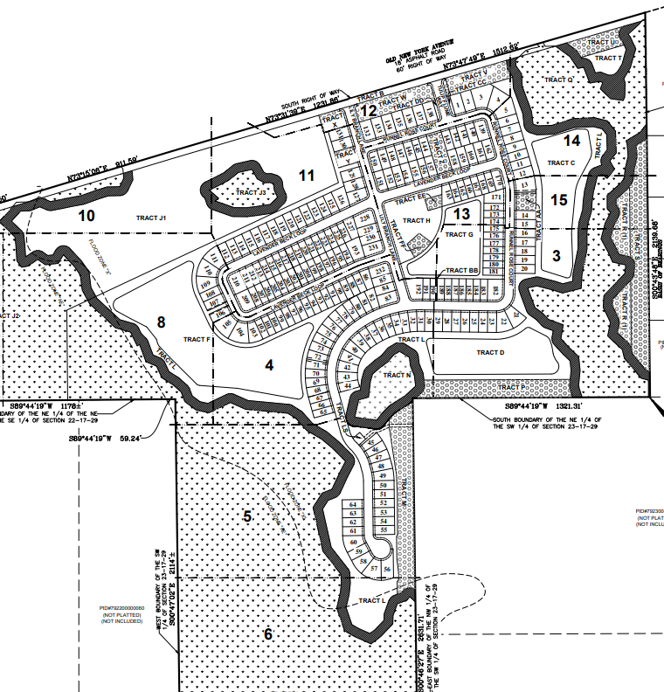  Figure 20 | Development design to implement the smart growth initiative goals, objectives and policies established in the Comprehensive Plan. The regulations within Section 72-547, of the Land Development Code, set forth a flexible process for authorizing conservation subdivisions with innovative designs and provide for standards and locational criteria to site lots in an area suitable for development and provide procedures for permanent conservation management of valuable natural resources. | Incentives currently within Section 72-547, of the LDC:  - Flexible Lot Sizes (Section 72-547(c)(3), of the LDC)  - Flexible Building Setbacks (Section 72-547(c)(3), of the LDC)  - Increased Lot Coverage (Section 72-547(c)(11), of the LDC)  - Increased Density (Section 72-547(c)(12), of the LDC)  Additional Incentives:  - Reduction in Tree Replacement Requirements (Section 2.2.3.A.)  - Reduced Building Permit Fees (Section 2.2.4.A.)  - Reduced Land Development Fees (Section 2.2.4.B.)  - Variance and/or Waiver Not Required (Section 2.2.5.A.) | Must follow the provisions of Section 72-547, of the Land Development Code.  Pairs well with: Maintaining Natural Topography (Section 4.2.1.A.), Preserving Floodplain (Section 4.2.1.B.), Retaining Tree Canopy and Native Vegetation (Section 4.2.2.A.), Retaining Large Riparian or Vegetated Natural Buffers (Section 4.2.2.B.), Common Open Space (Section 4.2.3.A.), Corridor Protection (Section 4.2.3.B.), Habitat Restoration or Habitat Management (Section 4.2.4.B.), Minimize Building Construction Footprint (Section 4.2.6.A.), Minimize Total Impervious Area (Section 4.2.6.B.), and Stormwater Treatment Park (Section 4.3.1.A.) | Land Development
4.2.3.A. | Common Open Space | 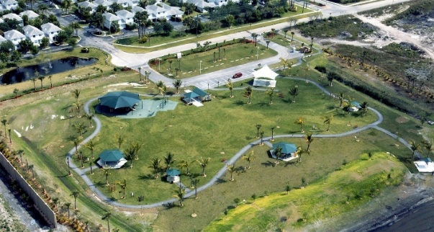Figure 21: Sunset Point Park located in Tamarac, FL. | Areas reserved and designed for the leisure or recreational use of the owners of a residential development and may contain recreational facilities. | - Flexible Lot Sizes (Section 2.2.1.A.)  - Flexible Building Setbacks (Section 2.2.1.B.)  - Off-Street Parking Flexibility (Section 2.2.2.F.)  - Increased Lot Coverage (Section 2.2.2.G.)  - Reduced Building Permit Fees (Section 2.2.4.A.)  - Reduced Land Development Fees (Section 2.2.4.B.)  - Variance and/or Waiver Not Required (Section 2.2.5.A.) | Option A: Provide an additional 5% common open space beyond the minimum required. This area may be preserved in a natural state, but cannot include the minimum tree preservation area required by Section 72-837, of the LDC.  Option B: Where no minimum common open space is required, provide a minimum 15% common open space. This cannot include the minimum tree preservation area required by Section 72-837, of the LDC.  Pairs well with: Maintaining Natural Topography (Section 4.2.1.A.), Preserving Floodplain (Section 4.2.1.B.), Retaining Tree Canopy and Native Vegetation (Section 4.2.2.A.), Retaining Large Riparian or Vegetated Natural Buffers (Section 4.2.2.B.), Cluster Subdivisions (Section 4.2.2.C.), Conservation Subdivisions (Section 4.2.2.D.), Corridor Protection (Section 4.2.3.B.), Habitat Restoration or Habitat Management (Section 4.2.4.B.), and Stormwater Treatment Park (Section 4.3.1.A.) | All Options: Zoning
4.2.3.B. | Corridor Protection | 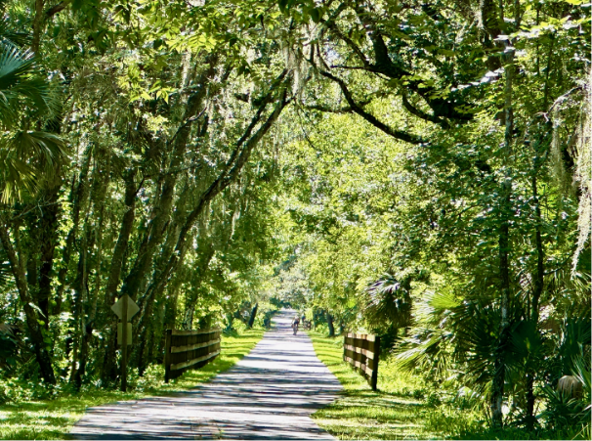  Figure 22: Vegetated multi-use trail in Volusia County, Florida | Linear corridors of protected open space that connect natural areas, parks and communities for recreational, ecological, and transportation purposes. | - BMP Permitted within Landscape Buffers and Building Setbacks (Section 2.2.2.B.)  - BMP Permitted within Landscape Islands and Row-Ends (Section 2.2.2.C.)  - BMP Credited as Common Open Space (Section 2.2.2.E.)  - Off-Street Parking Flexibility (Section 2.2.2.F.)  - Increased Lot Coverage (Section 2.2.2.G.)  - Reduced Building Permit Fees (Section 2.2.4.A.)  - Reduced Land Development Fees (Section 2.2.4.B.)  - Variance and/or Waiver Not Required (Section 2.2.5.A.) | Option A: Preserve natural land which provides a connection to (or is within) the Florida Wildlife Corridor or the Volusia Conservation Corridor and continues through the development project to allow future connection and expansion of the corridor. This area must be at least 30 feet wide and can count toward the required 15% tree preservation area. A conservation easement dedicated to Volusia County, severing all development rights, is required.  Option B: Creation of an internal vegetated multi-use trail of pervious material that connects to a larger pedestrian/bicycle network. The area dedicated to this use must include existing or planted native shade tree species and native understory vegetation. Tree species chosen must have enough space from the trail to ensure survival, as approved by the County Forester.  Pairs well with: Maintaining Natural Topography (Section 4.2.1.A.), Preserving Floodplain (Section 4.2.1.B.), Retaining Tree Canopy and Native Vegetation (Section 4.2.2.A.), Retaining Large Riparian or Vegetated Natural Buffers (Section 4.2.2.B.), Cluster Subdivisions (Section 4.2.2.C.), Conservation Subdivisions (Section 4.2.2.D.), Corridor Protection (Section 4.2.3.B.), Native Landscape, Fertilizers and Irrigation (Section 4.2.4.A.), and Habitat Restoration or Habitat Management (Section 4.2.4.B.) | Option A: Environmental Management  Option B: Development Engineering, Environmental Management & Traffic Engineering
4.2.4.A. | Native Landscape, Fertilizers and Irrigation | 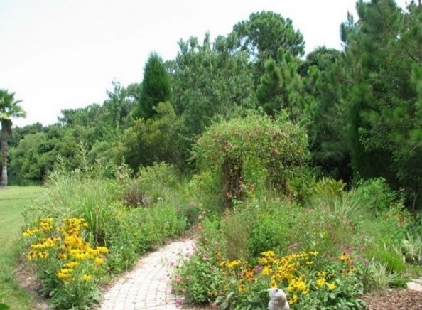  Figure 23 | This involves intentionally using plant species native to Florida, adapted to local conditions without requiring excessive irrigation or chemicals. Incorporating native vegetation into landscaping reduces water, fertilizer, and maintenance needs while providing habitat for local wildlife. Native landscapes preserve Volusia County's biodiversity, support ecosystem functions like pollination, and contribute to regional ecological health. | Option A:  - Off-Street Parking Flexibility (Section 2.2.2.F.)  - Reduced Building Permit Fees (Section 2.2.4.A.)  - Reduced Land Development Fees (Section 2.2.4.B.)  - Variance and/or Waiver Not Required (Section 2.2.5.A.)  Option B:  - All incentives for Option A  - Reduction in Tree Replacement Requirements (Section 2.2.3.A.) - for subdivision common areas and individual lots. | Option A: All planted vegetation within a commercial site is 100% Florida native species (including grasses). Smart Irrigation Controllers are required for the irrigation system. Educational signage describing the benefits of native plants and Be Floridian Now fertilizer principles are placed throughout public spaces.  Option B: The subdivision common areas/landscape buffers must have 100% Florida native vegetation (including grasses - non-native turfgrass is not permitted), Smart Irrigation Controllers for the irrigation system, and educational signage describing the benefits of native plants and Be Floridian Now fertilizer principles placed throughout the common areas.  In addition, 20% of the square-footage of each residential lot must be planted with and maintain native vegetation. Irrigation systems for the individual lots must have Smart Irrigation Controllers. The plat notes and Declaration of Covenants, Conditions, and Restrictions must identify the individual lot requirements. A typical planting detail is required to be provided with the Preliminary Plat application.  Pairs well with: Corridor Protection (Section 4.2.3.B.), Concentrated Landscape Parking Islands/Row Ends (Section 4.2.5.D.), Stormwater Treatment Park (Section 4.3.1.A.), Retention Pond (Section 4.3.1.B.), Detention Pond (Section 4.3.1.C.), Floating Wetland Mats (Section 4.3.2.A.), Vegetated Swale or Bioswale (Section 4.3.2.B.), Rain Gardens (Section 4.3.2.C.), Tree Box Filters and Rainfall Interceptor Trees (Section 4.3.2.D.), and Vegetated Roofs and Walls (Section 4.3.2.E.) | All Options: Environmental Management
4.2.4.B. | Habitat Management | 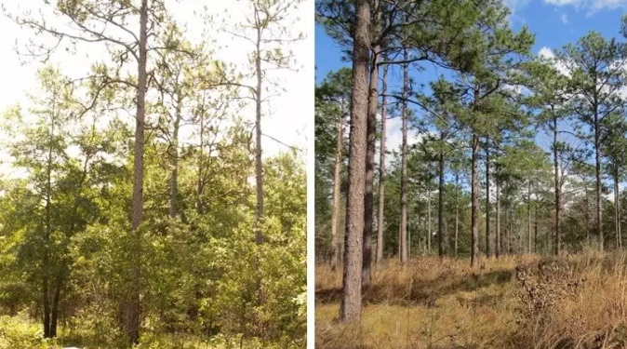  Figure 25: The left image depicts a sandhill community in 2011 before restoration management, and the right side shows the same sandhill community in 2017 after the implementation of restoration management. | This involves actions to rehabilitate, enhance, or sustainably manage natural habitats in and around development areas. The primary goal is to restore ecological functionality, biodiversity, and ecosystem services while minimizing adverse impacts on the environment and maximizing benefits for both humans and wildlife | - Flexible Building Setbacks (Section 2.2.1.B.)  - BMP Permitted within Landscape Buffers and Building Setbacks (Section 2.2.2.B.)  - BMP Credited as Landscaping (Section 2.2.2.D.)  - Reduced Building Permit Fees (Section 2.2.4.A.)  - Reduced Land Development Fees (Section 2.2.4.B.)  - Variance and/or Waiver Not Required (Section 2.2.5.A.) | Preserve 10 acres or more of contiguous undeveloped area, with a conservation easement dedicated to Volusia County, severing all development rights.  This can include the tree preservation area required by Section 72-837, of the LDC.  The habitat management plan must be submitted with the Final Site Plan or Preliminary Plat application. The Declaration of Covenants, Conditions, and Restrictions must identify the habitat management requirements. Annual reports must be submitted to the Land Development Office.  Pairs well with: Maintaining Natural Topography (Section 4.2.1.A.), Preserving Floodplain (Section 4.2.1.B.), Retaining Tree Canopy and Native Vegetation (Section 4.2.2.A.), Retaining Large Riparian or Vegetated Natural Buffers (Section 4.2.2.B.), Cluster Subdivisions (Section 4.2.2.C.), Conservation Subdivisions (Section 4.2.2.D.), and Corridor Protection (Section 4.2.3.B.) | Environmental Management
4.2.5.A. | Alternative Surface Material | 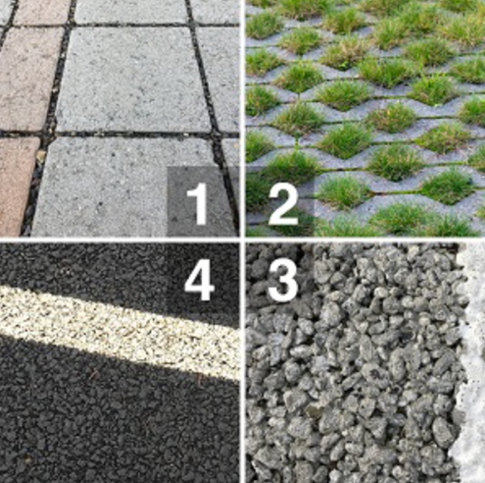  Figure 32:  1 – permeable pavers, 2 – grass pavers,  3 – pervious concrete, 4 – porous asphalt | Pervious pavements are retention systems and should be used as part of a treatment train to reduce stormwater volume. The treatment efficient is based on the amount of annual runoff volume infiltrated, which depends on the available storage volume within the pavement system, the underlying soil permeability, and the ability for the system to readily recover. | - Off-Street Parking Flexibility (Section 2.2.2.F.)  - Reduced Building Permit Fees (Section 2.2.4.A.)  - Reduced Land Development Fees (Section 2.2.4.B.)  - Variance and/or Waiver Not Required (Section 2.2.5.A.) | A minimum 50% of the off-street parking spaces (excluding ADA parking spaces) and 100% of the sidewalks (excluding sidewalks identified as ADA accessible routes) must be an alternative surface material (permeable pavers, grass pavers, pervious concrete, or porous asphalt).  The pervious surface type must be identified on the civil plans.  Pairs well with: Minimize Total Impervious Area (Section 4.2.6.B.) and Minimize Directly Connected Impervious Area (Section 4.2.6.C.) | Development Engineering
4.2.5.B. | Concentrated Landscape Parking Islands/Row-Ends | 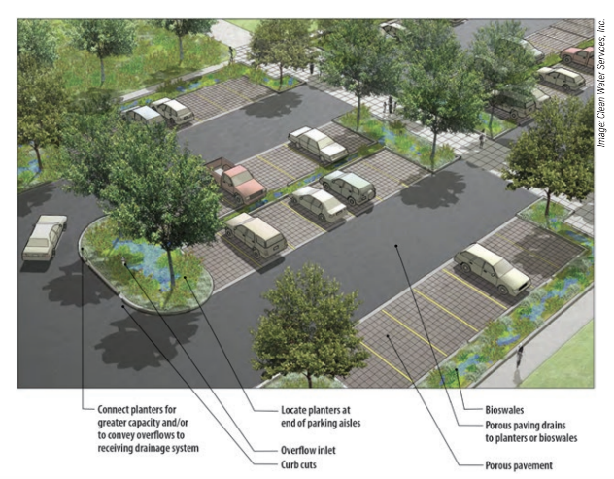  Figure 37 | Concentrated landscape islands and row ends are deliberate design elements that focus vegetation in specific areas within a developed site, commonly found in parking lots. These areas feature native plants chosen for local conditions to enhance biodiversity, provide habitat for wildlife, improve air quality, and reduce heat island effects. They also manage stormwater runoff, promote soil infiltration, and enhance overall sustainability and resilience. | - BMP Permitted within Landscape Islands and Row-Ends (Section 2.2.2.C.)  - BMP Credited as Landscaping (Section 2.2.2.D.)  - BMP Credited as Common Open Space (Section 2.2.2.E.)  - Off-Street Parking Flexibility (Section 2.2.2.F.)  - Reduced Building Permit Fees (Section 2.2.4.A.)  - Reduced Land Development Fees (Section 2.2.4.B.)  - Variance and/or Waiver Not Required (Section 2.2.5.A.) | Parking areas within commercial sites and subdivision common areas must provide concentrated landscape islands/row-ends with a minimum area of 300 square feet with no width less than 20 feet, if it abuts one parking space. If abutting two parking spaces, the minimum size must be doubled.  Design must include an alternative curb design to facilitate stormwater runoff.  Concentrated landscape islands/row-ends must be at a sufficient distance from structures to ensure clearance for fire engines at mature tree growth.  Pairs well with: Curb Elimination, Cuts and Alternative Designs (Section 4.2.5.B.), Alternative Surface Material (Section 4.2.5.C.), Minimize Total Impervious Area (Section 4.2.6.B.), and Minimize Directly Connected Impervious Area (Section 4.2.6.C.) | Zoning
4.2.6.A. | Minimize Building Construction Footprint | 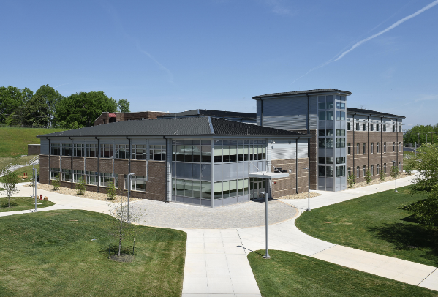  Figure 41 | Maximizing multi-story building designs reduces site disturbance and impervious footprint, lowering stormwater runoff. Stem-wall construction on sloping sites minimizes disturbance and environmental impact, especially in areas like Florida where phosphorus leaching is a concern. | - Increased Floor Area Ratio (Section 2.2.1.D.)  - Increased Maximum Height (Section 2.2.2.A.)  - Off-Street Parking Flexibility (Section 2.2.2.F.)  - Reduced Building Permit Fees (Section 2.2.4.A.)  - Reduced Land Development Fees (Section 2.2.4.B.)  - Variance and/or Waiver Not Required (Section 2.2.5.A.) | Utilize multistory construction to reduce building lot coverage by at least 25% of the maximum building lot coverage permitted within Section 72-241, of the Zoning Ordinance.  This is only permitted within commercial and industrial zoning classifications.  Pairs well with: Maintain Natural Topography (Section 4.2.1.A.), Preserving Floodplain (Section 4.2.1.B.), Retaining Tree Canopy and Native Vegetation (Section 4.2.2.A.), Retaining Large Riparian or Vegetated Natural Buffers (Section 4.2.2.B.), Cluster Subdivision (Section 4.2.2.C.), Conservation Subdivision (Section 4.2.2.D.), and Minimize Total Impervious Area (Section 4.2.6.B.) | Zoning
4.2.6.B. | Total Impervious Area | 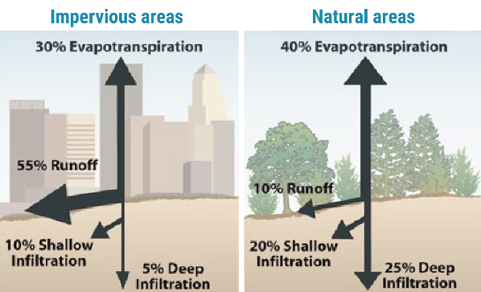  Figure 42 | Total impervious areas (TIAs) encompass all surfaces within a developed site that prevent or inhibit the infiltration of water into the ground. | Option A:  - Flexible Building Setbacks (Section 2.2.1.B.)  - Increased Floor Area Ratio (Section 2.2.1.D.)  - Increased Maximum Height (Section 2.2.2.A.)  - Off-Street Parking Flexibility (Section 2.2.2.F.)  - Reduced Building Permit Fees (Section 2.2.4.A.)  - Reduced Land Development Fees (Section 2.2.4.B.)  - Variance and/or Waiver Not Required (Section 2.2.5.A.)  Option B:  - Flexible Lot Sizes (Section 2.2.1.A.)  - Flexible Building Setbacks (Section 2.2.1.B.)  - Reduced Building Permit Fees (Section 2.2.4.A.)  - Reduced Land Development Fees (Section 2.2.4.B.)  - Variance and/or Waiver Not Required (Section 2.2.5.A.) | Option A: Reduce the maximum impervious area within a commercial or industrial site to 50%. The notes on the Final Site Plan must state this maximum.  Option B: Design the stormwater system to account for 10% more than the allowable lot coverage permitted within Section 72-241, of the Zoning Ordinance, for each individual lot within a residential development. This must be reflected  The notes on a Final Plat or Final Site Plan must state this maximum. If a subdivision, this must also be stated within the Declaration of Covenants, Conditions and Restrictions (DCCRs).  Pairs well with: Maintain Natural Topography (Section 4.2.1.A.), Preserving Floodplain (Section 4.2.1.B.), Retaining Tree Canopy and Native Vegetation (Section 4.2.2.A.), Retaining Large Riparian or Vegetated Natural Buffers (Section 4.2.2.B.), Cluster Subdivision (Section 4.2.2.C.), Conservation Subdivision (Section 4.2.2.D.), Alternative Surface Material (Section 4.2.5.C.), Concentrated Landscape Islands/Row Ends (Section 4.2.5.D.), Minimize Building Construction Footprint (Section 4.2.6.A.), and Minimize Directly Connected Impervious Area (Section 4.2.6.B.) | Development Engineering
4.2.6.C. | Minimize Directly Connected Impervious Areas | 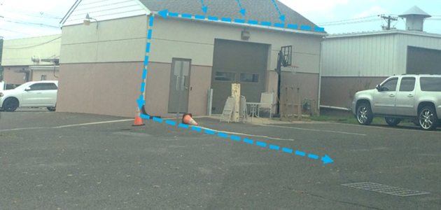  Figure 43: An example of directly connected impervious area.  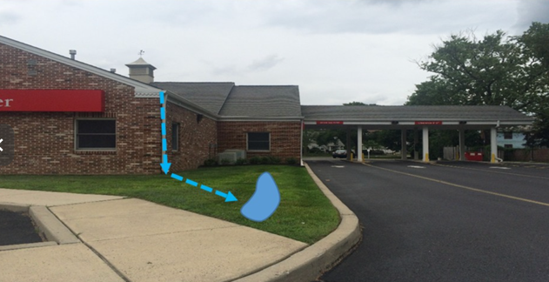  Figure 44: An example of disconnected impervious areas. | Directly connected impervious areas (DCIAs) allow runoff to be conveyed without interception by permeable areas that allow for infiltration and treatment.  Disconnecting impervious areas from roofs, small parking lots, courtyards, driveways, sidewalks, and other impervious surfaces allows runoff to flow onto adjacent pervious areas where it is infiltrated and filtered. | - BMP Permitted within Landscape Buffers and Building Setbacks (Section 2.2.2.B.)  - BMP Permitted within Landscape Islands and Row-Ends (Section 2.2.2.C.)  - BMP Credited as Common Open Space (Section 2.2.2.E.)  - Reduced Building Permit Fees (Section 2.2.4.A.)  - Reduced Land Development Fees (Section 2.2.4.B.)  - Variance and/or Waiver Not Required (Section 2.2.5.A.) | All roof stormwater runoff must be directed into a pervious area (i.e. rain garden, swale, etc.).  The disconnected area must be identified on the civil plans and within a table.  Pairs well with: Alternative Surface Material (Section 4.2.5.C.), Concentrated Landscape Islands/Row Ends (Section 4.2.5.D.) and Minimize Total Impervious Area (Section 4.2.6.B.) | Zoning

LID Best Management Practices (BMPs) Table – Stormwater Storage, Treatment and Conveyance
Section | Stormwater BMP | Examples | Description | Incentive | Requirements to gain Incentives | Reviewing Entity
4.3.1.A. | Stormwater Treatment Park | 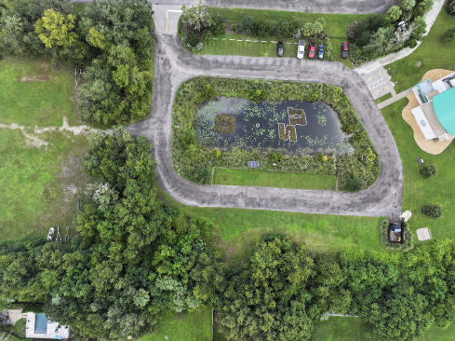  Figure 45: Stetson University Sandra Aquatic Center | Creation of stormwater treatment park within a commercial site or subdivision can serve as a multifunctional landscape that can enhance water quality, reduce flood risks, and promote groundwater recharge, while offering opportunities for passive/active recreation. | - BMP Permitted within Landscape Buffers and Building Setbacks (Section 2.2.2.B.)  - BMP Credited as Landscaping (Section 2.2.2.D.)  - BMP Credited as Common Open Space (Section 2.2.2.E.)  - Reduced Building Permit Fees (Section 2.2.4.A.)  - Reduced Land Development Fees (Section 2.2.4.B.)  - Variance and/or Waiver Not Required (Section 2.2.5.A.) | Create a passive/active recreational stormwater treatment park with educational signage, one or more clearly defined, visible entrances connecting to other internal sidewalks, a sidewalk surrounding the pond with pedestrian scale lighting, with no fewer than three of the following:  - Playground meeting the Consumer Product Safety Commission playground safety guidelines for public use,  - Two 15’ x 20’ picnic shelters with a minimum of 2 picnic tables each,  - One 20’ x 30’ covered pavilion or shelter with a minimum of 5 picnic tables each,  - Five standalone picnic tables,  - Open “free play” areas,  - Fenced dog park, or  - Three-piece ASTM F3101 Compliant Outdoor Fitness Site or individual stations.  All passive/active recreational facilities and ponds must be located on the civil plans. Planted vegetation must be located on the landscape plan.  Option A: Wet Pond – Must include a littoral zone comprised of native emergent and submerged aquatic macrophytic vegetation. Biosorption Activated Media (BAM) must be used and can only contain non-petroleum-based products (expanded clay, sawdust, palm fronds, limestone, etc.).  Option B: Dry Pond – Must include an upland buffer of native trees, shrubs and understory vegetation. Biosorption Activated Media (BAM) must be used and can only contain non-petroleum-based products (expanded clay, sawdust, palm fronds, limestone, etc.).  Pairs well with: Cluster Subdivision (Section 4.2.2.C.), Conservation Subdivision (Section 4.2.2.D.), Common Open Space (Section 4.2.3.A.), Native Landscape, Fertilizers, and Irrigation (Section 4.2.4.A.), Retention Pond (Section 4.3.1.B.), Detention Pond (Section 4.3.1.C.), Stormwater Harvesting (Section 4.3.1.G.), and Floating Wetland Mats (Section 4.3.2.A.) | All Options: Development Engineering and Zoning
4.3.1.B. | Wet Pond | 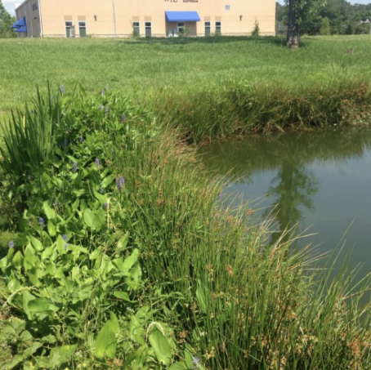  Figure 49: The above image depicts a wet pond with a littoral shelf vegetation. | A wet pond refers to a constructed stormwater management facility designed to collect and temporarily store stormwater in a permanently wet impoundment in such a manner as to provide for treatment through physical, chemical, and biological processes with subsequent gradual release of the stormwater. Depending on the design, wet ponds may incorporate additional features such as forebays, outlet structures, and emergency spillways to regulate water levels and ensure proper functioning during storm events. | - Flexible Lot Sizes (Section 2.2.1.A.)  - Flexible Building Setbacks (Section 2.2.1.B.)  - Reduced Building Permit Fees (Section 2.2.4.A.)  - Reduced Land Development Fees (Section 2.2.4.B.)  - Variance and/or Waiver Not Required (Section 2.2.5.A) | A wet pond is designed to capture 15% more stormwater than required by the minimum standards within Division 8, of the LDC. The entirety of the pond must include a littoral zone compromised of native emergent and submersed aquatic macrophytic vegetation. Biosorption Activated Media (BAM) must be used and can only contain non-petroleum-based products (expanded clay, sawdust, palm fronds, limestone, etc.).  Note: The 15% shall not include additional capacity for compensating storage for fill in the floodplain.  Pairs well with: Native Landscape, Fertilizers, and Irrigation (Section 4.2.4.A.), Stormwater Treatment Park (Section 4.3.1.A.), Stormwater Harvesting (Section 4.3.1.G.), and Floating Wetland Mats (Section 4.3.2.A.) | Development Engineering & Environmental Management
4.3.1.C. | Dry Pond | 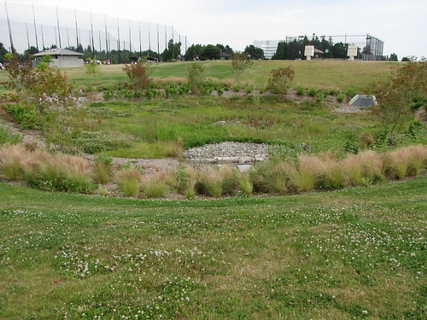  Figure 54 | A dry pond is a constructed stormwater management facility designed to prevent the discharge of a given volume to stormwater runoff into surface waters. It stores a defined quantity of runoff, allowing it to percolate through permeable soils into the shallow ground water aquifer. Vegetation may be incorporated into the pond's design to stabilize soil, enhance infiltration, and provide habitat for wildlife. | - Flexible Lot Sizes (Section 2.2.1.A.)  - Flexible Building Setbacks (Section 2.2.1.B.)  - Reduced Building Permit Fees (Section 2.2.4.A.)  - Reduced Land Development Fees (Section 2.2.4.B.)  - Variance and/or Waiver Not Required (Section 2.2.5.A) | A dry pond is designed to capture 15% more stormwater than required by the minimum standards within Division 8, of the LDC. The entirety of the pond must include an upland buffer of native trees, shrubs and understory vegetation. Biosorption Activated Media (BAM) must be used and can only contain non-petroleum-based products (expanded clay, sawdust, palm fronds, limestone, etc.).  Note: The 15% shall not include additional capacity for compensating storage for fill in the floodplain.  Pairs well with: Native Landscape, Fertilizers, and Irrigation (Section 4.2.4.A.) and Stormwater Treatment Park (Section 4.3.1.A.) | Development Engineering & Environmental Management
4.3.1.D. | Underground Retention and Detention Systems | 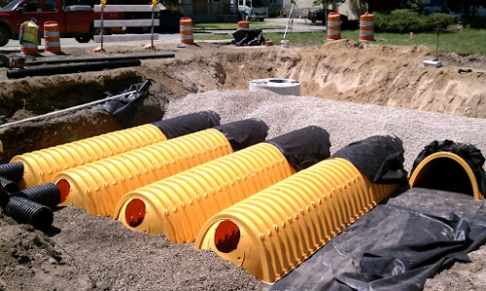  Figure 57: An underground detention system located in Kirk Point Park. | Underground stormwater management systems, like retention and detention systems, store excess stormwater underground using chambers, tanks, or pipes. These systems are designed to manage stormwater runoff by temporarily storing and infiltrating excess water into the surrounding soil or to continually hold water, only discharging into other stormwater infrastructure. | - Flexible Lot Sizes (Section 2.2.1.A.)  - Flexible Building Setbacks (Section 2.2.1.B.)  - Increased Density (Section 2.2.1.C.)  - Increased Lot Coverage (Section 2.2.2.G.)  - Reduced Building Permit Fees (Section 2.2.4.A.)  - Reduced Land Development Fees (Section 2.2.4.B.)  - Variance and/or Waiver Not Required (Section 2.2.5.A.) | An underground storage system is installed to minimize impact of 10% of natural areas on-site within a commercial or multifamily site. The water table must be appropriate for the use of this BMP.  Note: The applicant cannot gain an incentive if this is the only option to meet minimum stormwater management requirements of Division 8 on-site (i.e. the site is constrained).  Pairs well with: Maintaining Natural Topography (Section 4.2.1.A.), and Common Open Space (Section 4.2.3.A.). | Development Engineering
4.3.1.E. | Infiltration & Exfiltration Trenches | 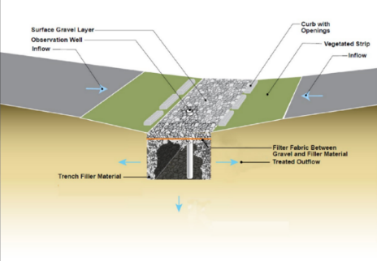  Figure 58: Infiltration Trench  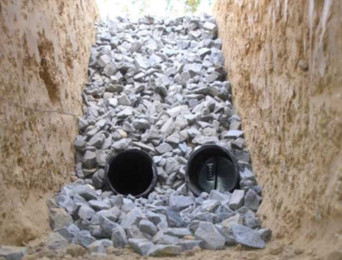  Figure 59: Exfiltration Trench | An infiltration trench is a shallow trench filled with permeable materials like gravel or crushed stone, designed to capture stormwater runoff and promote infiltration into the soil. It often includes a perforated pipe or stone-filled channel at the bottom for drainage and even water distribution. Stormwater entering the trench percolates through the media, allowing pollutants to settle out and water to infiltrate the soil. Pavement design may vary based on the use of the trench in the right-of-way.  An exfiltration trench is subsurface stormwater management system consisting of a conduit such as perforated pipe surrounded by natural (gravel or crushed stone) or artificial aggregate which temporarily store and infiltrates stormwater runoff. It redistributes water horizontally, aiding groundwater recharge and reducing surface runoff. | - Flexible Lot Sizes (Section 2.2.1.A.)  - Flexible Building Setbacks (Section 2.2.1.A.)  - Increased Density (Section 2.2.1.C.)  - Increased Lot Coverage (Section 2.2.2.G.)  - Reduced Building Permit Fees (Section 2.2.4.A.)  - Reduced Land Development Fees (Section 2.2.4.B.)  - Variance and/or Waiver Not Required (Section 2.2.5.A.) | The infiltration/exfiltration trench must be used on-site and may be used to meet total stormwater volume required by Division 8, of the Land Development Code. This must be demonstrated in the stormwater calculations.  This BMP can only be utilized in a commercial site, private streets, or outside the public right-of-way. The water table must be appropriate for the use of this BMP.  Pairs well with: Stormwater Treatment Park (Section 4.3.1.A.), Retention Pond (Section 4.3.1.B.), Detention Pond (Section 4.3.1.C.), and Underground Retention and Detention Systems (Section 4.3.1.D.) | Development Engineering
4.3.1.F. | Stormwater Harvesting | 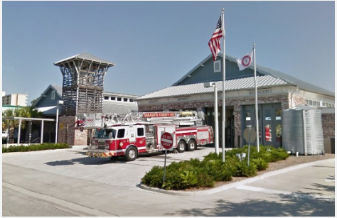  Figure 63: Cistern at fire station in Sarasota County, FL | Stormwater harvesting captures, treats, and reuses runoff from surfaces like rooftops for various purposes. It involves collecting water into storage tanks, cisterns, rain barrels, or ponds, then treating it for potable or non-potable uses. | - Flexible Building Setbacks (Section 2.2.1.A.)  - BMP Permitted within Landscape Buffers and Setbacks (Section 2.2.2.B.)  - Reduced Building Permit Fees (Section 2.2.4.A.)  - Reduced Land Development Fees (Section 2.2.4.B.)  - Variance and/or Waiver Not Required (Section 2.2.5.A.) | A stormwater harvesting method must be used on-site and may be used to meet total stormwater volume required by Division 8, of the Land development Code. This must be demonstrated in the stormwater calculations.  The proposed stormwater harvesting vessel (pond, cisterns, etc.) and all related piping, etc. and the reuse activity must be demonstrated on the Final Site Plan construction plans. This is only permitted within multifamily, commercial, and industrial zoning classifications.  Note:  - Harvested stormwater for non-potable uses must be approved by the Florida Department of Health.  - A cistern must be designed to eliminate openings for mosquitos and protected from sunlight.  - Incentives cannot be gained by using a stormwater harvesting park to meet minimum fire water requirements required by the Florida Fire Prevention Code, only. An additional non-potable use must be included.  Pairs well with: Stormwater Treatment Park (Section 4.3.1.A.), Retention Pond (Section 4.3.1.B.), and Vegetated Roofs and Walls (Section 4.3.2.E.) | Development Engineering & Environmental Management
4.3.2.A. | Vegetated Swale | 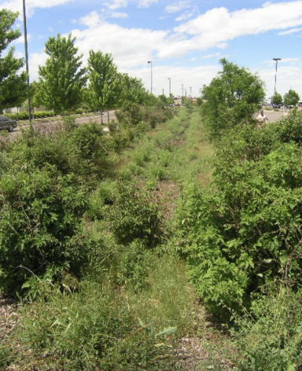  Figure 65 | Vegetated swales are shallow channels with a top width-to-depth ratio of at least 6:1 or slide slopes of 3 feet horizontal to 1 foot vertical. They hold water only after rainfall, planted with suitable vegetation for soil stabilization and stormwater treatment. Swales are designed considering soil erodibility, percolation, slope, length, and drainage area to prevent erosion and reduce pollutant concentration in discharge. | - BMP Permitted within Landscape Buffers and Building Setbacks (Section 2.2.2.B.)  - BMP Permitted within Landscape Islands and Row-Ends (Section 2.2.2.C.)  - BMP Credited as Landscaping (Section 2.2.2.D.)  - Reduced Building Permit Fees (Section 2.2.4.A.)  - Reduced Land Development Fees (Section 2.2.4.B.)  - Variance and/or Waiver Not Required (Section 2.2.5.A.) | A vegetated swale must be used on-site and may be used to meet total stormwater volume required by Division 8, of the Land development Code. This must be demonstrated in the stormwater calculations.  All vegetation must be native and identified within the civil and landscape plans.  Pairs well with: Native Landscape, Fertilizers, and Irrigation (Section 4.2.4.A.), Curb Elimination, Cuts and Alternative Designs (Section 4.2.5.B.), Concentrated Landscape Parking Islands/Row Ends (Section 4.2.5.D.), Stormwater Treatment Park (Section 4.3.1.A.), and Retention Pond (Section 4.3.1.B.) | Development Engineering & Environmental Management
4.3.2.B. | Rain Gardens | 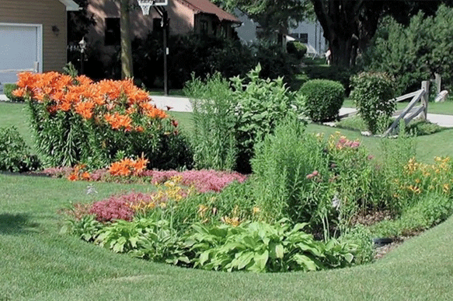  Figure 70: Small retention basins that are integrated into a site’s landscaping. | Rain gardens are shallow depressions planted with native Florida vegetation, placed in landscapes or parking lot islands to capture runoff from hard surfaces like roofs or sidewalks. They slow water flow, holding it briefly to allow natural infiltration or evaporation. | - BMP Permitted within Landscape Buffers and Building Setbacks (Section 2.2.2.B.)  - BMP Permitted within Landscape Islands and Row-Ends (Section 2.2.2.C.)  - BMP Credited as Landscaping (Section 2.2.2.D.)  - BMP Credited as Common Open Space (Section 2.2.2.E.)  - Reduced Building Permit Fees (Section 2.2.4.A.)  - Reduced Land Development Fees (Section 2.2.4.B.)  - Variance and/or Waiver Not Required (Section 2.2.5.A.) | A rain garden must be used on-site and may be used to meet total stormwater volume required by Division 8, of the Land development Code. This must be demonstrated in the stormwater calculations.  The landscape plan must depict native plant species, location, and number and any landscape rocks, etc. Species do not need to be chosen from the Zoning Landscape Plant List, as they may be aquatic in nature.  Pairs well with: Native Landscape, Fertilizers, and Irrigation (Section 4.2.4.A.), Curb Elimination, Cuts and Alternative Designs (Section 4.2.5.B.), Concentrated Landscape Parking Islands/Row Ends (Section 4.2.5.D.), Minimize Total Impervious Area (Section 4.2.6.B.), Minimize Directly Connected Impervious Area (Section 4.2.6.C.), and Stormwater Treatment Park (Section 4.3.1.A.) | Development Engineering & Zoning
4.3.2.C. | Tree Box Filters and Rainfall Interceptor Trees | 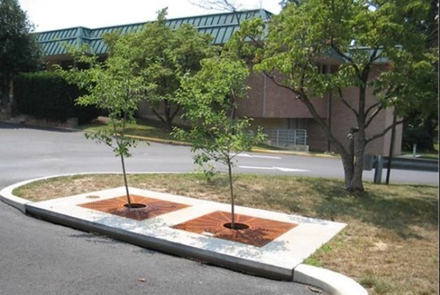  Figure 79: The above image depicts a tree box filter. | A tree box filter is a tree vault containing amended soils underlain with crushed gravel media, which is connected to the overall stormwater system through perforated underdrain pipes (UACDC Low Impact Development: a design manual for urban areas).  Inceptor trees are used adjacent to impervious surfaces as part of the stormwater treatment system to reduce runoff volume and pollution from the area by intercepting and capturing rainfall before it reaches the ground. | - BMP Permitted within Landscape Islands and Row-Ends (Section 2.2.2.C.)  - BMP Credited as Landscaping (Section 2.2.2.D.)  - Reduced Building Permit Fees (Section 2.2.4.A.)  - Reduced Land Development Fees (Section 2.2.4.B.)  - Variance and/or Waiver Not Required (Section 2.2.5.A.) | A tree box filter with a Florida native rainfall interceptor tree must be used on-site and may be used to meet total stormwater volume required by Division 8, of the Land development Code. This must be demonstrated in the stormwater calculations.  Pairs well with: Native Landscape, Fertilizers and Irrigation (Section 4.2.4.A.), Curb Elimination, Cuts and Alternative Designs (Section 4.2.5.B.), and Concentrated Landscape Parking Islands/Row Ends (Section 4.2.5.D.) | Development Engineering & Environmental Management
4.3.2.D. | Vegetated Roofs and Walls | 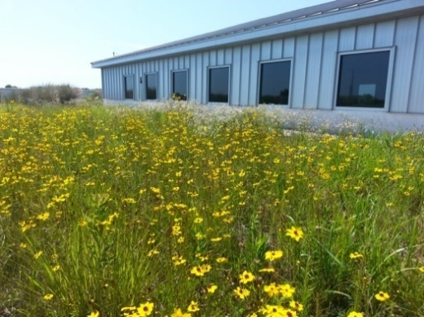  Figure 82: The above image depicts a green roof located on the Escambia County Office in Pensacola, Florida. | Vegetated roofs and walls reduce the stormwater volume and annual mass of pollutants discharged. A vegetated roof can have a portion, or the entire area covered with vegetation. Vegetated walls are constructed to house plant material and engineered soil or inorganic growing medium. | - Flexible Building Setbacks (Section 2.2.1.A.)  - BMP Credited as Landscaping (Section 2.2.2.D.)  - Reduced Building Permit Fees (Section 2.2.4.A.)  - Reduced Land Development Fees (Section 2.2.4.B.)  - Variance and/or Waiver Not Required (Section 2.2.5.A.) | A vegetated roof or wall must be used on-site and may be used to meet total stormwater volume required by Division 8, of the Land development Code. This must be demonstrated in the stormwater calculations.  All vegetation must be native an identified within the landscape plans.  Pairs well with: Native Landscape, Fertilizers, and Irrigation (Section 4.2.4.A.) and Stormwater Harvesting (Section 4.3.1.G.) | Development Engineering & Environmental Management

To promote creativity in site design, the applicant may present alternative LID Best Management Practices (i.e. biosorption activated media (BAM), oversized pipes, flow control devices, up-flow filter systems, perforated pipes, floating wetland mats, etc.) and gain appropriate incentives, as approved by the Development Review Committee.

