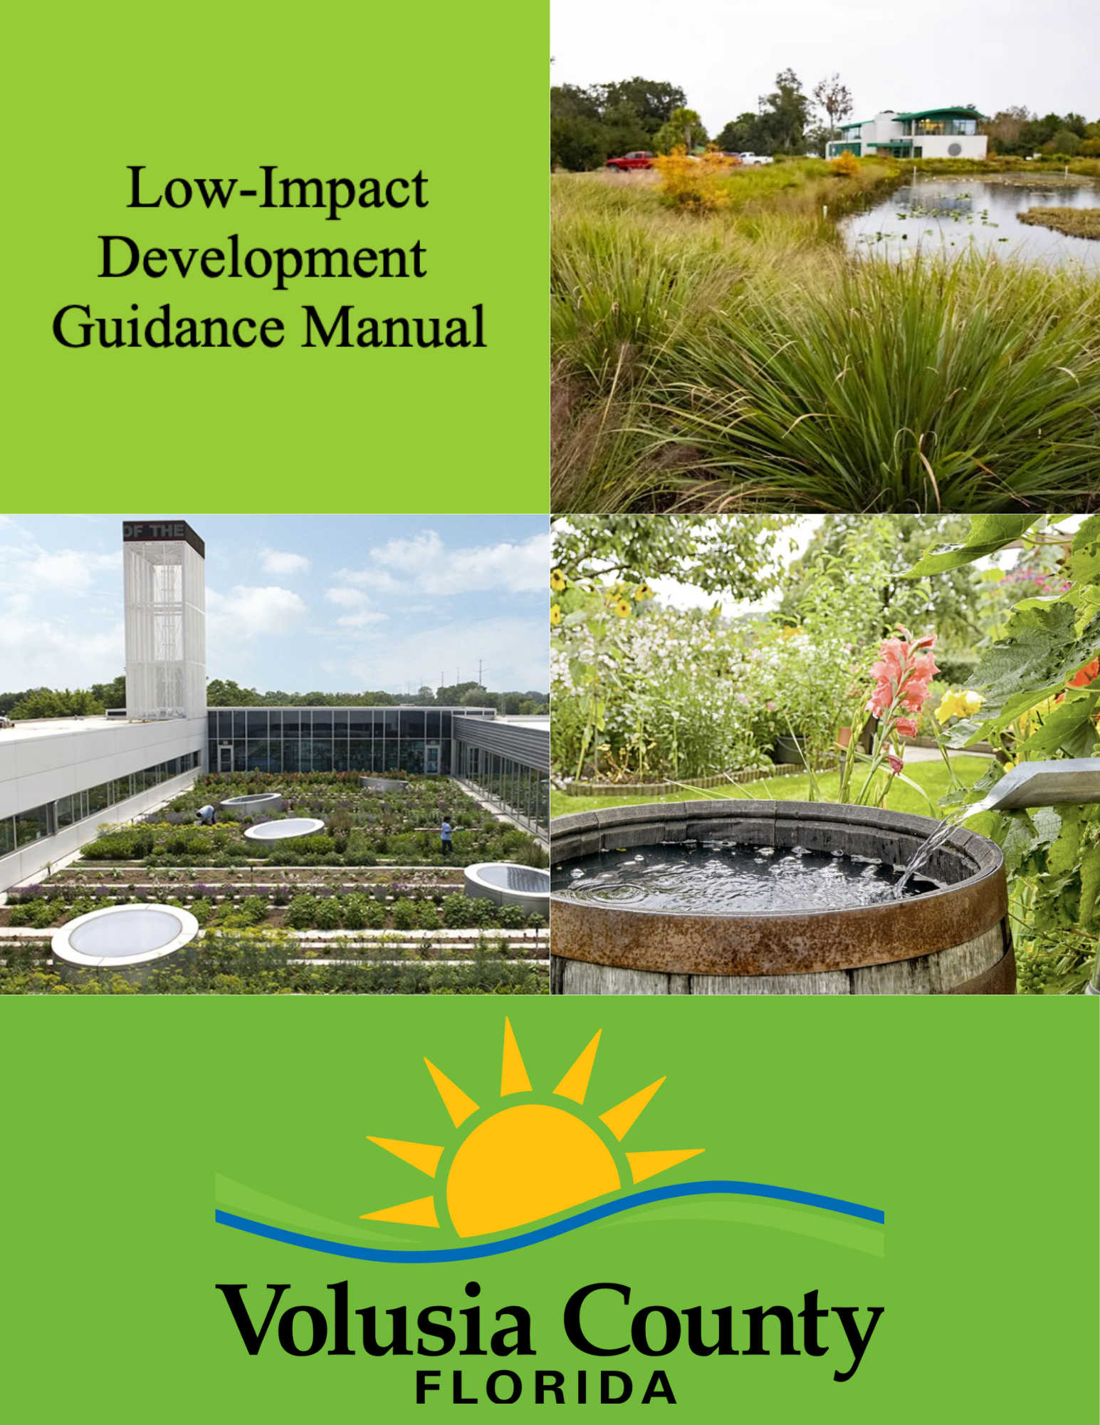October 2024

Table of Contents

Table of Contents 2
Chapter 1: Introduction 5
1.1 Purpose of Manual 5
1.2 Background 5
1.3 Implementing Low-Impact Development 6
1.3.1 Building Design 6
1.3.2 Property Design 6
1.3.3 Street Design 7
1.3.4 Open Space Design 8
1.4 Stormwater Quality Performance Standards 8
Chapter 2: 9
Technical Requirements & Incentives 9
2.1 Standards 9
2.1.1 Overall 9
2.1.2 Pre-Application Meeting 9
2.1.3 Submittal Documents 9
2.1.4 Subdivisions 10
2.1.5 Site Plans 10
2.2 Incentives 10
2.2.1 Lot Development 10
2.2.2 Zoning 11
2.2.3 Environmental 12
2.2.4 Fees 12
2.2.5 Other 12
2.3 BMP Incentive Matrix (Draft in separate attachment) 13
2.4 BMP Table (Draft in separate attachment) 14
Chapter 3: Evaluating Your Site 15
3.1 Evaluating Predevelopment Conditions 15
3.2 Hydrology 16
3.3 Topography 16
3.4 Soils 17
3.5 Vegetation 17
Chapter 4: Catalog of Stormwater Best Management Practices 18
4.1 Introduction to Best Management Practices 18
4.2 Site Design BMPs 19
4.2.1 Retain Natural Landforms 19
4.2.2 Preserve Existing Vegetation 23
4.2.3 Preserve Functional Green Spaces 27
4.2.4 Planted Vegetation 28
4.2.5 Alternative Street and Parking Area Designs 31
4.2.6 Minimizing Runoff Volume and Rate 37
4.3 Stormwater Storage, Treatment and Conveyance BMPs 40
4.3.1 Mechanical 40
4.3.2 Biological 52
Chapter 5: Maintenance of LID Practices 66
5.1 Introduction 66
5.2 Maintenance Responsibilities for LID Techniques in Subdivisions 66
5.3 Maintenance Responsibilities for LID Techniques in Site Plans 66
5.4 Site Design LID Maintenance Requirements 66
5.4.1 Native Landscape, Fertilizers and Irrigation 66
5.4.2 Habitat Management 67
5.4.3 Alternative Surface Material 67
5.5 Stormwater Storage, Treatment, and Conveyance LID Maintenance Requirements 68
5.5.1 Wet Pond 68
5.5.2 Dry Pond 68
5.5.3 Underground Retention and Detention Systems 68
5.5.4 Infiltration Trench 69
5.5.5 Exfiltration Trench 69
5.5.6 Stormwater Harvesting 70
5.5.7 Vegetated Swale 70
5.5.8 Rain Gardens 71
5.5.9 Tree Box Filters 71
5.5.10 Vegetated Roofs and Walls 72
Resources 73

Chapter 1: Introduction

1.1 Purpose of Manual
Welcome to the Low-Impact Development (LID) Guidance Manual, tailored to support land development projects in Volusia County, Florida. This resource offers detailed technical guidance and design specifications for effective stormwater management, focusing on LID techniques and serves as a tool for developers, engineers, and stakeholders involved in shaping the county's landscapes. By providing you information on LID stormwater management practices, we aim to guide you in implementing environmentally friendly solutions that align with Volusia County's objectives.
While LID practices are not mandatory, Volusia County recognizes their significant contribution to achieving water resource objectives, environmental sustainability, and resilience goals. In support of this, Volusia County has implemented an incentivized menu approach, affording flexibility and choice to those engaged in development projects. This menu approach empowers stakeholders to select LID practices that align with their specific needs and project requirements, fostering a collaborative effort towards responsible stormwater management. Volusia County's commitment to encouraging LID practices reflects a proactive stance in balancing urban development with environmental conservation, promoting a community-wide commitment to sustainable water resource management.

1.2 Background
Low-Impact Development (LID) is an ecologically driven stormwater management approach, prioritizing soft engineering strategies to mitigate rainfall on-site through a network of vegetated treatments. By leveraging the innate abilities of vegetation, LID seeks to emulate and sustain the natural hydrological functions of a site prior to development. The essence of LID lies in its capacity to infiltrate, filter, store, and evaporate stormwater in a decentralized manner. Diverging from the conventional "pipe-and-pond" approach, which funnels runoff away through pipes, catchment basins, and curbs and gutters, LID mitigates stormwater close to the source. It strategically addresses the challenges of polluted runoff by utilizing a distributed treatment landscape, weaving together nature-based solutions that harmonize with the environment. This background section explores the core principles and practices of LID, unraveling the potential it holds for sustainable and resilient stormwater management in diverse landscapes, such as those found in Volusia County, Florida.
A site-specific suite of LID best management practices can be applied to many development scenarios in Volusia County. Regardless of the project context, LID requires consideration of the following core site planning and design objectives:
- Preserve or conserve existing site features and assets that facilitate natural hydrologic function.
- Minimize generation of runoff from impervious surfaces and contamination as close to the source as possible.
- Promote the distribution of retention, detention, treatment, and infiltration of runoff.
- Harvest stormwater and rainwater on site.
- Minimize site disturbance and compaction of soils through low impact clearing, grading, and construction measures.
The toolbox of LID best management practices is most effective when applied in a treatment train, or series of complementary stormwater management practices and techniques.

1.3 Implementing Low-Impact Development
The principles of Low-Impact Development (LID) transcend project size and land-use types, offering scalability and adaptability to diverse development scenarios. By breaking down development into four key components — building, property, street, and open space — stakeholders gain a clear framework for action within each realm. This approach highlights the multifaceted nature of LID, providing stakeholders with actionable opportunities to integrate sustainable practices at various scales.
Embracing LID means engaging in practices that not only minimize adverse effects on the environment but actively contribute to the restoration and enhancement of ecosystem functioning. In essence, LID is a dynamic and forward-thinking approach that empowers stakeholders to play a role in shaping development patterns for the betterment of current and future generations.

1.3.1 Building Design
Low-impact buildings consider innovative approaches for the roof, walls, and ground. Implementing LID techniques in these key areas can significantly contribute to sustainable stormwater management and overall environmental resilience.
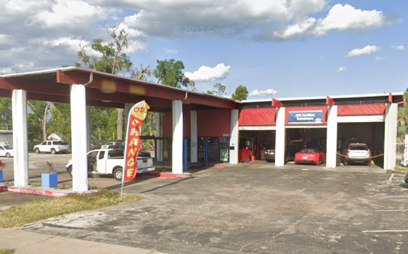Figure 1 - Conventional: drain, direct, discharge | 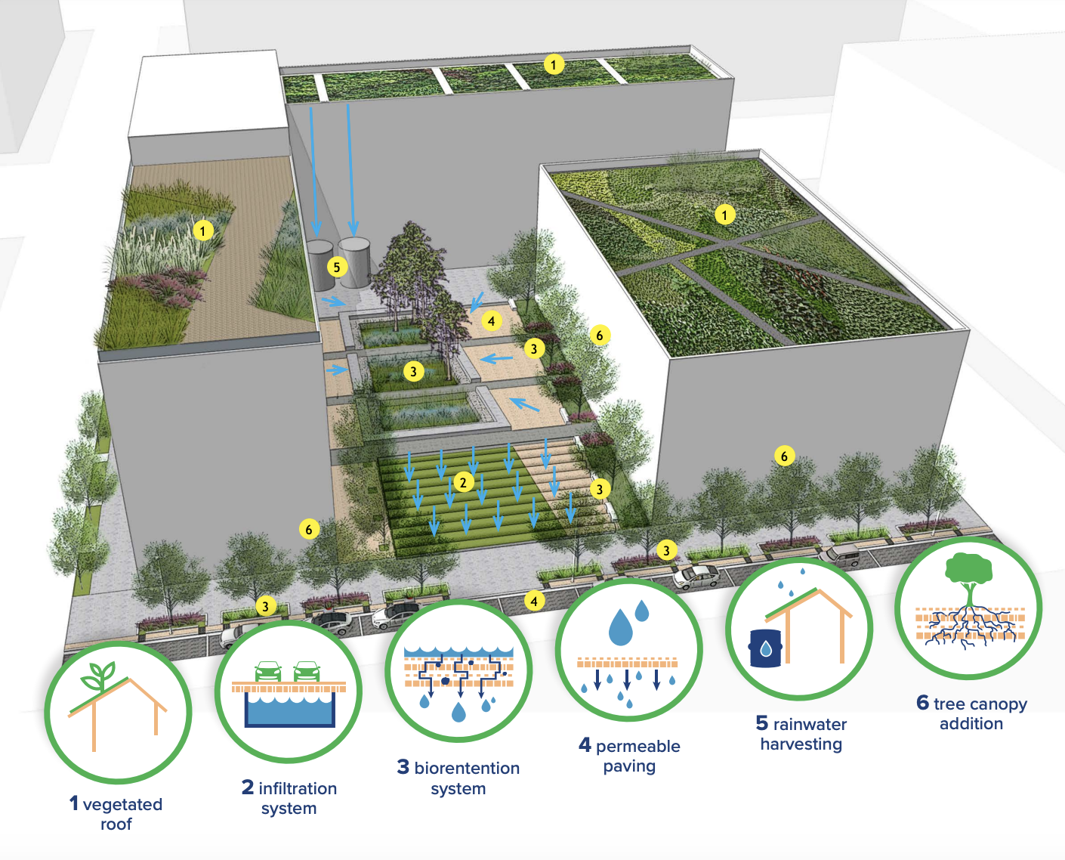  Figure 2 - Low-Impact: slow, spread, soak

1.3.2 Property Design
Unlike conventional property designs, low-impact property design involves a thoughtful approach to introduce productive landscapes, increase biodiversity, enhance on-site infiltration, and minimize impervious surfaces.
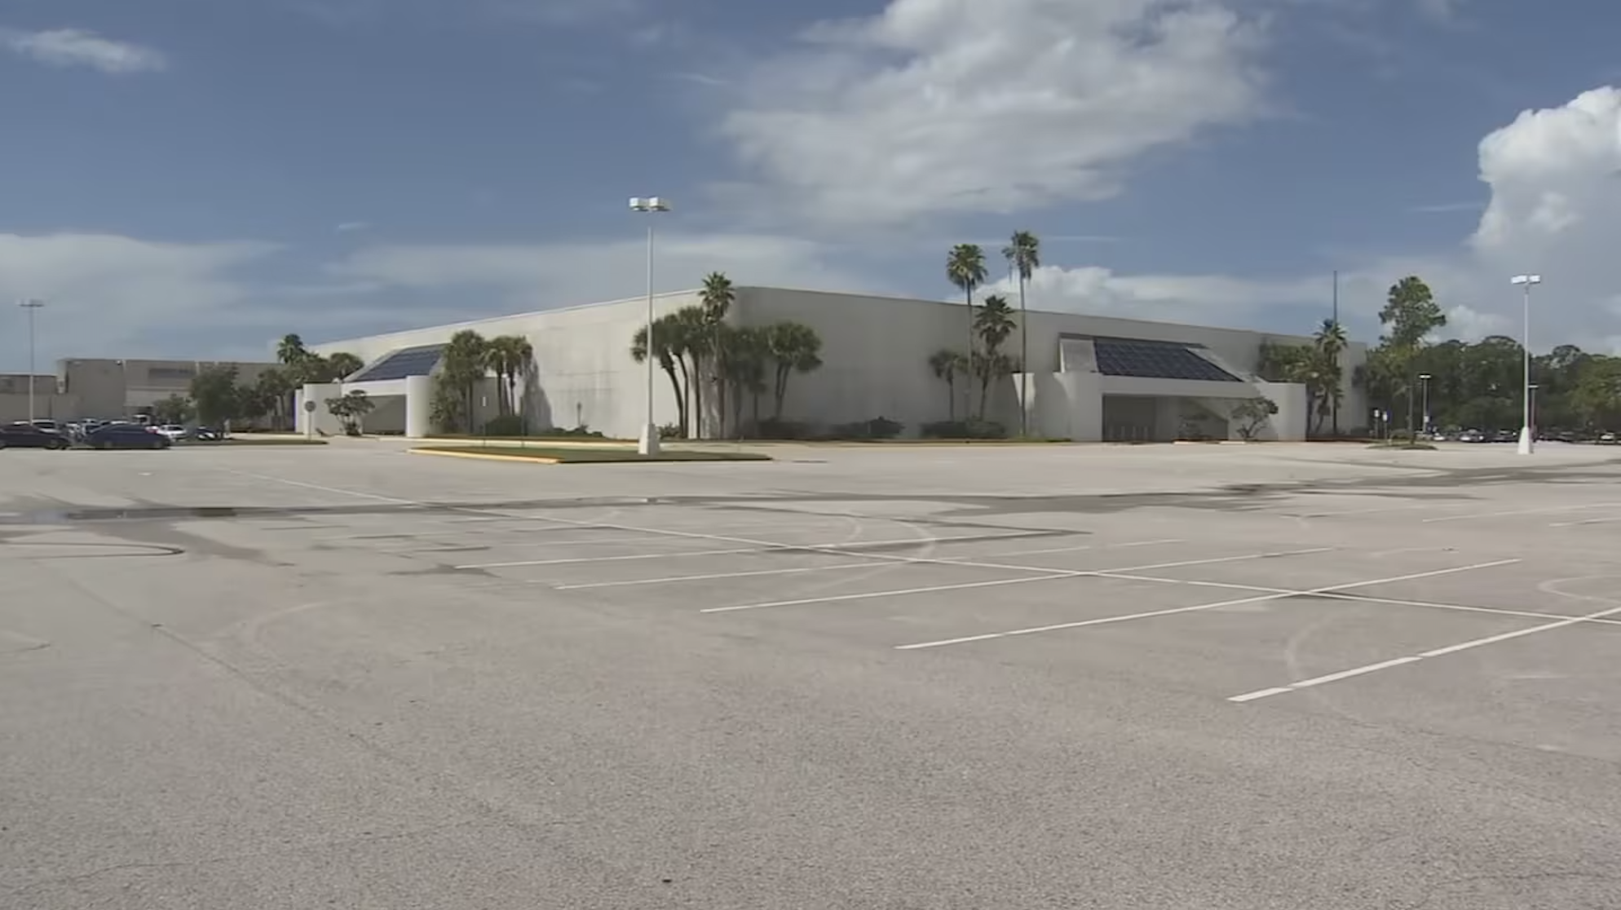Figure 3 - Conventional Parking: drain, direct, discharge | 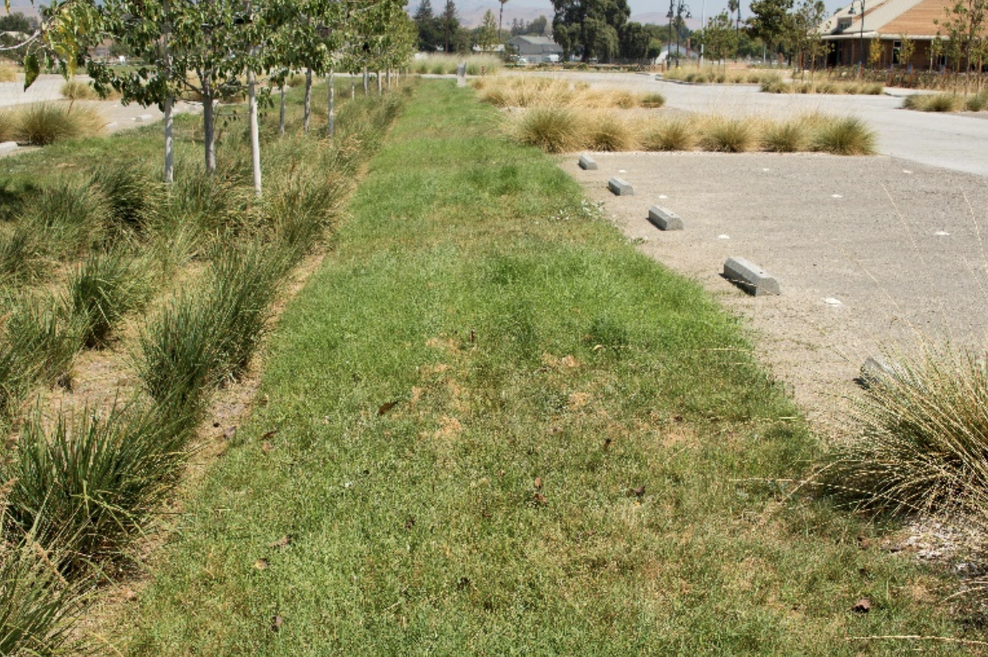  Figure 4 - Low-Impact Parking: slow, spread, soak
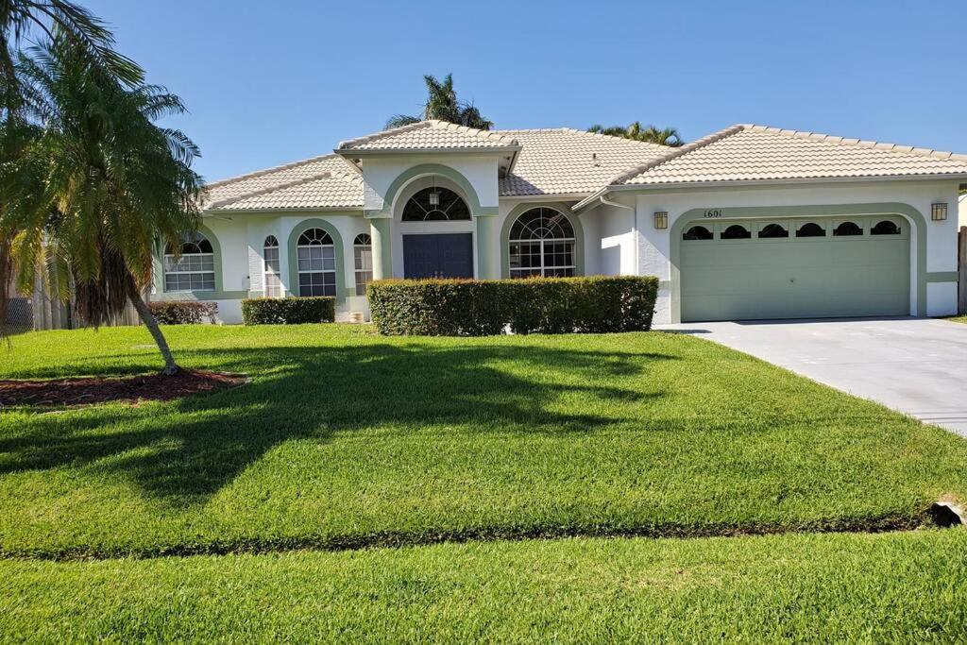Figure 5 - Conventional Lawn: drain, direct, discharge | 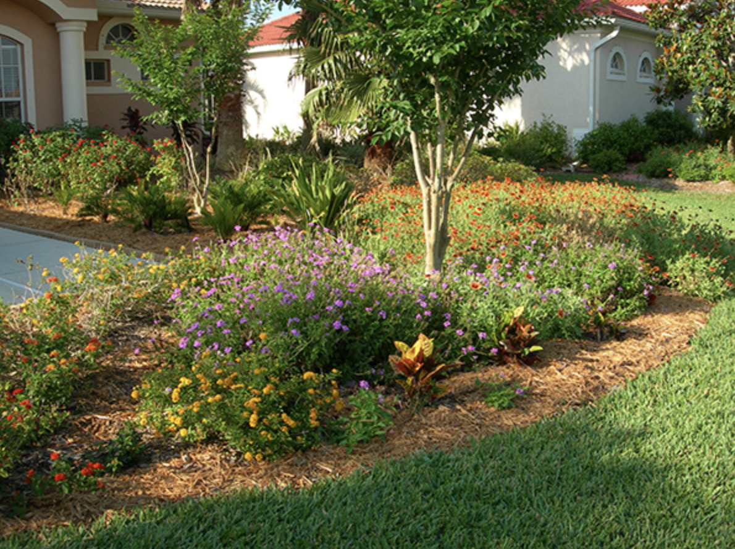  Figure 6 - Low-Impact Lawn: slow, spread, soak

1.3.3 Street Design
LID techniques within the street, employ curb alternatives, and integrate Florida native landscapes, while maintaining safety and accessibility.
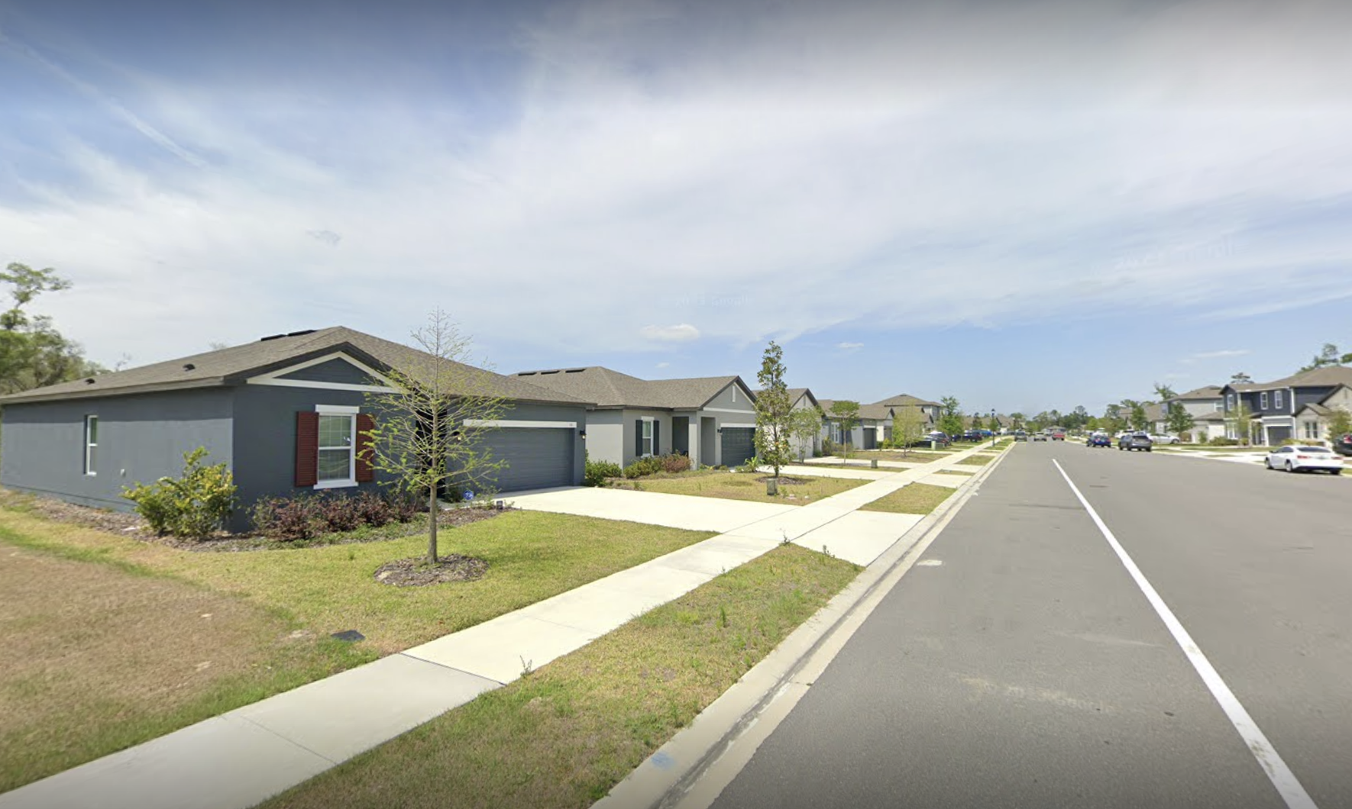Figure 7 - Conventional: drain, direct, discharge | 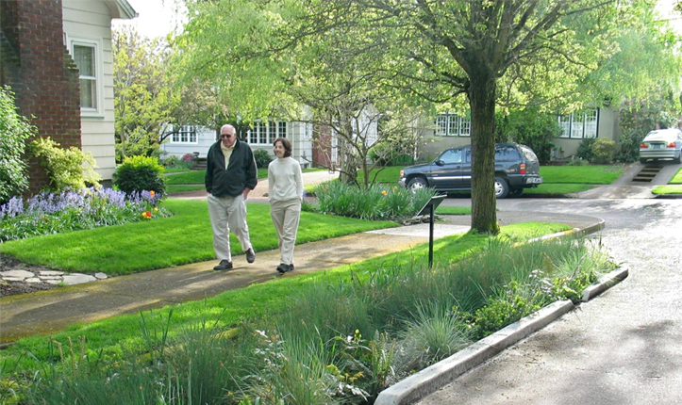  Figure 8 - Low-Impact: slow, spread, soak

1.3.4 Open Space Design
When contemplating the integration of LID principles into open space design, it's crucial to explore strategies that prioritize conservation, transform parks, and enhance corridors.
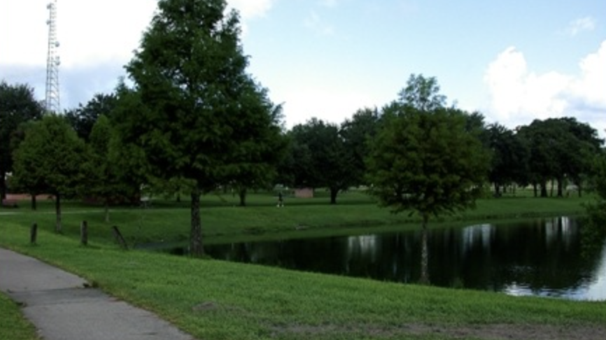Figure 9 - Conventional: drain, direct, discharge | 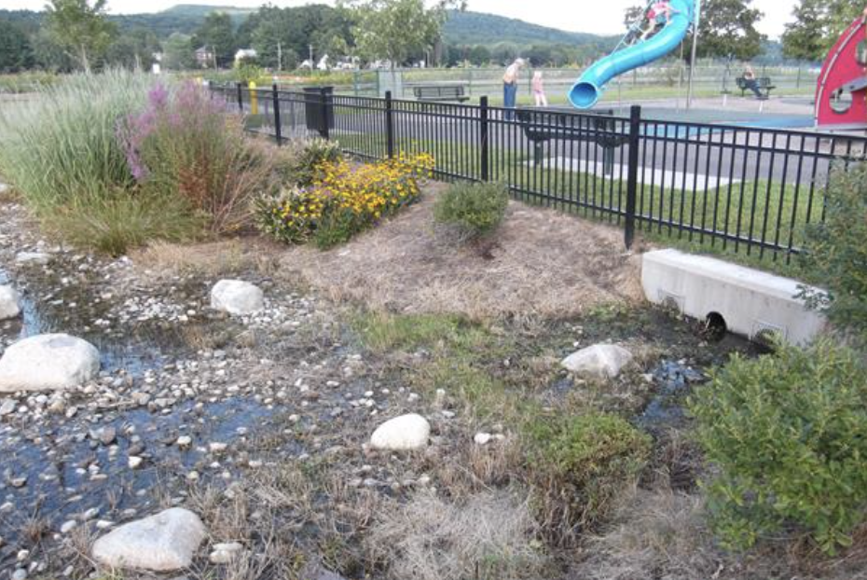  Figure 10 - Low-Impact: slow, spread, soak

1.4 Stormwater Quality Performance Standards
Volusia County recognizes the critical importance of maintaining high standards for stormwater quality. To ensure the protection of our water resources and the preservation of ecological integrity, the County requires that all development activity comply with the water quality standards set forth by the Florida Department of Environmental Protection (FDEP) and the St. Johns River Water Management District (SJRWMD).

Chapter 2:

Technical Requirements & Incentives

2.1 Standards
The following standards for development are required in conjunction with Division 19 Low Impact Development, Chapter 72 Code of Ordinances, as amended.

2.1.1 Overall
All LID best management practices and incentives are permitted by right and do not require any additional waivers by enforcement officials, the Development Review Committee, or variances from the Planning and Land Development Regulation Commission.
Specific requirements for each incentive are located in Section 2.2. A developer must choose a minimum of four (4) Site Design BMPs and two (2) Stormwater Storage, treatment, and Conveyance BMPs to gain incentives. Once the six (6) BMPs are chosen, the developer can use all applicable incentives as identified within the BMP Incentive Matrix and BMP Table.

2.1.2 Pre-Application Meeting
A pre-application meeting, coordinated by the Land Development Activity, is recommended to discuss the proposed project, best management practices, and incentives.

2.1.3 Submittal Documents
The following submittal documents are required for applications using LID techniques, as referenced below. The BMP Table may list additional requirements if a specific BMP is chosen by the developer.
- A cover letter, detailing all best management practices and incentives implemented in the design, is required with submission of all applications utilizing LID techniques.
- An Environmental Impact Assessment (EIA) is required with submission of an Overall Development Plan and Final Site Plan. This must include the following.
  - Identification and evaluation of predevelopment conditions including hydrology, topography, soils, air quality, critical habitat, threatened and endangered species, historic/specimen trees, and invasive species.
  - Identification of minimum federal, state, and local minimum requirements for protection and permitting.
  - Evaluation of how the application of chosen LID best management practices for the proposed development assists with impacts to the predevelopment conditions. See Chapter 3: Evaluating Your Site and Planning for LID for helpful information.
  - Evaluation of whether the proposed development will negatively impact the environment.

2.1.4 Subdivisions
- A Final Plat shall designate the homeowners’ association or property owners’ association as the managing entity of all LID improvements, which shall be responsible for raising all monies required for operations, maintenance, or physical improvements to these areas. This language shall be incorporated into the covenants and restrictions enforced by the homeowners’ association.

2.1.5 Site Plans
- A statement on the final site plan, affirming a perpetual commitment to LID practices and compliance with maintenance obligations, is required.
- Inspection of compliance with these requirements will be overseen by the Land Development Manager, centralizing enforcement efforts and ensuring consistent adherence to specified maintenance obligations for LID practices.

2.2 Incentives
The following incentives are designed to appeal to a variety of stakeholders, encouraging widespread adoption of sustainable stormwater management techniques. The developer must choose a minimum of four (4) Site Design BMPs and two (2) Stormwater Storage, Treatment, and Conveyance BMPs. Once the minimum six (6) are chosen, the developer receives all incentives associated with implementing each chosen BMP, as permitted within the regulations below. Please be advised, these incentives do not override any regulations within the Florida Fire Prevention Code, other state and federal regulations, or those stated within Section 72-1167(a), of the Land Development Code.

2.2.1 Lot Development
A. Flexible Lot Sizes
The developer may create the preferred minimum lot size for the subdivision development. A lot development plan must be provided with the Overall Development Plan and Preliminary Plat applications.
B. Flexible Building Setbacks
The developer may identify the preferred minimum building setbacks for any primary or secondary structure within an interior lot in the development. However, on a project’s perimeter lots, boundaries, or tracts, primary or secondary structures must comply with the minimum principal or accessory use yard requirements of the property’s zoning classification.
The minimum building setbacks must be identified on a lot development plan with the Overall Development Plan and Preliminary Plat applications, and within the notes on a Conceptual Site Plan and Final Site Plan application.
C. Increased Density
The developer may increase the density in urban residential zoning classifications within Urban Low Intensity to 8 dwelling units per acre and increase to 16 dwelling units per acre within Urban Medium Intensity.
Increased density is not permitted within rural land use classifications. In addition, conservation subdivisions cannot gain additional density bonuses for implementing LID BMPs beyond those permitted by Section 72-547, of the Land Development Code.
D. Increased Floor Area Ratio
The developer may increase the floor area ratio by 10% of the maximum within Urban Low Intensity, Urban Medium Intensity, Urban High Intensity, Commercial, and Industrial land use classifications.

2.2.2 Zoning
A. Increased Maximum Height
The maximum height permitted within Section 72-241, of the Zoning Ordinance, may be increased by 30 feet within multifamily, commercial and industrial zoning classifications.
Height incentives are not permitted in the following areas:
- Between the Atlantic Ocean and the westerly boundary of any lots or parcels that abut the easterly right-of-way line of the easternmost north-south public maintained roadway.
- The area 50 feet west of the westerly right-of-way line of the easternmost north-south public maintained roadway.
B. BMP Permitted within Landscape Buffers and Setbacks
The engineer does not have to abide by the prohibitions related to stormwater within Section 72-284, of the Zoning Ordinance.
C. BMP Permitted within Landscape Islands and Row-Ends
The engineer does not have to abide by the prohibitions related to stormwater within Section 72-284, of the Zoning Ordinance.
D. BMP Credited as Landscaping
The engineer does not have to abide by the specific planting requirements of Section 72-284, of the Zoning Ordinance, but may propose an alternative native planting plan with the stormwater best management practice to the Zoning Enforcement Official.
E. BMP Credited as Common Open Space
The specific Site Design or Stormwater Storage, Treatment and Conveyance best management practice is permitted within and counts toward common open space areas. A maximum 50% of the pond area can be used as common open space.
F. Off-Street Parking Flexibility
The minimum and maximum number of off-street parking spaces, required within Section 72-286, of the Zoning Ordinance, may be increased or decreased by 25%. This does not apply to single-family dwellings.
G. Increased Lot Coverage
The maximum lot coverage consisting of principal and accessory buildings and structures permitted within Section 72-241, of the Zoning Ordinance, may be increased by 5%.

2.2.3 Environmental
A. Reduction in Tree Replacement Requirements
This incentive allows for a five-percent reduction in tree replacement required by Section 72-842(a), of the Land Development Code. Therefore, the tree replacement for this incentive is based on the replacement of 10 percent of the total cross-sectional area of the trunk of the tree removed.

2.2.4 Fees
Fees will be reduced when the initial application is submitted. If the developer chooses to remove LID best management practices from the plan during the review process, the reduced fee amount must be paid prior to issuance of a Development Order or Certificate of Occupancy.
A. Reduced Building Permit Application Fees
Building permit application fees for residential (RES) and commercial (COM) structures may be reduced by 10 percent. This does not include accessory structures or ancillary permit application fees or applications that are using a Private Provider service for plan review as described in Florida Statutes 553.
B. Reduced Land Development Application Fees
The following initial application fees may be reduced by 10 percent:
Subdivision Review Fees
Overall Development Plan Development Order
Preliminary Plat Development Order
Final Plat Development Order
Site Plan Review Fees
Final Site Plan Development Order

2.2.5 Other
A. Variance and/or Waiver Not Required
The BMP and associated incentive are permitted by right, unless otherwise stated within the Comprehensive Plan

2.3 BMP Incentive Matrix (Draft in separate attachment)
The BMP Incentive Matrix aims to provide a snapshot of the BMP categories and incentives, giving a planner or design engineer a quick guide to utilize when designing a site.

2.4 BMP Table (Draft in separate attachment)
The BMP Table provides a brief definition, examples, the associated incentives, requirements to receive incentives, and reviewing entity.

Chapter 3: Evaluating Your Site

3.1 Evaluating Predevelopment Conditions
Assessing predevelopment conditions is a crucial step in determining the most suitable Best Management Practices (BMPs) for your site. Predevelopment conditions refer to the natural state of the site before any construction or development takes place. Understanding these conditions helps in identifying potential environmental impacts and selecting appropriate BMPs to mitigate those impacts. These conditions encompass the existing features of the site, including both assets and constraints. While new development projects may exhibit natural or native landscapes, redevelopment projects often involve altered environments. During this phase, planners or design engineers should thoroughly identify and document site conditions conducive to various LID processes such as rainfall interception, capture, storage, evaporation, transpiration, infiltration, treatment, and harvesting. Equally important is the documentation of any constraints present, which aids in determining mitigation strategies to address degraded conditions effectively.
One way to begin this evaluation is by tracing the path of rainfall as it moves within and through the site, considering the following:
- Natural features such as tree canopies and vegetation intercept and capture rainfall, facilitating evaporation and transpiration back into the atmosphere.
- The topography of the site may either encourage stormwater drainage away from the site or promote on-site capture and infiltration.
- Understanding the hydrologic soil groups present on the site is essential for assessing their infiltration capacity and managing stormwater effectively.
- Consideration should be given to any soil disturbances or compaction, as these factors can significantly impact infiltration rates and increase runoff.
- Evaluating the water table elevation across the site provides insights into groundwater dynamics and potential impacts on stormwater management.
- Identification and protection of critical areas such as wetlands or riparian zones are vital for their role in natural pollutant filtration and water quality preservation.
- Physical structures such as buildings and parking alter natural drainage patterns; parking lots intercept rainfall and convey stormwater to other areas or away from the site.
- Impervious surfaces, both natural and structural, hinder stormwater infiltration and promote runoff.
- Assessing the effectiveness of existing engineered stormwater treatment systems and exploring opportunities for enhancement or retrofitting can improve overall water quality management on-site.
Recommended data sets and analyses to gather for the site and surrounding areas include but are not limited to the following:
- Historical and current land-use maps
- Aerial imagery
- Road and utility surveys
- Topographic and drainage maps
- Floodplain and wetland maps
- Riparian zone/stream buffer maps
- Historical soil information
- Tree and vegetation surveys
- Rainfall data
- Hydrologic analyses
With this information, planners and design engineers can pinpoint crucial site assets and constraints pertinent to LID.

3.2 Hydrology
Evaluating a site’s natural hydrology allows for a comprehensive study of the site's water flow patterns, including the identification of natural drainage pathways, water sources, and areas potentially prone to flooding. Understanding the hydrological characteristics of the site enables planners and design engineers to develop strategies that mimic natural processes, reduce runoff, and protect water quality. The table demonstrates the inverse relationship between impervious surface coverage and key hydrological processes. As impervious surface coverage increases, runoff increases, while infiltration and evapotranspiration decrease. This highlights the importance of managing impervious surfaces to mitigate the adverse effects on the hydrological cycle and overall ecosystem health.
Impervious Surface | Runoff | Infiltration | Evapotranspiration
0% (Natural Ground) | 10% | 50% | 40%
10%-20% | 20% | 45% | 35%
35%-50% | 30% | 35% | 35%
75%-100% | 55% | 15% | 30%

3.3 Topography
The evaluation of a site’s topography aims to provide a thorough analysis of the site's elevation, slope, and overall landform. By inventorying topographical assets, planners and design engineers can identify opportunities for sustainable design interventions, such as strategically locating impervious surfaces, preserving natural drainage channels, and implementing contour-based landscaping. Understanding the topography ensures that LID practices are tailored to the site's unique physical characteristics, optimizing stormwater management, and minimizing environmental impact.
Traditional construction methods typically require the alteration of natural contours and soil conditions. Preserving the natural slope of the landscape is crucial during LID site development. It's essential to design buildings and infrastructure around the existing topography rather than altering the land to accommodate building designs. Constructing buildings in harmony with the slope of the landscape is achieved by considering methods such as stem wall construction or pier and beam/raised floor foundations, as opposed to the traditional slab-on-grade approach. Raised floor construction without exterior fill on sloped sites minimizes the need for fill and reduces disturbances to the lot-level soil. Raised floor construction, with the finished floor elevation exceeding both the existing base flood elevation and projected sea level rise, minimizes the need for fill and reduces disturbances to the existing topography while providing resilience against future sea level rise and flooding.

3.4 Soils
Evaluating a site's soil composition is fundamental to effective LID. The objective is to delineate the extent of each soil type, determine their hydrologic group classifications, and assess their capacity for stormwater infiltration.
The soil profile includes the hydrologic soil group, depth, extent, and infiltration capacity that is present throughout the site. The diverse range of soil profiles will guide where the placement of impervious areas, open, or vegetated space will be located. Soil groups with low hydrologic function, such as clays and disturbed soils, are the ideal placement for infrastructure such as buildings, parking areas, roadways, ponds, and other impervious structures. Site locations with highly permeable soils are ideal areas for the inclusion of LID techniques. To protect the natural soil characteristics of the site, it is essential that construction activities limit soil compaction in areas where there are higher permeable soils.

3.5 Vegetation
Vegetation is a key component in the ecological balance of a site, influencing both stormwater management and overall environmental health. By cataloging plant species, density, and distribution, planners and design engineers can make informed decisions about preserving natural habitats, integrating green infrastructure, and strategically placing vegetated buffers. Understanding the vegetation assets of a site facilitates the incorporation of practices like green roofs, rain gardens, and permeable surfaces, enhancing biodiversity and contributing to the aesthetic and ecological value of the developed area.
The protection of trees and native vegetation plays an important role in promoting carbon dioxide adsorption, oxygen production, dust filtration, soil stabilization and enrichment, erosion prevention, surface drainage improvement and aquifer recharge, water pollution reduction, wildlife habitat, energy conservation, scenic beauty, and well-being of the community. Traditional site development typically includes clearing onsite vegetation and introducing new vegetation. This not only disturbs native soils but requires greater amounts of water and nutrients compared to the vegetation that was present pre-development. Preserving pre-development vegetation on the site and planting native vegetation is a sustainable practice that decreases the efforts and costs of maintenance.

Chapter 4: Catalog of Stormwater Best Management Practices

4.1 Introduction to Best Management Practices
This section of the guidance manual showcases the practices designed for the effective design, construction, operation, maintenance, and management of stormwater treatment systems that incorporate Low-Impact Development (LID) techniques or Best Management Practices (BMPs). These practices can be employed individually or orchestrated in a strategic sequence known as the BMP Treatment Train. The BMP Treatment Train operates as a dynamic and integrated framework, combining the strengths of various BMPs to achieve a synergistic effect in the removal of pollutants from stormwater runoff. Effective stormwater management practices aim to reduce pollutant loads by intercepting, capturing, treating, and infiltrating stormwater runoff before it reaches receiving waters. Pollutant load reduction refers to the amount of sediment, nutrients, and other contaminants that are carried by stormwater runoff into local water bodies. The BMPs are categorized into two key categories: Site Design BMPs and Stormwater Storage, Treatment, and Conveyance BMPs.
The toolbox of LID best management practices is most effective when applied in a treatment train, or series of complementary stormwater management practices and techniques.
Pursuant to the Environmental Resource Permit Applicant’s Handbook Volume I Appendix O (effective 6/28/2024), the calculated overall efficiency of a treatment train must account for the reduced loading or concentrations that are available for removal by the subsequent downstream treatment device. This relationship is shown the in equation below.
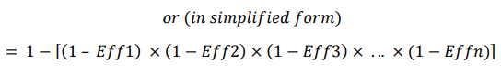
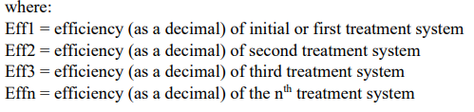
“The Agencies [The Florida Department of Environmental Protection and Florida’s five water management districts] encourage the use of Low Impact Design (LID) approaches, such as Green Stormwater Infrastructure (GSI), which can be used to supplement or replace traditional stormwater infrastructure for managing the impacts of rain and stormwater runoff. GSI and LID reduce pollution and treat stormwater by detaining or retaining rainfall near its source and providing treatment processes for stormwater use, instead of conveying stormwater to a downstream conventional treatment and discharge system. When applied early in the design process, low impact design techniques can reduce stormwater runoff volume and pollutants generated from project areas. Thus, the use of GSI and LID, depending on the technology, can also treat stormwater in a manner similar to a traditional stormwater treatment BMP by treating total nitrogen and total phosphorus.” (Environmental Resource Permit Applicant’s Handbook Volume I, 2024 June 28).

4.2 Site Design BMPs
Site Design BMPs focus on strategies that preserve the existing natural features and minimize the disruption to the natural hydrology of a site. The primary goal is to design and plan developments in a way that reduces impervious surfaces, protects, and enhances essential ecosystems, and maintains the site's natural drainage patterns.
Traditional stormwater management approaches aim to target runoff away from development sites into man-made drainage systems. LID uses the natural, pre-development features of a site to maximize on-site filtration, storage, and treatment of runoff while reducing the disruptive effects of urban runoff patterns. Benefits of implementing site design LID techniques include:
- Maintain natural infiltration of stormwater.
- Reduce the discharge of pollutants into local waterways.
- Reduce flood impacts on county infrastructure.
- Create a more aesthetically pleasing development.
- Lower water management and treatment costs.
- Promote water conservation.

4.2.1 Retain Natural Landforms
As described in section 3.3, retention of natural landforms is a key LID practice, which ensures development of the site is tailored to its unique physical characteristics, optimizing stormwater management, and minimizing environmental impact.
A. Maintain Natural Topography
Understanding the significance of maintaining natural topography is fundamental for effective LID practices. Preserving natural topography, the inherent arrangement of landforms and surface features, enables us to utilize its innate capabilities in regulating water flow, controlling erosion, and reducing the risks related to flooding. Protecting natural hydrology helps minimize erosion by diverting additional flow and safeguards existing channels or flow paths, thereby maintaining water velocity through the site. Preserving natural topography is crucial when designing resilient stormwater management systems that work in harmony with the landscape (Lake George Association, n.d.).
Retaining natural landscape depressions is a fundamental function of LID. This involves preserving and utilizing existing low-lying areas in the landscape to manage stormwater runoff, enhance biodiversity, and promote sustainable land use practices. These depressions can serve as valuable retention or detention areas for stormwater, allowing for natural infiltration, storage, and gradual release of runoff. By retaining natural landscape depressions, developers can minimize the need for costly stormwater management infrastructure while preserving the ecological integrity of the site.
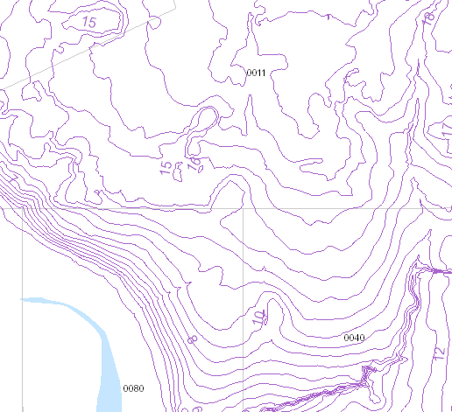
Figure 11: Topographic map
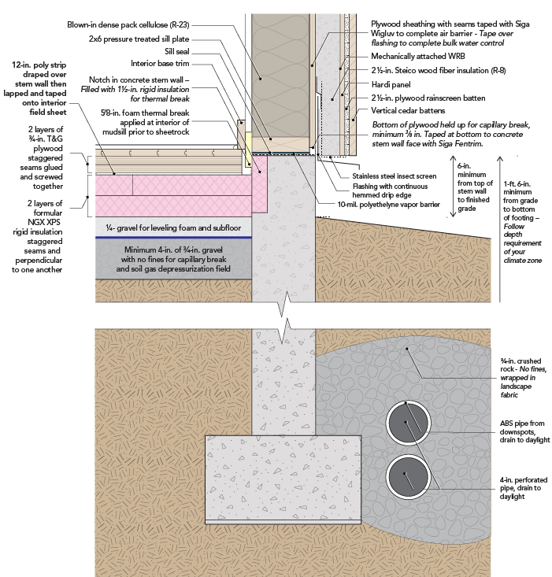
Figure 12

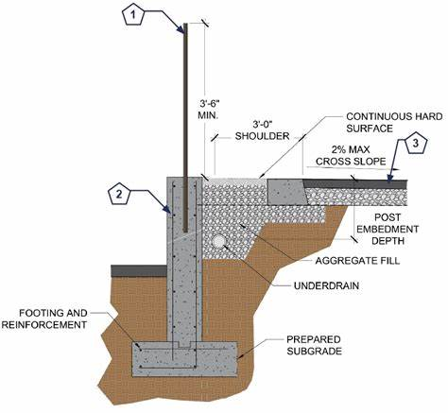
Figure 13

Requirements to gain incentives

Option A: Maintain natural topography for 30% of the site. The area must be contiguous and preserved with a conservation easement dedicated to Volusia County, severing all development rights. The submitted Final Site Plan or Overall Development Plan and Preliminary Plat must identify the square-footage/acreage of these areas.

Option B: The notes on a Final Plat or Final Site Plan must state stem-wall construction is required for all primary structures. If a subdivision, this must also be stated within the Declaration of Covenants, Conditions and Restrictions (DCCRs).

Fill/grading is limited to the footprint of and a 15-foot perimeter around the building to facilitate stormwater conveyance. This must be depicted within the engineered drawings on the Final Site Plan or Preliminary Plat application.

Incentives

Option A: All incentives for Option B, Increased Density, Increased Floor Area Ratio, and Increased Lot Coverage.

Option B: Flexible Lot Sizes, Flexible Building Setbacks, Increased Maximum Height, Off-Street Parking Flexibility, Reduced Building Permit Fees, Reduced Land Development Fees, and Variance and/or Waiver Not Required.

B. Preserving Floodplain
Preserving floodplains is paramount due to their multifaceted contributions to flood loss reduction and ecological stability. Floodplains serve as natural buffers against the destructive forces of flooding by storing excess water, effectively mitigating flood peaks and velocities. This storage capacity, particularly crucial in urban settings vulnerable to even minor storms, significantly minimizes the risk of severe damage. Moreover, the natural topography of floodplains, coupled with their vegetation, facilitates the reduction of flow rates and erosion, safeguarding riparian habitats and riverine ecosystems. Floodplains play a vital role in slowing runoff, allowing for water infiltration and groundwater recharge, which aids in maintaining local water sources and purifying water as it percolates through the soil. During non-flood periods, floodplains regulate flow by facilitating groundwater discharge, thereby mitigating seasonal flood peaks, and reducing the occurrence of extremely low flows. Preserving these invaluable natural features not only safeguards human settlements from flood-related disasters but also sustains the ecological health and resilience of environments (FEMA, 2022).
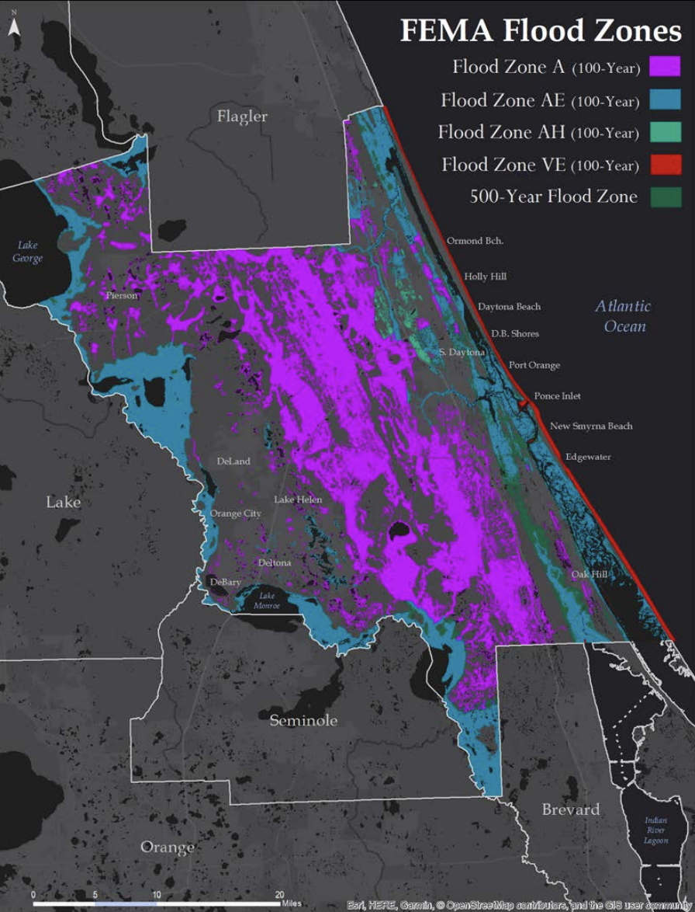
Figure 14: FEMA Flood Zones in Volusia County.
Requirements to gain incentives

100% of the FEMA Flood Hazard Areas identified at the time of application are protected through a conservation easement dedicated to Volusia County, severing all development rights, when they encompass 30% or more of the site. This can include the tree preservation area required by Section 72-837, of the LDC.

Incentives

Flexible Lot Sizes, Flexible Building Setbacks, Increased Density, Increased Floor Area Ratio, Increased Maximum Height, Increased Lot Coverage, Reduction in Tree Replacement Requirements, Reduced Building Permit Fees, Reduced Land Development Fees, and Variance and/or Waiver Not Required.

4.2.2 Preserve Existing Vegetation
Introduced in section 3.5, existing vegetation influences both stormwater management and overall health, acting as a key component in the ecological balance of a site.
A. Retaining Tree Canopy and Native Vegetation
Preserving tree canopy is crucial for effective stormwater management, serving as the first line of defense in controlling runoff. Retaining native and large tree canopies is an essential step in maximizing the interception and evapotranspiration capacity of landscapes, leading to a reduction in stormwater runoff generation. Research suggests that tree canopies have the capacity to intercept approximately 15-20% of the water from a storm event that falls on their leaves. This underscores the importance of prioritizing tree preservation to mitigate the impacts of urbanization on stormwater management and overall environmental health.
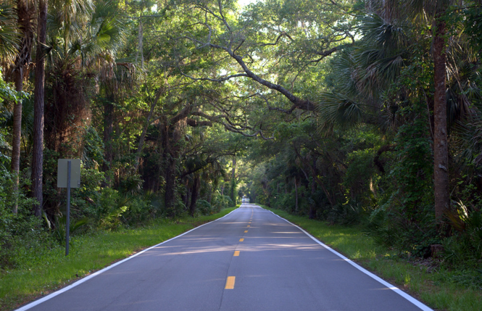
Figure 15: The above image depicts large tree canopies in Ormond Beach, Florida.

Requirements to gain incentives

Retain an additional 5% of the square footage of any development for the preservation of existing trees beyond the minimum requirements of Section 72-837, of the LDC. A conservation easement dedicated to Volusia County, severing all development rights, is required.

Incentives

Reduction in Tree Replacement Requirements, Reduced Building Permit Fees, Reduced Land Development Fees, and Variance and/or Waiver Not Required.

B. Retaining Large Riparian or Vegetated Natural Buffers
Vegetated natural buffers are defined as areas with vegetation suitable for sediment removal along with nutrient uptake and soil stabilization that are set aside between developed areas and a receiving water or wetland for stormwater treatment purposes. These strips or areas of vegetation strategically located along the edges of water bodies, drainage canals, or developed areas (such as landscape buffers) help to mitigate the impacts of stormwater runoff and protect water quality. These buffers typically consist of native trees, shrubs, grasses, and other vegetation that help to slow down, filter, and absorb stormwater before it enters water bodies. The benefits include serving as a wildlife corridor, reducing noise, and reducing the potential for siltation into receiving water.
Vegetated natural buffers can also be used to treat stormwater runoff in rear-lot portions of a residential development that cannot be feasibly routed to the system serving the roads and fronts of the lots.

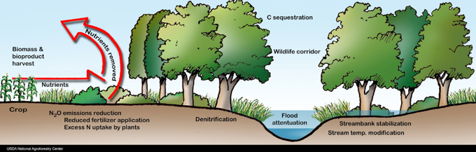
Figure 16: Benefits of vegetated buffers
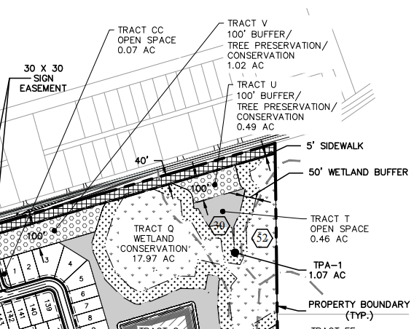
Figure 17: Excerpt of construction plan with large landscape buffers
Requirements to gain incentives

Option A: Retain a 20% greater buffer than the minimum required by Division 11, of the LDC, adjacent to all wetland/surface waters on 100% of the site.

Option B: Retain a 20% greater natural landscape buffer than the minimum required by Section 72-284, or the Zoning Ordinance, along all property boundaries.

Incentives

Flexible Building Setbacks, BMP Permitted within Landscape Buffers and Building Setbacks, BMP Credited as Landscaping, Increased Lot Coverage, Reduced Building Permit Fees, Reduced Land Development Fees, and Variance and/or Waiver Not Required.
C. Cluster Subdivisions
Clustering built infrastructure at the development or subdivision scale represents a highly effective technique for mitigating the overall environmental impacts of a project. This strategy involves consolidating buildings and amenities into compact, cohesive clusters, which brings numerous benefits. This approach minimizes site disturbance, preserving valuable natural areas and wildlife habitat, and reduces the total stormwater runoff from the site by reducing the length of roads, minimizing total impervious area, and decreasing the need for extensive stormwater infrastructure, cluster development promotes more efficient land use. Cluster subdivision regulations are described in Section 72-304, of the Zoning Ordinance.
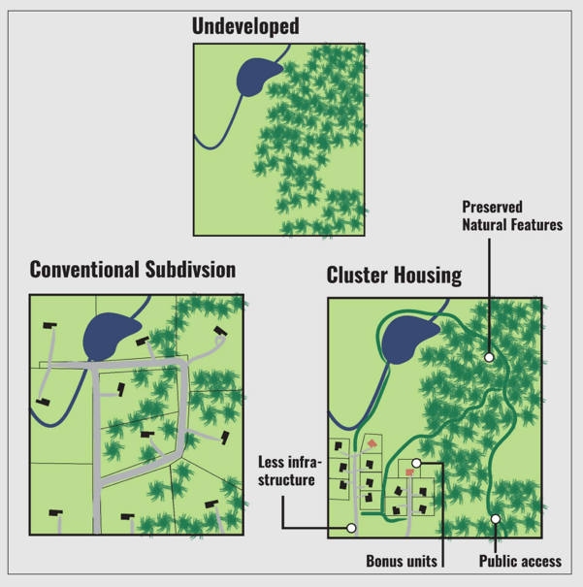
Figure 18
Requirements to gain incentives

Must follow the provisions of Section 72-304, of the Zoning Ordinance.

Incentives

Currently within Section 72-304, of the Zoning Ordinance: Flexible Lot Sizes and Flexible Building Setbacks.
Additional Incentives: Increased Lot Coverage, Reduction in Tree Replacement Requirements, Reduced Building Permit Fees, Reduced Land Development Fees, and Variance and/or Waiver Not Required.

D. Conservation Subdivisions
Conservation Development (CD) is a land use planning strategy that integrates environmental conservation principles into the design and implementation of development projects. This approach seeks to preserve open space, protect natural habitats, and minimize ecological footprints while accommodating growth and development. A CD in Volusia County involves clustering buildings, preserving sensitive areas, and implementing conservation easements or land trusts to safeguard critical ecosystems. CD’s require at least 60% of a site’s buildable land to be permanently protected open space. This contrasts with conventional development where the site is subdivided, regardless of ecological structure. CD regulations are described in Section 72-547, of the Land Development Code, Article III, Chapter 72 Code of Ordinances, and can incorporate LID BMPs into the design.
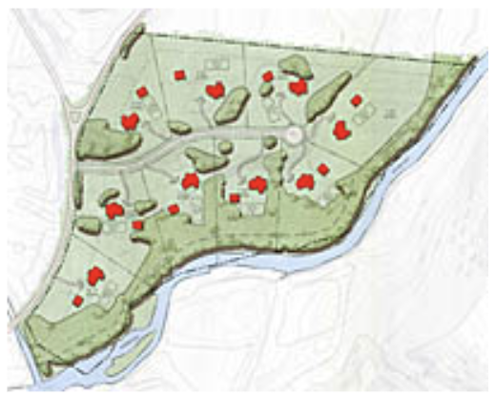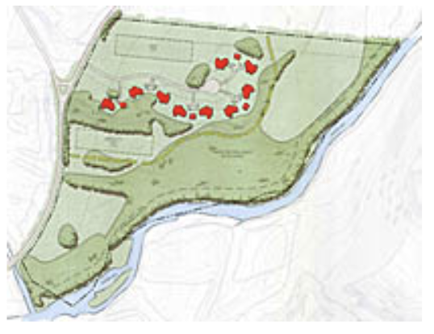
Figure 19: The left image displays a traditional development, and the right image displays a conservation development

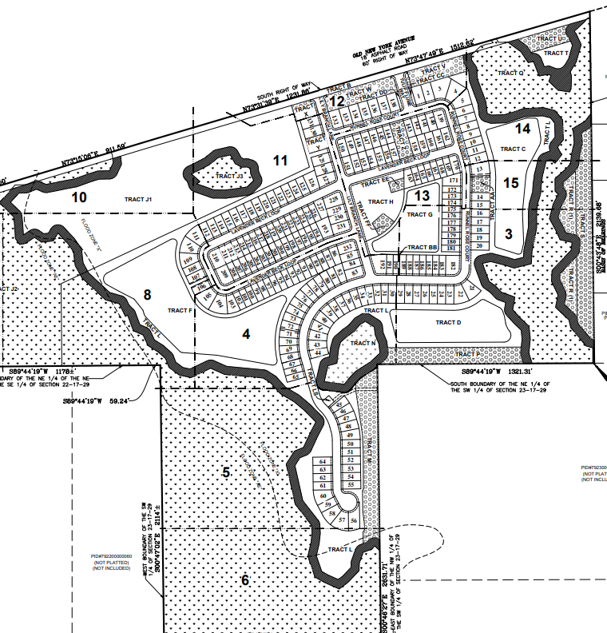
Figure 20: Conservation subdivision construction plan

Requirements to gain incentives

Must follow the provisions of Section 72-547, of the Land Development Code.

Incentives

Currently within Section 72-547, of the Land Development Code: Flexible Lot Sizes, Flexible Building Setbacks, Increased Lot Coverage, and Increased Density.
Additional Incentives: Reduction in Tree Replacement Requirements, Reduced Building Permit Fees, Reduced Land Development Fees, and Variance and/or Waiver Not Required.

4.2.3 Preserve Functional Green Spaces
Functional green spaces include active and passive common open space areas and natural habitats. Preserving these areas and providing corridors within urban and suburban landscapes is important for maintaining ecological balance, fostering community well-being, and ensuring long-term sustainability.
A. Common Open Space
Common open space areas are reserved and designed for the leisure or recreational use of the owners of a residential development and may include recreational facilities. Common open space can be referred to as public space when including recreation facilities, or in nonresidential uses, such features as plazas or courtyards. Within the LID framework, stormwater best management practices are permitted within common open space areas, as provided within the BMP Table and Incentive Matrix.
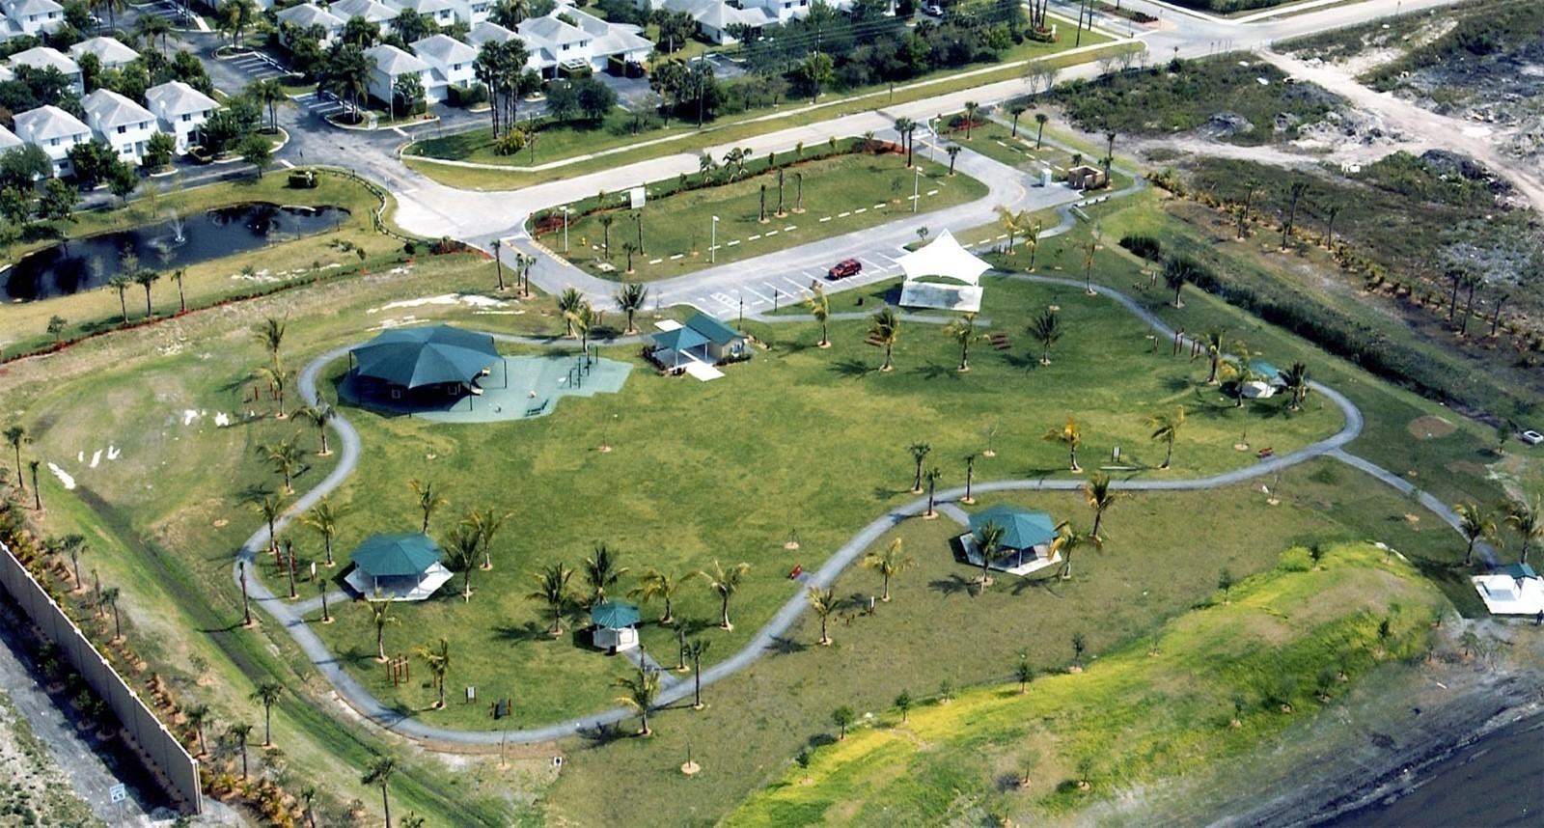
Figure 21: Sunset Point Park located in Tamarac, FL.

Requirements to gain incentives

Option A: Provide an additional 5% common open space beyond the minimum required. This area may be preserved in a natural state, but cannot include the minimum tree preservation area required by Section 72-837, of the LDC.

Option B: Where no minimum common open space is required, provide a minimum 15% common open space. This cannot include the minimum tree preservation area required by Section 72-837, of the LDC.

Incentives

Flexible Lot Sizes, Flexible Building Setbacks, Off-Street Parking Flexibility, Increased Lot Coverage, Reduced Building Permit Fees, Reduced Land Development Fees, and Variance and/or Waiver Not Required.

B. Corridor Protection
Linear corridors of protected open space that connect natural areas, parks, and communities for recreational, ecological, and transportation purposes can preserve and restore nature in urban developments and can revitalize underutilized urban sectors. Corridors offer pathways for walking and cycling, spaces for outdoor activities, and vegetated buffers along waterways or urban areas. They serve to preserve wildlife habitats, promote biodiversity, and mitigate the effects of urban development.
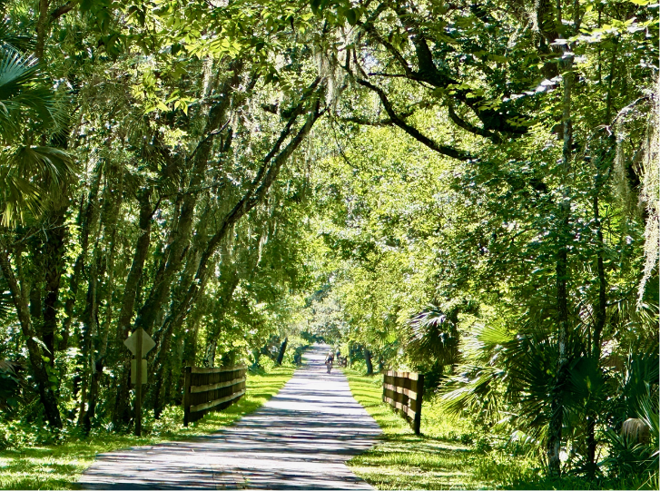
Figure 22: Vegetated multi-use trail in Volusia County, Florida
Requirements to gain incentives

Option A: Preserve natural land which provides a connection to (or is within) the Florida Wildlife Corridor or the Volusia Conservation Corridor and continues through the development project to allow future connection and expansion of the corridor. This area must be at least 30 feet wide and can count toward the required 15% tree preservation area. A conservation easement dedicated to Volusia County, severing all development rights, is required.

Option B: Creation of an internal vegetated multi-use trail of pervious material that connects to a larger pedestrian/bicycle network. The area dedicated to this use must include existing or planted native shade tree species and native understory vegetation. Tree species chosen must have enough space from the trail to ensure survival, as approved by the County Forester.

Incentives

BMP Permitted within Landscape Buffers and Building Setbacks, BMP Permitted within Landscape Islands and Row-Ends, BMP Credited as Common Open Space, Off-Street Parking Flexibility, Increased Lot Coverage, Reduced Building Permit Fees, Reduced Land Development Fees, and Variance and/or Waiver Not Required.

4.2.4 Planted Vegetation
Intentionally planting, preserving, or restoring habitats and vegetation indigenous to the State of Florida will reduce the use of fertilizers and irrigation, giving a development a dramatic leg up on nutrient uptake, water storage and soil stability, compared to developments which utilize non-native or invasive species.

A. Native Landscape, Fertilizers, and Irrigation
Native plants have evolved to thrive in the local climate, soil types, and hydrological conditions. Incorporating a native Florida landscape design is resource-efficient and will minimize the need for supplemental inputs like fertilizers, irrigation, pesticides, or herbicides and is crucial for effective stormwater management and ecological balance. Additionally, native landscapes help to preserve the unique biodiversity of Volusia County and contribute to the overall ecological health of the region by promoting plant diversity and supporting ecosystem functions such as pollination and soil stabilization.
Plant material on any developed site should limit the use of non-native turf grass, such as St. Augustine Grass and Zoysia Grass, and utilize alternatives like Seeding Paspalum or native Florida groundcovers for active recreational areas. Moreover, incorporating native plants such as live oaks, magnolias, hickories, slash pine, and longleaf pine enhances the sustainability and resilience of development projects while preserving local ecosystems and biodiversity. The Volusia County Habitat Planting Guidelines and Zoning Landscape Buffer Plant List provide specific examples of trees, scrubs, and groundcovers to assist with site planting.
Incorporating smart irrigation controllers, such as evapotranspiration controller or soil moisture sensors, are above and beyond a typical rain sensor. A soil moisture sensor helps to provide real-time data on soil moisture levels, enabling precise and targeted irrigation practices. By accurately assessing the moisture content of the soil, irrigation systems can adjust watering schedules based on actual plant needs, reducing water waste, and promoting water conservation. This proactive approach ensures that plants receive adequate hydration while minimizing the risk of overwatering, which can lead to soil erosion, nutrient runoff, and increased water consumption. Additionally, the use of moisture sensors helps optimize resource allocation, improve plant health, and contribute to the overall resilience and efficiency of LID practices in urban and suburban landscapes.
Standard requirements for fertilizer use in Volusia County can be found in Article VIII Florida Friendly Fertilizer Use, Chapter 50 Code of Ordinances. The Volusia County irrigation requirements are found in Section 72-284(6), Division 8 Supplementary Regulations, Article II Zoning, Chapter 72 Code of Ordinances, and Division 10 Water Wise Landscape Irrigation, Article III Minimum Standards for Environmental Protection, Chapter 50 Code of Ordinances.

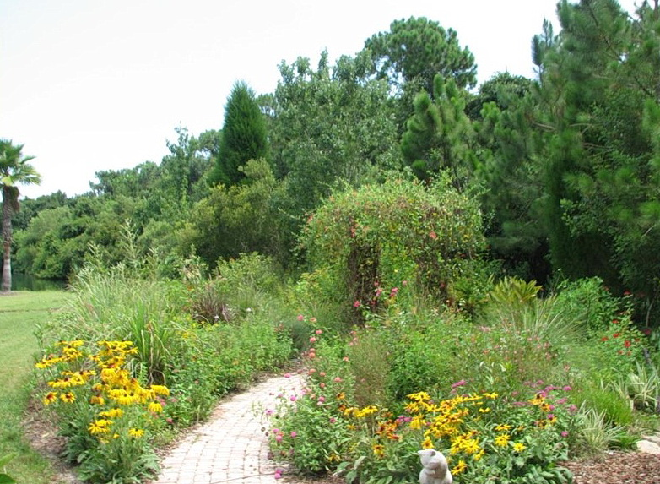  Figure 23 | 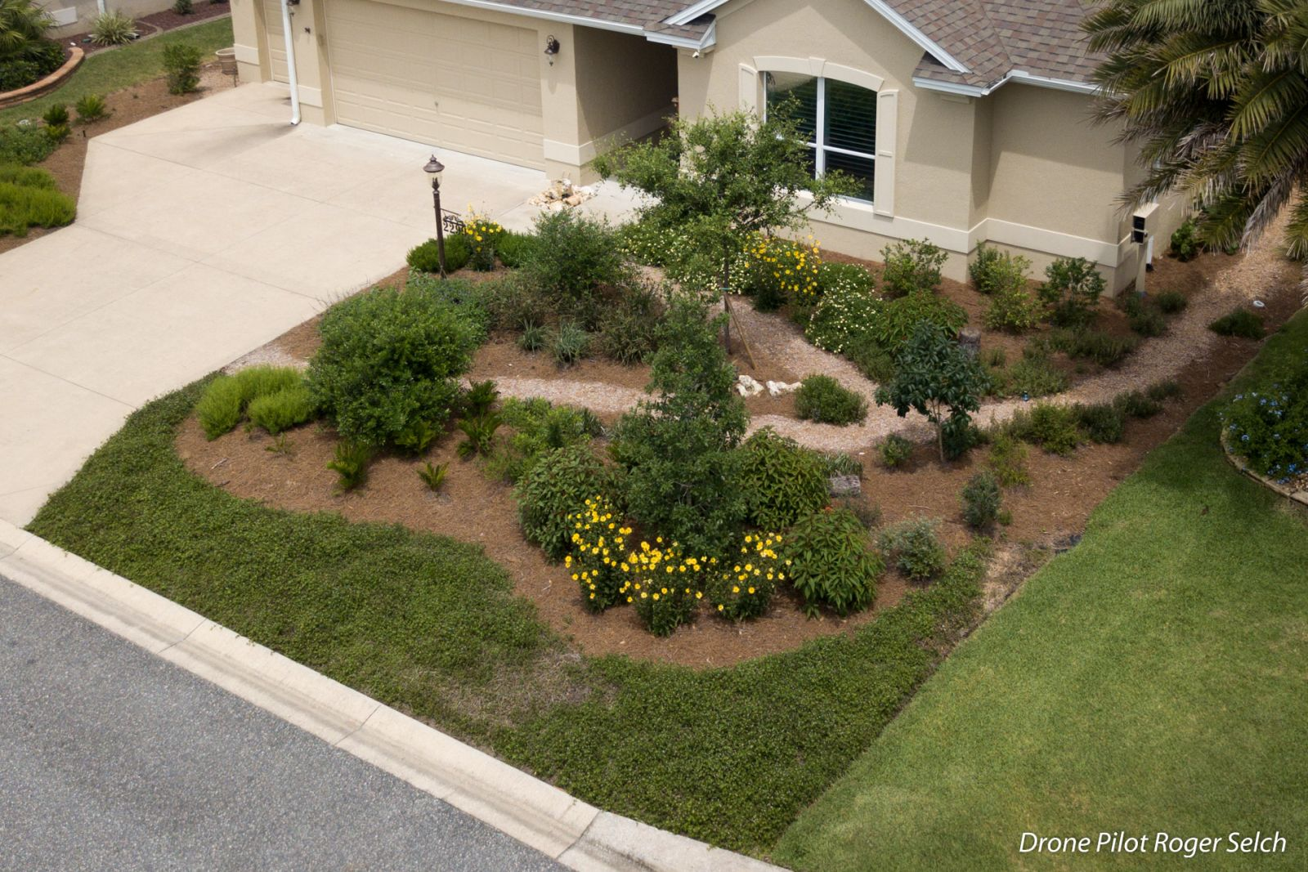  Figure 24

Requirements to gain incentives

Option A: All planted vegetation within a commercial site is 100% Florida native species (including grasses). Smart Irrigation Controllers are required for the irrigation system. Educational signage describing the benefits of native plants and Be Floridian Now fertilizer principles are placed throughout public spaces.
Option B: The subdivision common areas/landscape buffers must have 100% Florida native vegetation (including grasses - non-native turfgrass is not permitted), Smart Irrigation Controllers for the irrigation system, and educational signage describing the benefits of native plants and Be Floridian Now fertilizer principles placed throughout the common areas.
In addition, 20% of the square-footage of each residential lot must be planted with and maintain native vegetation. Irrigation systems for the individual lots must have Smart Irrigation Controllers. The plat notes and Declaration of Covenants, Conditions, and Restrictions must identify the individual lot requirements. A typical planting detail is required to be provided with the Preliminary Plat application.

Incentives

Option A: Off-Street Parking Flexibility, Increased Lot Coverage, Reduced Building Permit Fees, Reduced Land Development Fees, and Variance and/or Waiver Not Required.
Option B: All incentives for Option A and Reduction in Tree Replacement Requirements.
B. Habitat Management
Habitat management plays a crucial role in promoting sustainable land use practices while preserving and enhancing natural ecosystems. This can include rehabilitating degraded or altered habitats to their natural state, such as restoring wetlands, re-establishing native plant communities, removing invasive species, or creating wildlife corridors and wildlife habitats within developed areas. By restoring and managing natural habitats, LID projects can improve biodiversity, enhance ecosystem services, and mitigate the impacts of urbanization on local ecosystems.

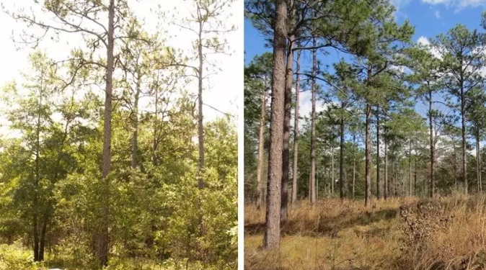
Figure 25: The left image depicts a sandhill community in 2011 before restoration management, and the right side shows the same sandhill community in 2017 after the implementation of restoration management.

Requirements to gain incentives

Preserve 10 acres or more of contiguous undeveloped area, with a conservation easement dedicated to Volusia County, severing all development rights. This can include the tree preservation area required by Section 72-837, of the LDC.

The habitat management plan must be submitted with the Final Site Plan or Preliminary Plat application. The Declaration of Covenants, Conditions and Restrictions must identify the habitat management requirements. Annual reports must be submitted to the Land Development Office.

Incentives

Flexible Building Setbacks, BMP Permitted within Landscape Buffers and Building Setbacks, BMP Credited as Landscaping, Reduced Building Permit Fees, Reduced Land Development Fees, and Variance and/or Waiver Not Required.

4.2.5 Alternative Street and Parking Area Designs
LID street designs aim to minimize impervious surfaces, enhance water quality, and promote groundwater recharge while simultaneously fostering vibrant, livable, and environmentally conscious urban spaces.
To facilitate a multi-pronged stormwater management approach in alternative street and parking area designs, the project engineer can incorporate planted Florida native vegetation (Section 4.2.4.A.) and engineered systems such has permeable pavements (Section 4.2.5.A.) and tree box filters (Section 4.3.2.D.) to slow, filter, and cleanse stormwater runoff from these impervious surfaces. This design approach will also contribute to replenishing groundwater reservoirs, absorbing carbon emissions, enhancing air quality, and enhancing the visual appeal of neighborhoods.
Curb elimination, curb cuts, perforated pre-cast curbs, flush curbs, and vegetated curb extensions are all alternative designs to facilitate the natural flow of stormwater, allowing for improved infiltration into the soil and reducing the volume of runoff reaching storm drains. This approach helps mitigate flooding, improve water quality, and promote groundwater recharge.
Alternative designs may be presented and reviewed by the County Development Engineer. All alternative street designs must be dedicated to and maintained by a homeowners or property owners association.
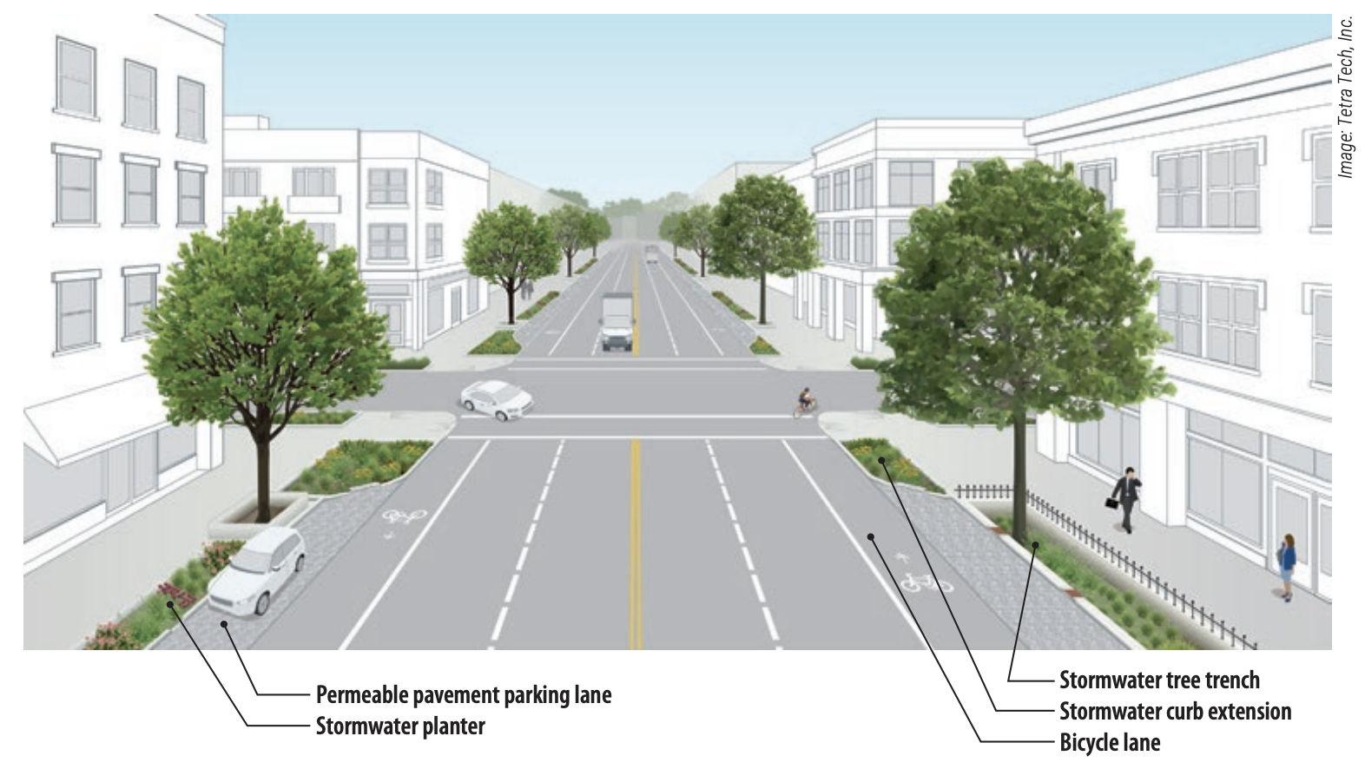
Figure 26: Alternative street design example.

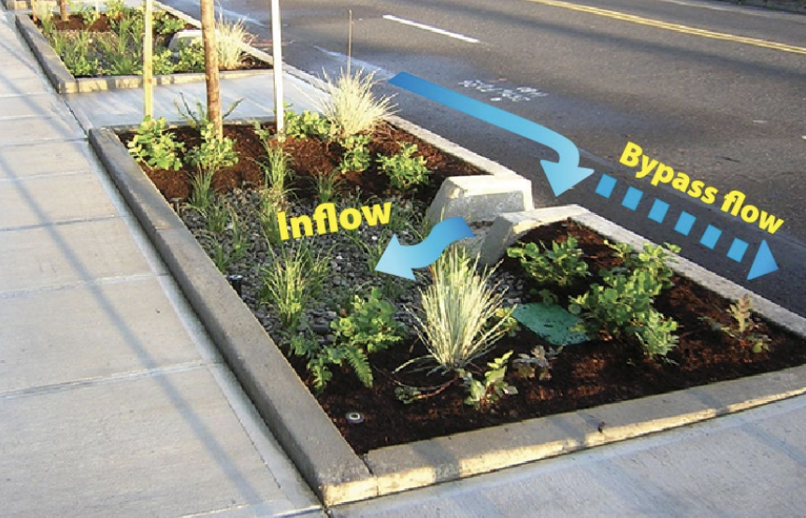Figure 27: Curb cut facilitates the entry of street runoff. If it reaches capacity, excess water will be directed to a bypass the system. | 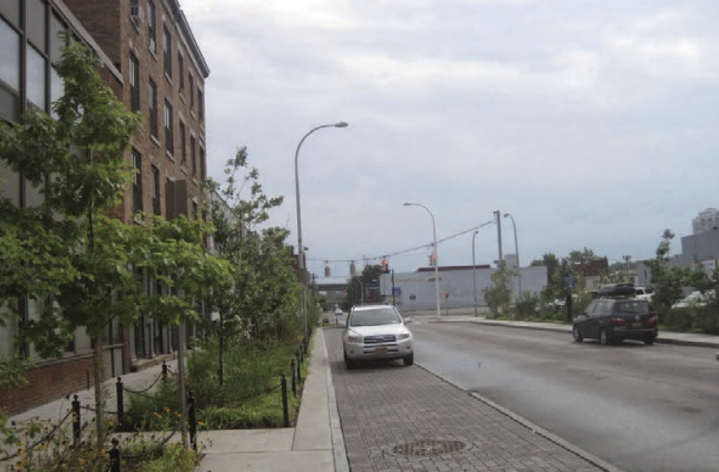Figure 28: A permeable interlocking concrete paver parking lane is adjacent to a sidewalk planter.

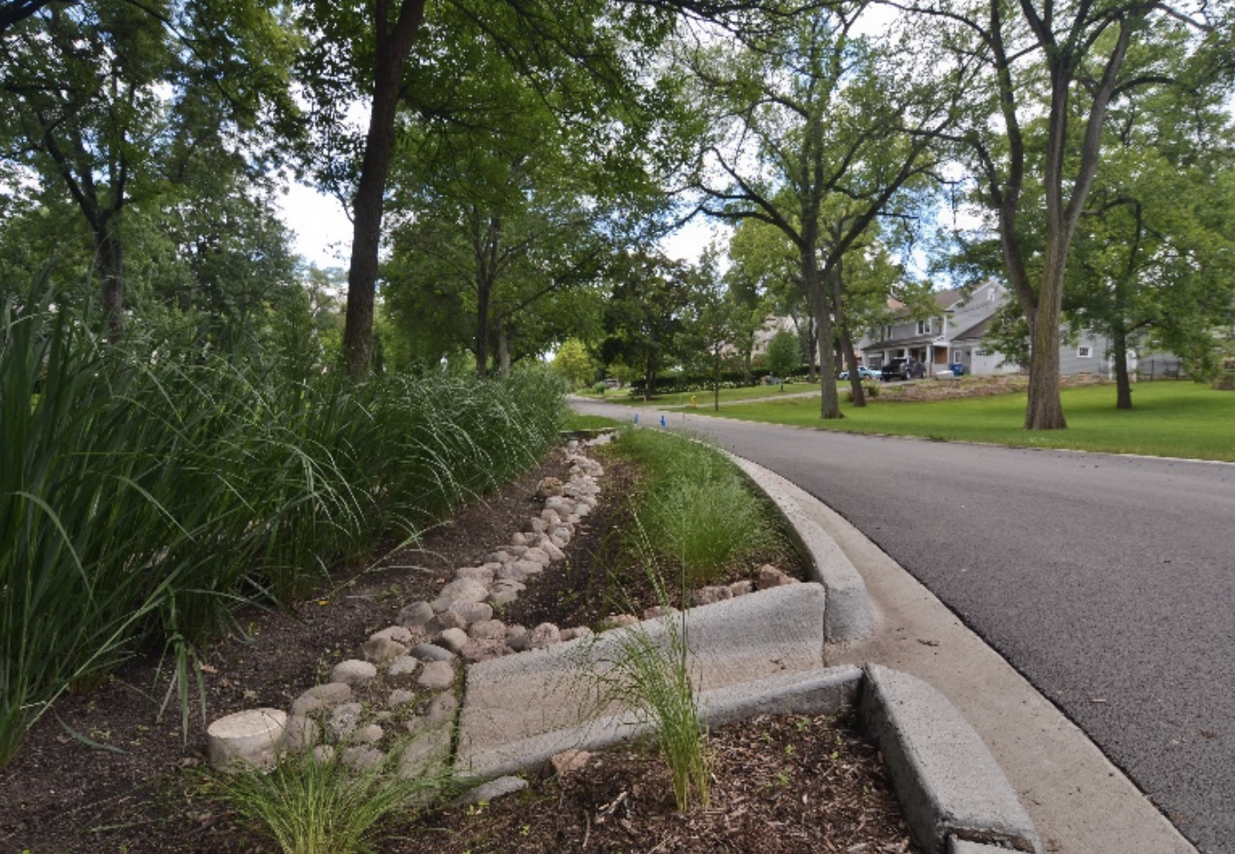  Figure 29: Curb cut | 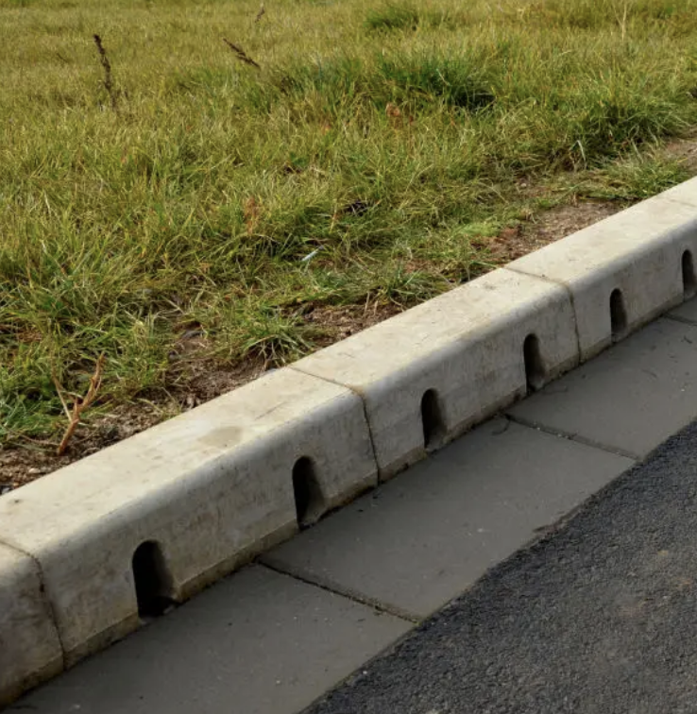  Figure 30: Perforated Pre-Cast Curbs
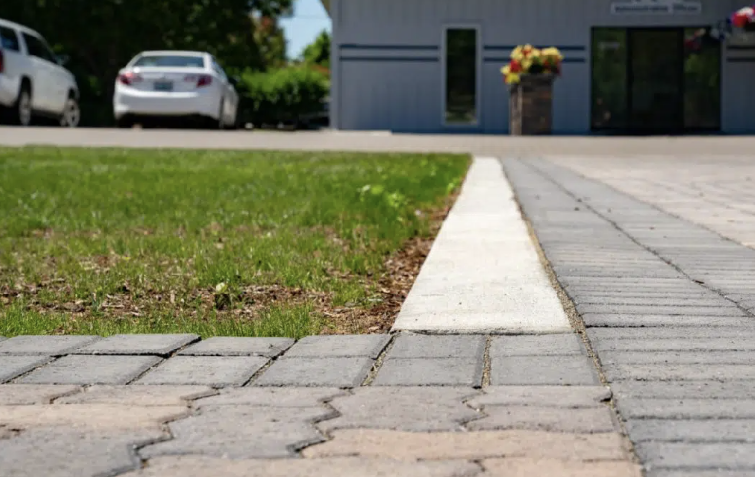
Figure 31: Flush curb
A. Alternative Pervious Surface Material
Pervious pavement systems allow water to percolate and enter the soil below, reducing the volume and peak of stormwater runoff. Permeable surfaces include modular paving systems (concrete pavers, modular grass or gravel grids) or poured-in-place pavement (porous concrete, permeable asphalt). They work best on flat surfaces or with gentle slopes. Pervious pavement systems are retention systems that should be used as part of a BMP treatment train to reduce stormwater volume and pollutant load from parking lots and similar areas. These systems allow water to infiltrate through the pavement surface, rather than running off. The use of this BMP can enhance opportunities for green space creation and environmental sustainability within urban or built environments.

Pursuant to the Environmental Resource Permit Applicant’s Handbook Volume I (Revised 7/9/2024), the nutrient capability of these systems can be calculated in the same way as a dry retention system.

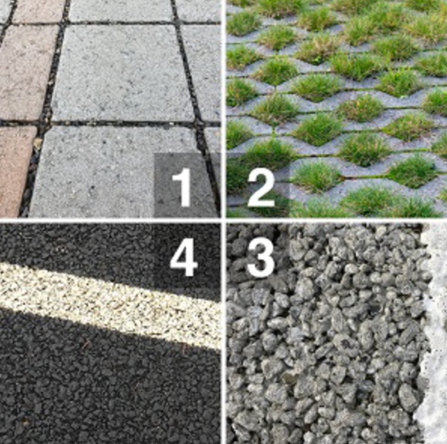  Figure 32: 1 – Permeable Pavers, 2 – Grass Pavers, 3 – Pervious Concrete, and 4 – Porous Asphalt | 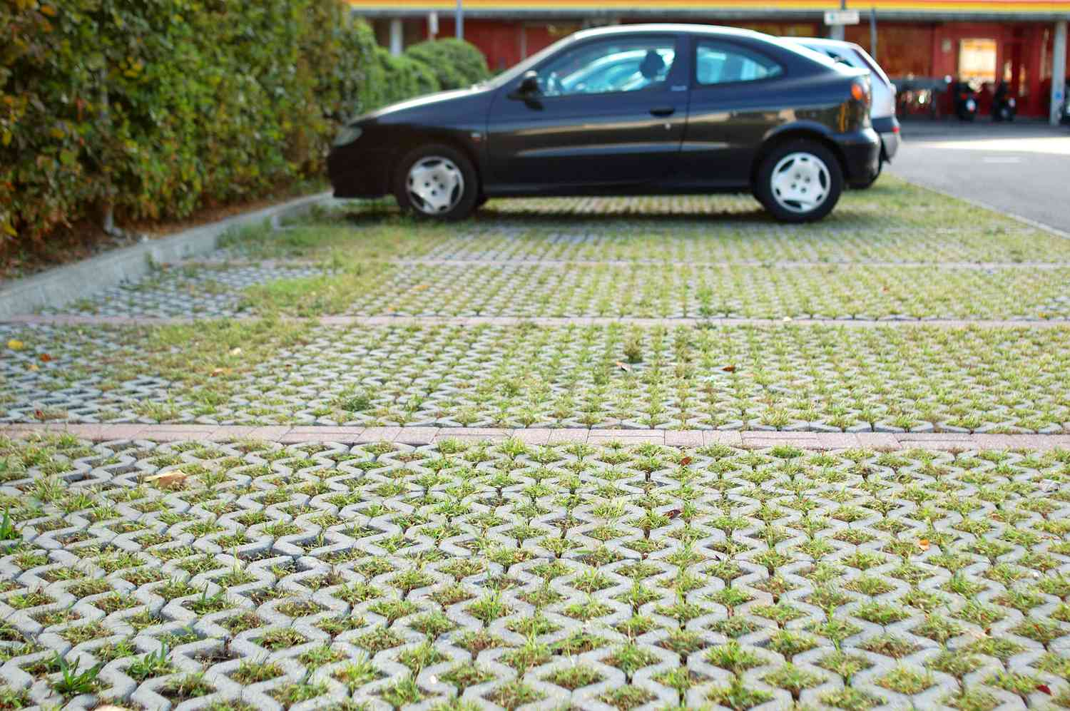  Figure 33: Grass Pavers
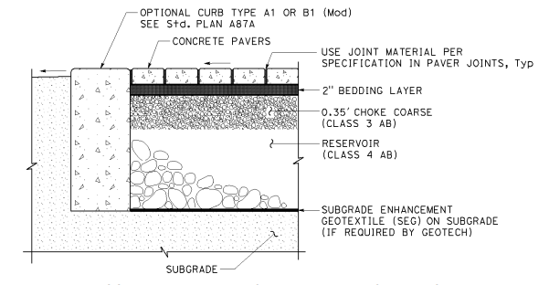
Figure 34: Example of a permeable interlocking concrete paver typical section.
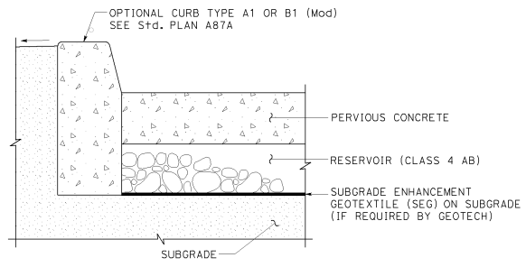
Figure 35: Example of a pervious concrete typical section.

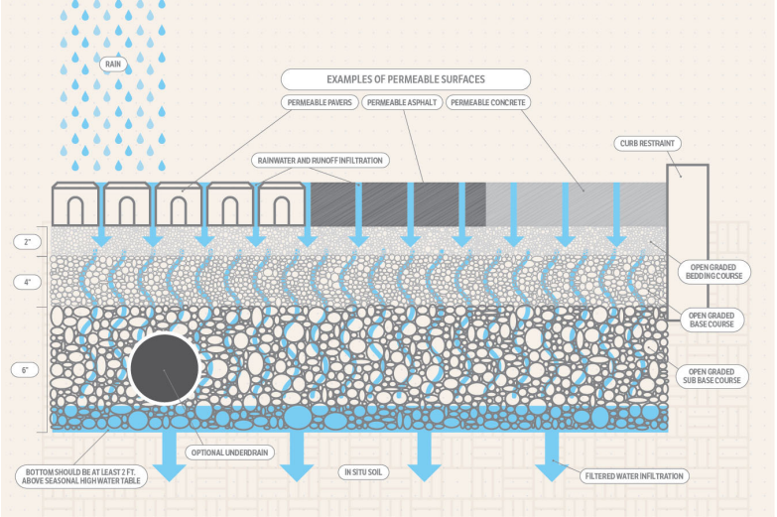
Figure 36: Examples of permeable surfaces

Requirements to gain incentives

A minimum 50% of the off-street parking spaces (excluding ADA parking spaces) and 100% of the sidewalks (excluding sidewalks identified as ADA accessible routes) must be an alternative surface material (permeable pavers, grass pavers, pervious concrete, or porous asphalt).

Incentives

Off-Street Parking Flexibility, Reduced Building Permit Fees, Reduced Land Development Fees, and Variance and/or Waiver Not Required.
B. Concentrated Landscape Parking Islands and Row Ends
Concentrated landscape islands and row ends refer to intentional design features that concentrate vegetation and landscaping in specific areas within a developed site. Concentrated landscape islands and row ends typically feature native plants, shrubs, and trees selected for their ability to thrive in the local climate, soil conditions, and heat generated by the parking area. By concentrating vegetation in these designated areas, developers can create green spaces that enhance biodiversity, provide habitat for wildlife, improve air quality, and reduce heat island effects. Additionally, these features can help manage stormwater runoff, promote soil infiltration, and contribute to the overall sustainability and resilience of the development.
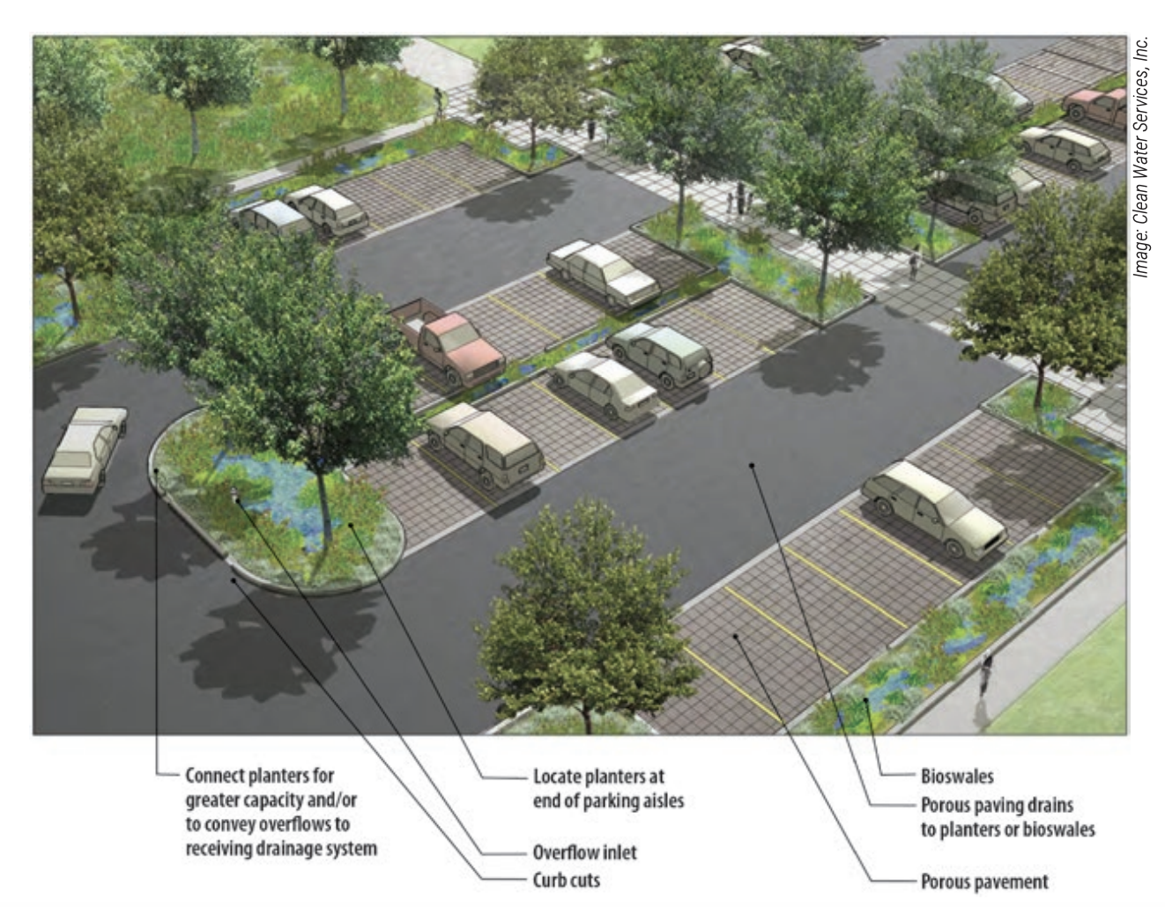Figure 37 | 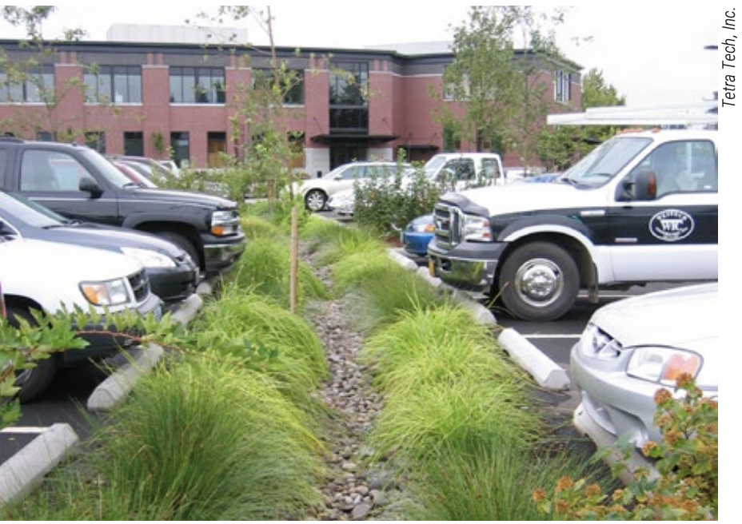Figure 38
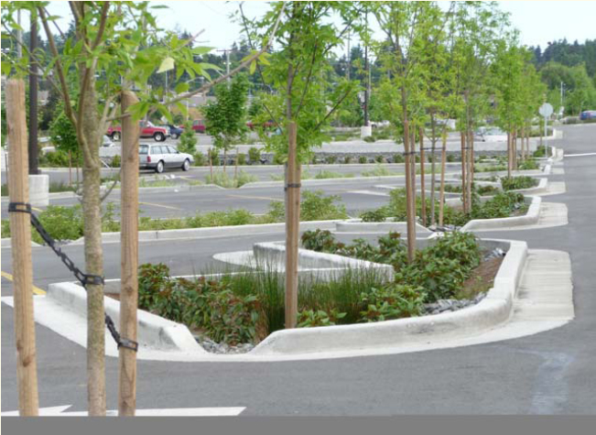
Figure 39
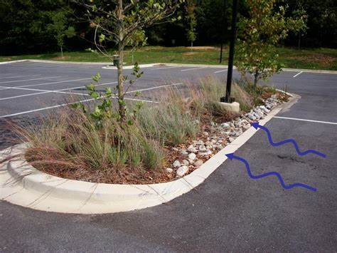
Figure 40

Requirements to gain incentives
Parking areas within commercial sites and subdivision common areas must provide concentrated landscape islands/row-ends with a minimum area of 300 square feet with no width less than 20 feet, if it abuts one parking space. If abutting two parking spaces, the minimum size must be doubled.
Design must include an alternative curb design to facilitate stormwater runoff.
Concentrated landscape islands/row-ends must be at a sufficient distance from structures to ensure clearance for fire engines at mature tree growth.

Incentives

BMP Permitted within Landscape Islands and Row-Ends, BMP Credited as Landscaping, BMP Credited as Common Open Space; Off-Street Parking Flexibility, Reduced Building Permit Fees, Reduced Land Development Fees, and Variance and/or Waiver Not Required.

4.2.6 Minimizing Runoff Volume and Rate
A. Minimize Building Construction Footprint
To minimize the impervious footprint and disturbance of the site, the design professional should consider multi-story building design options. By constructing vertically, projects can optimize square footage while reducing the area of impervious surfaces, lessening stormwater runoff from the site. Moreover, on sloping sites, rather than importing fill to level the terrain for slab-on-grade foundations, employing stem-wall construction techniques can significantly minimize the area disturbed and compacted. This approach not only mitigates environmental disruption but also addresses concerns regarding the potential differences in composition between fill material and native soils, particularly in regions like Florida where phosphorus leaching is a notable consideration.
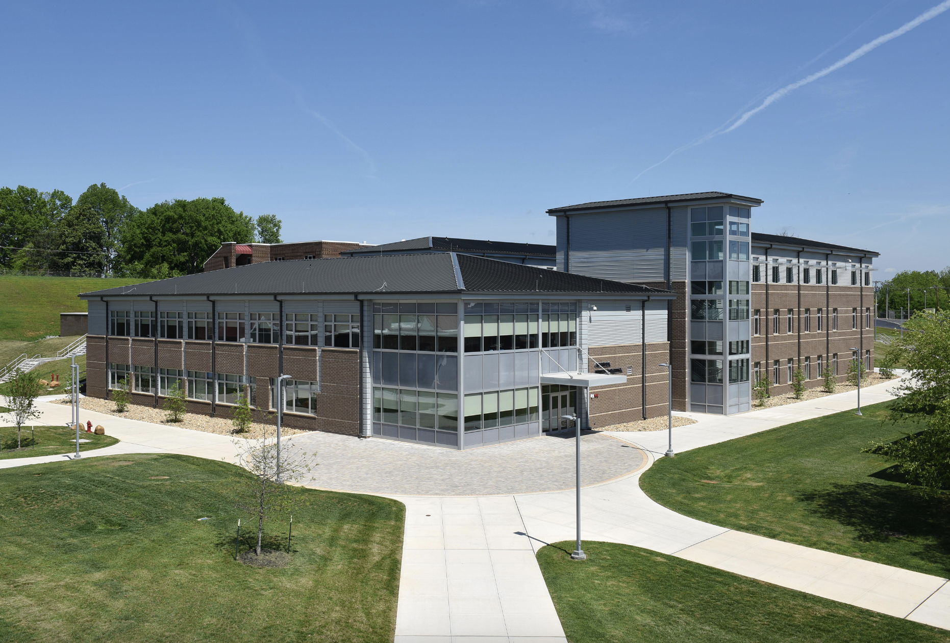
Figure 41
Requirements to gain incentives
Utilize multistory construction to reduce building lot coverage by at least 25% of the maximum building lot coverage permitted within Section 72-241, of the Zoning Ordinance. This is only permitted within commercial and industrial zoning classifications.
Incentives

Increased Floor Area Ratio, Increased Maximum Height, Off-Street Parking Flexibility, Reduced Building Permit Fees, Reduced Land Development Fees, and Variance and/or Waiver Not Required.
B. Total Impervious Area
By minimizing these impervious surfaces, developers can effectively manage stormwater runoff, reduce the risk of erosion and pollution, and promote sustainable land use practices.
Total Impervious Area (TIA) encompasses all surfaces within a development site that prevent or inhibit the infiltration of water into the ground, including but not limited to rooftops, roads, parking lots, sidewalks, and driveways. As TIA increases, so does the volume and velocity of stormwater runoff. Managing TIA is crucial for mitigating the adverse impacts of urbanization on hydrological systems and maintaining ecological balance. Effective strategies for minimizing TIA include prioritizing compact development layouts to reduce the overall footprint of impervious surfaces and using permeable pavement materials for parking lots and sidewalks to facilitate infiltration.
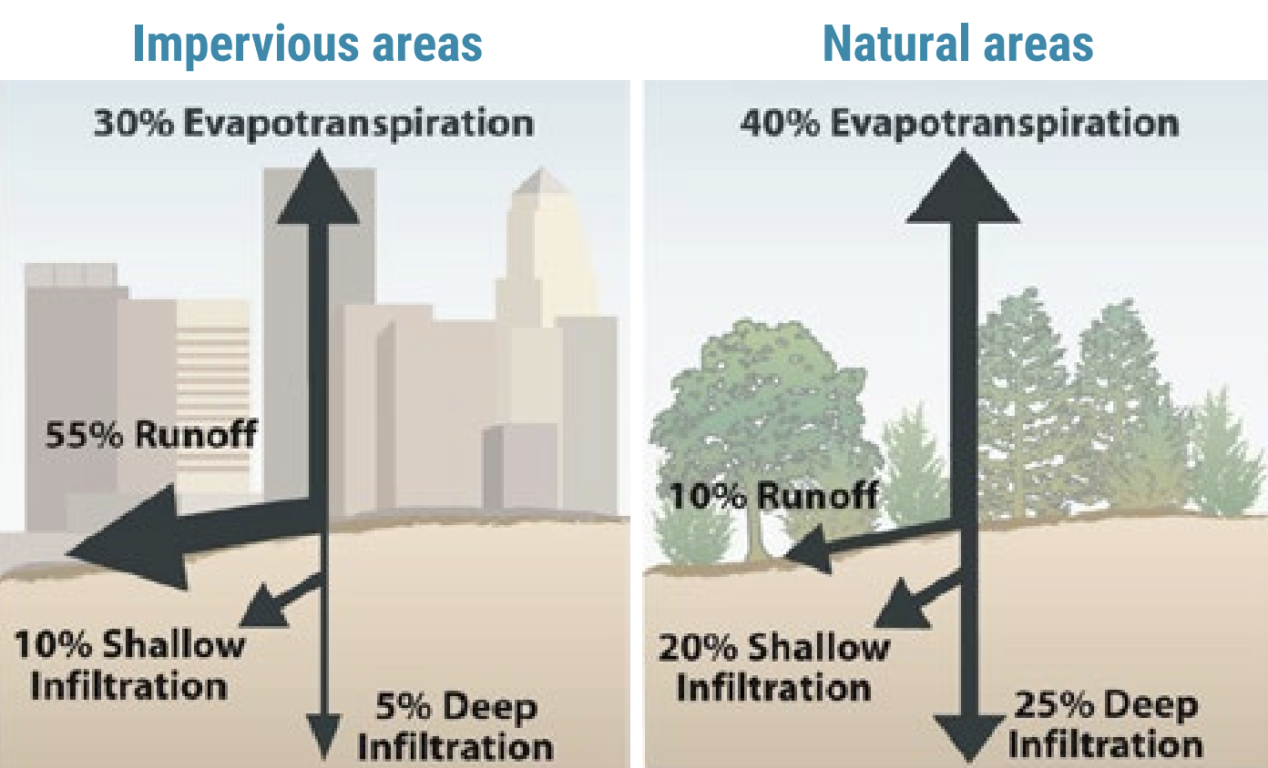
Figure 42
Requirements to gain incentives
Option A: Reduce the maximum impervious area within a commercial or industrial site to 50%. The notes on the Final Site Plan must state this maximum.
Option B: Design the stormwater system to account for 10% more than the allowable lot coverage permitted within Section 72-241, of the Zoning Ordinance, for each individual lot within a residential development. This must be reflected
The notes on a Final Plat or Final Site Plan must state this maximum. If a subdivision, this must also be stated within the Declaration of Covenants, Conditions and Restrictions (DCCRs).
Incentives

Option A: Flexible Building Setbacks, Increased Floor Area Ratio, Increased Maximum Height, Off-Street Parking Flexibility, Reduced Building Permit Fees, Reduced Land Development Fees, and Variance and/or Waiver Not Required.
Option B: Flexible Lot Sizes, Flexible Building Setbacks, Reduced Building Permit Fees, Reduced Land Development Fees, and Variance and/or Waiver Not Required.
C. Minimize Directly Connected Impervious Areas
Directly connected impervious areas (DCIAs) allow runoff to be conveyed without interception by permeable areas that allow for infiltration and treatment. Disconnecting impervious areas from roofs, small parking lots, courtyards, driveways, sidewalks, and other impervious surfaces allows runoff to flow onto adjacent pervious areas where it is infiltrated and filtered. One way to reduce DCIAs is to design the site to divert sheet flow into a swale, infiltration basin, rain garden, vegetated natural buffer, or other pervious area.

