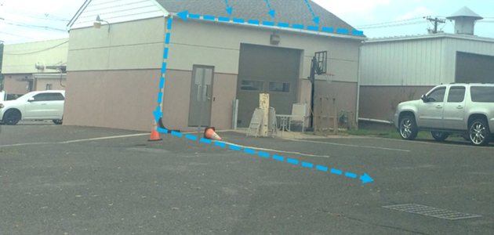Figure 43: The image above depicts an example of directly connected impervious area. | 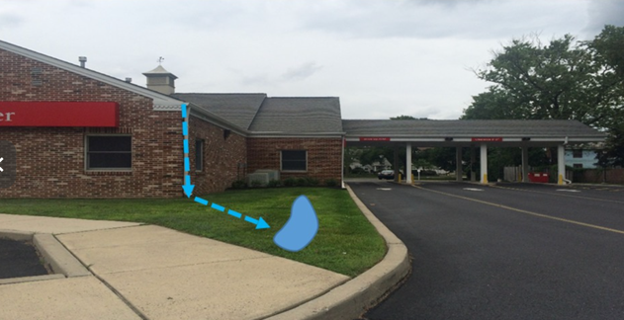Figure 44: The image above depicts an example of disconnected impervious areas

Requirements to gain incentives
All roof stormwater runoff must be directed into a pervious area (i.e. rain garden, swale, etc.). The disconnected area must be identified on the civil plans and within a table.
Incentives
BMP Permitted within Landscape Buffers and Building Setbacks, BMP Permitted within Landscape Islands and Row-Ends, BMP Credited as Common Open Space, Reduced Building Permit Fees, Reduced Land Development Fees, and Variance and/or Waiver Not Required.

4.3 Stormwater Storage, Treatment and Conveyance BMPs
These BMPs are designed to provide effective engineered solutions for storing and treating stormwater runoff. These practices involve the use of specialized structures such as wet/dry ponds, infiltration/exfiltration trenches, rain gardens, and other mechanical and biological solutions to capture, retain, and treat stormwater before it is discharged into natural water bodies.

4.3.1 Mechanical
Mechanical stormwater storage, treatment and conveyance refers to engineered solutions for stormwater management. One engineering solution which can be used within many stormwater management BMPs is Biosorption Activated Media (BAM). BAM is composed of natural or engineered materials with high surface area and adsorptive properties, such as activated carbon, zeolite, or biochar, which are specifically designed to capture and retain pollutants such as heavy metals, nutrients, organic compounds, and suspended solids. These systems are most used within retention BMPs such as basins, rain gardens, vegetated swales, planter boxes, exfiltration trenches, pervious pavements, and tree vaults.

A. Stormwater Treatment Park
Planners and design engineers can utilize parks for passive and active recreation, stormwater management, water conservation, and severing development rights within FEMA Flood Hazard Areas.

Stormwater Treatment Parks are green spaces designed to manage and filter stormwater runoff while providing recreational amenities and ecological benefits and can be designed at a smaller scale within a residential subdivision or a large commercial center. These parks can incorporate integrated bioretention areas and permeable pavements or filter strips and rain gardens, to capture, detain, and treat stormwater. Treatment Parks serve as multifunctional landscapes that enhance water quality, reduce flood risks, and promote groundwater recharge, all while offering opportunities for passive recreation, environmental education, and community engagement. Below is an example of the Sandra Stetson Aquatic Center’s Stormwater Treatment Area. It will remove an estimated 80% of the total nitrogen and 56% of total phosphorous (both from fertilizers), along with 79% of sediments and suspended solids.

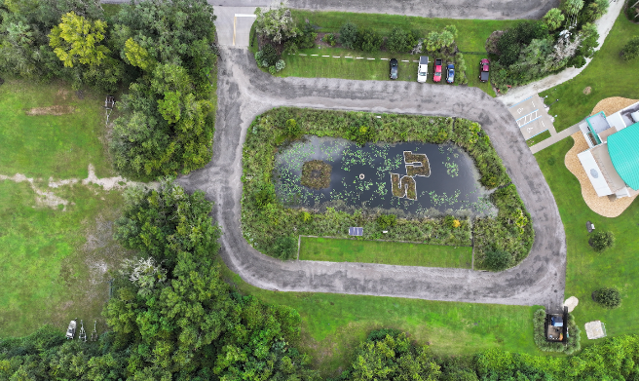
Figure 45: Stetson University Sandra Aquatic Center
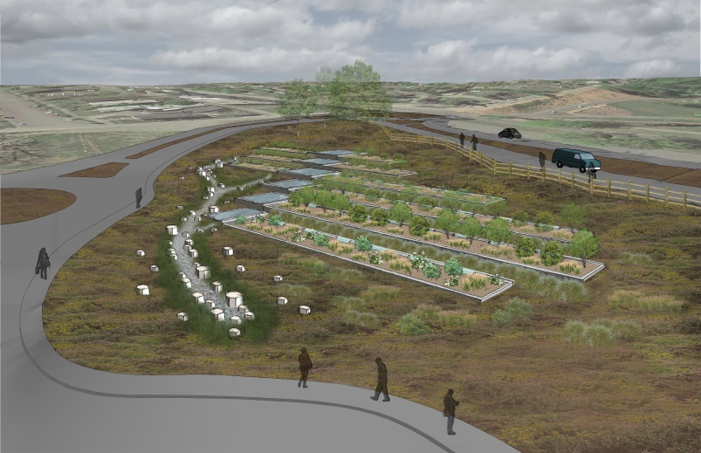
Figure 46: Point Defiance Regional Stormwater Treatment Facility
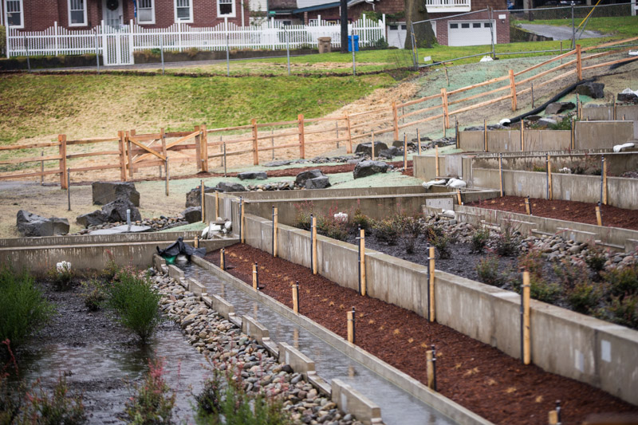
Figure 47: Point Defiance Regional Stormwater Treatment Facility
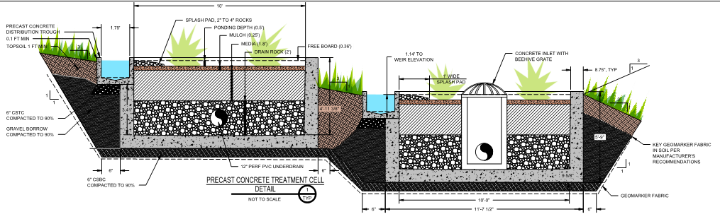
Figure 48: Treatment cells

Requirements to gain incentives
Create a passive/active recreational stormwater treatment park with educational signage, one or more clearly defined, visible entrances connecting to other internal sidewalks, a sidewalk surrounding the pond with pedestrian scale lighting, with no fewer than three of the following:
  - Playground meeting the Consumer Product Safety Commission playground safety guidelines for public use,
  - Two 15’ x 20’ picnic shelters with a minimum of 2 picnic tables each,
  - One 20’ x 30’ covered pavilion or shelter with a minimum of 5 picnic tables each,
  - Five standalone picnic tables,
  - Open “free play” areas,
  - Fenced dog park, or
  - Three-piece ASTM F3101 Compliant Outdoor Fitness Site or individual stations.
All roof stormwater runoff must be directed into a pervious area (i.e. rain garden, swale, etc.). The disconnected area must be identified on the civil plans and within a table. All passive/active recreational facilities and ponds must be located on the civil plans. Planted vegetation must be located on the landscape plan.
Option A: Wet Pond – Must include a littoral zone comprised of native emergent and submerged aquatic macrophytic vegetation. Biosorption Activated Media (BAM) must be used and can only contain non-petroleum-based products (expanded clay, sawdust, palm fronds, limestone, etc.).
Option B: Dry Pond – Must include an upland buffer of native trees, shrubs and understory vegetation. Biosorption Activated Media (BAM) must be used and can only contain non-petroleum-based products (expanded clay, sawdust, palm fronds, limestone, etc.).
Incentives
BMP Permitted within Landscape Buffers and Building Setbacks, BMP Permitted within Landscape Islands and Row-Ends, BMP Credited as Common Open Space, Reduced Building Permit Fees, Reduced Land Development Fees, and Variance and/or Waiver Not Required.
B. Wet Pond
A wet pond refers to a constructed stormwater management facility designed to collect and temporarily store stormwater in a permanently wet impoundment in such a manner as to provide for treatment through physical, chemical, and biological processes with subsequent gradual release of the stormwater. Depending on the design, wet ponds may incorporate additional features such as forebays, outlet structures, and emergency spillways to regulate water levels and ensure proper functioning during storm events.
The littoral zone can be established with native plants by planting rooted native aquatic plants. The planting plan must consider the design water elevation fluctuations of the wet pond and the ability of specific plants to be established and thrive. Specific design criteria for wet pond littoral zones are found in Section 8.6 of the Environmental Resource Permit Applicant’s Handbook, Volume II: For use within the geographic limits of the St. Johns River Water Management District (revised June 28, 2024).
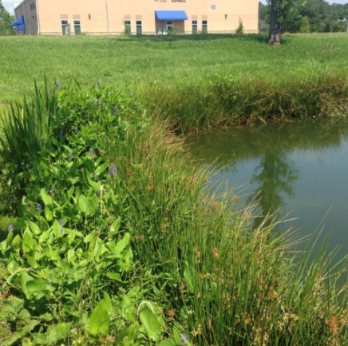 | 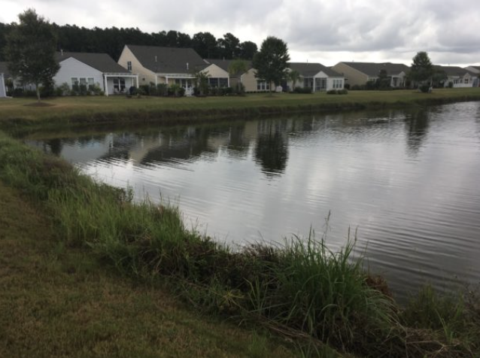
Figure 49 & 50: The above images display wet ponds with littoral shelf vegetation, which improves nutrient uptake, reduces the erosion of banks, and provides wildlife habitat.
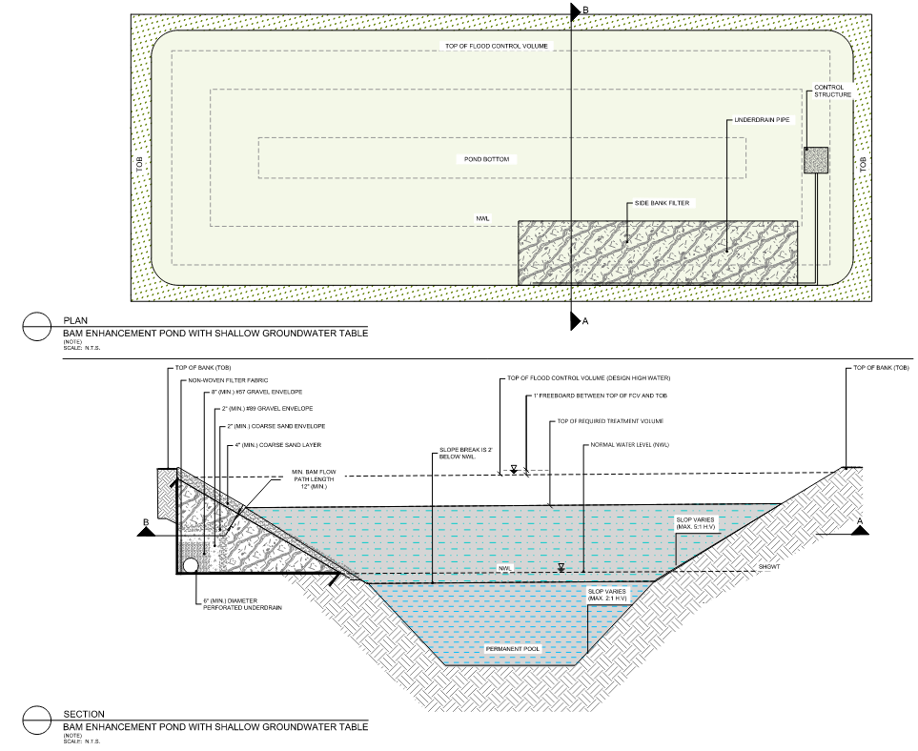
Figure 51: Example of BAM enhancement with a shallow groundwater table.

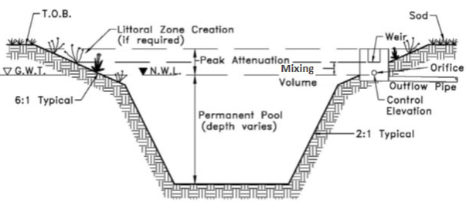
Figure 52

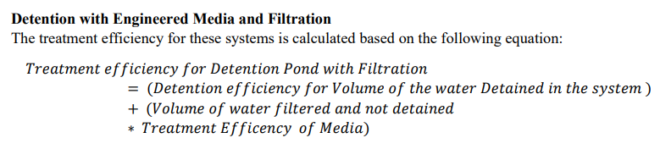
Figure 53

Requirements to gain incentives
A wet pond is designed to capture 15% more stormwater than required by the minimum standards within Division 8, of the LDC. The entirety of the pond must include a littoral zone compromised of native emergent and submersed aquatic macrophytic vegetation. Biosorption Activated Media (BAM) must be used and can only contain non-petroleum-based products (expanded clay, sawdust, palm fronds, limestone, etc.).
Note: The 15% shall not include additional capacity for compensating storage for fill in the floodplain.
Incentives
Flexible Lot Sizes, Flexible Building Setbacks, Reduced Building Permit Fees, Reduced Land Development Fees, and Variance and/or Waiver Not Required.

C. Dry Pond
A dry pond is a constructed stormwater management facility designed to prevent the discharge of a given volume to stormwater runoff into surface waters. It stores a defined quantity of runoff, allowing it to percolate through permeable soils into the shallow ground water aquifer. Vegetation may be incorporated into the pond's design to stabilize soil, enhance infiltration, and provide habitat for wildlife.
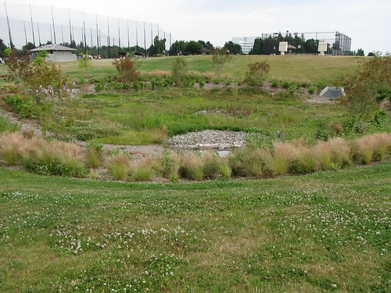
Figure 54
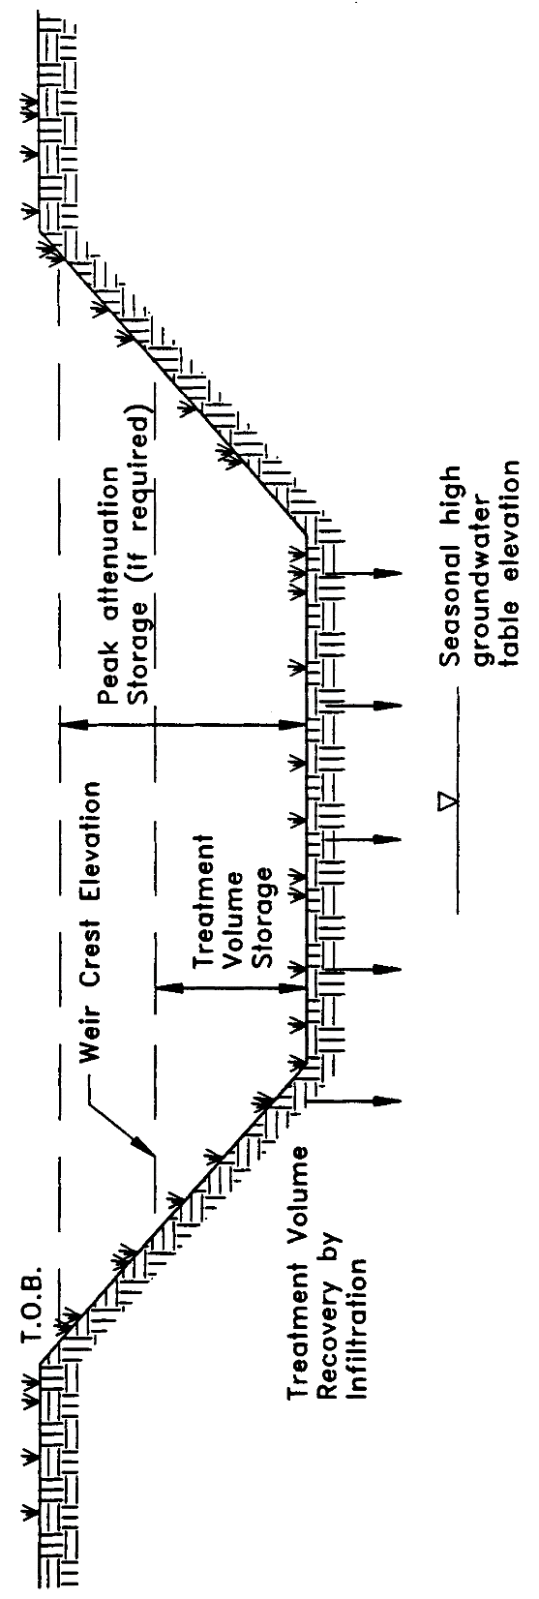
Figure 55
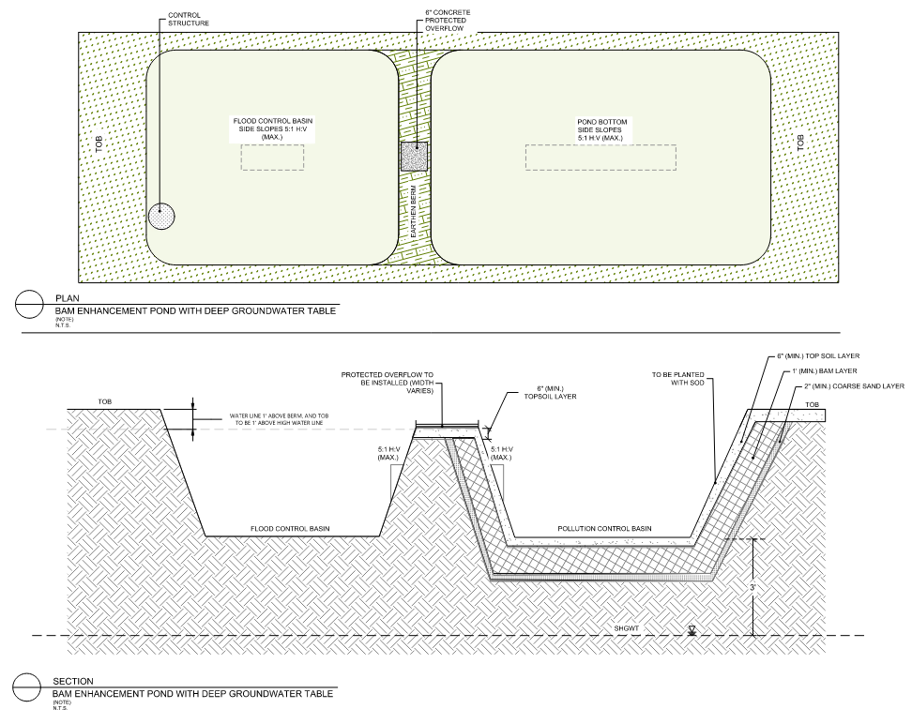
Figure 56: Example of BAM enhancement with a deep groundwater table.
Requirements to gain incentives
A dry pond is designed to capture 15% more stormwater than required by the minimum standards within Division 8, of the LDC. The entirety of the pond must include an upland buffer of native trees, shrubs and understory vegetation. Biosorption Activated Media (BAM) must be used and can only contain non-petroleum-based products (expanded clay, sawdust, palm fronds, limestone, etc.).
Note: The 15% shall not include additional capacity for compensating storage for fill in the floodplain.
Incentives
Flexible Lot Sizes, Flexible Building Setbacks, Reduced Building Permit Fees, Reduced Land Development Fees, and Variance and/or Waiver Not Required.
D. Underground Retention and Detention Systems
Underground stormwater management systems, like retention and detention systems, store excess stormwater underground using chambers, tanks, or pipes. These systems are designed to manage stormwater runoff by temporarily storing and infiltrating excess water into the surrounding soil or to continually hold water, only discharging into other stormwater infrastructure. These underground systems help to reduce the volume and velocity of runoff, minimize erosion, improve water quality, and promote groundwater recharge, all while reducing the impact of the site for development.
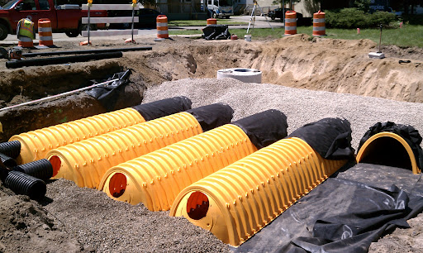
Figure 57
Requirements to gain incentives
An underground storage system is installed to minimize impact of 10% of natural areas on-site within a commercial or multifamily site. The water table must be appropriate for the use of this BMP.
Note: The applicant cannot gain an incentive if this is the only option to meet minimum stormwater management requirements of Division 8 on-site (i.e. the site is constrained).
Incentives
Flexible Lot Sizes, Flexible Building Setbacks, Increased Density, Increased Lot Coverage, Reduced Building Permit Fees, Reduced Land Development Fees, and Variance and/or Waiver Not Required.
E. Infiltration & Exfiltration Trenches
An infiltration trench refers to a shallow excavation or trench filled with permeable materials such as gravel, crushed stone, or engineered soil mixtures where stormwater enters from the top. These trenches are designed to capture stormwater runoff and promote infiltration of water into the underlying soil. As stormwater enters the trench, it percolates through the permeable media, allowing pollutants and sediments to settle out and water to infiltrate into the surrounding soil. The pavement design may vary based on the use of the trench in the right-of-way.
An exfiltration trench is subsurface stormwater management system consisting of a conduit such as perforated pipe surrounded by natural (gravel or crushed stone) or artificial aggregate which temporarily store and infiltrates stormwater runoff. Unlike infiltration trenches, which focus on directing water downward into the soil, exfiltration trenches encourage water to move horizontally out of the trench and into the surrounding area. The perforated pipe increases the storage available in the trench and helps promote infiltration by making delivery of the runoff more effective and evenly distributed over the length of the system. This facilitates groundwater recharge and helps to mitigate surface runoff. Exfiltration trenches are typically used in areas where infiltration into the soil is limited or where there is a need to redistribute water away from a specific location.
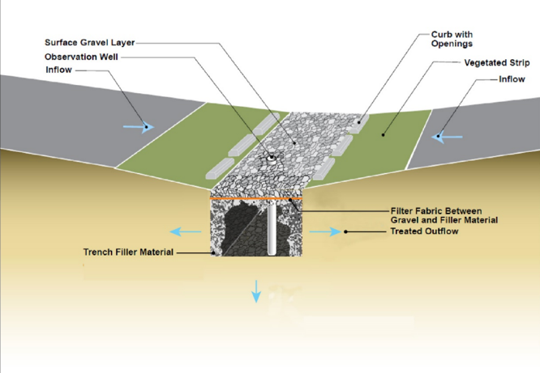  Figure 58: The above image depicts a cross-section of an infiltration trench. | 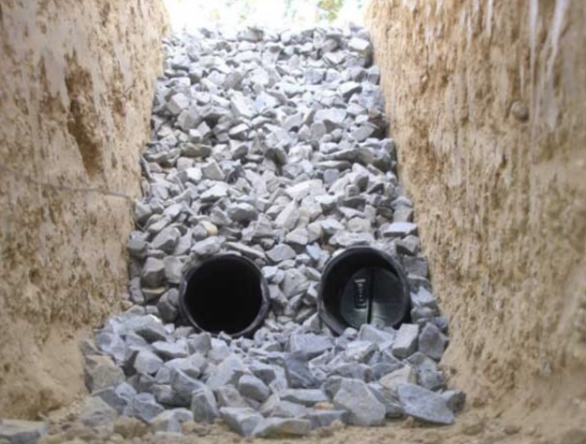  Figure 59: The above image depicts an exfiltration trench.
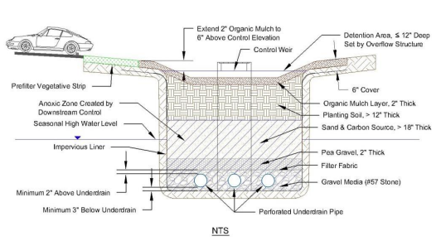
Figure 60: Cross section of depression area or pavement biofiltration system

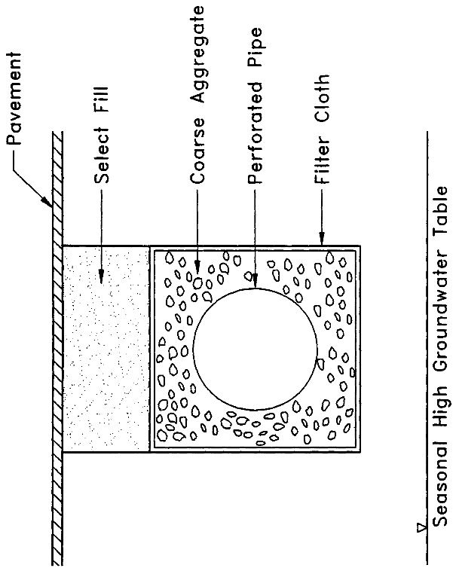
Figure 61

Requirements to gain incentives
The infiltration/exfiltration trench must be used on-site and may be used to meet total stormwater volume required by Division 8, of the Land Development Code. This must be demonstrated in the stormwater calculations.
This BMP can only be utilized in a commercial site, private streets, or outside the public right-of-way. The water table must be appropriate for the use of this BMP.
Incentives
Flexible Lot Sizes, Flexible Building Setbacks, Increased Density, Increased Lot Coverage, Reduced Building Permit Fees, Reduced Land Development Fees, and Variance and/or Waiver Not Required.
G. Stormwater Harvesting
Stormwater harvesting refers to infrastructure designed to capture, store, treat, and reuse stormwater runoff for various purposes. Specifically, it prevents the discharge of a given volume of stormwater into surface waters by deliberate application of stormwater for irrigation or industrial uses (such as cooling water, process water, and wash water). These systems typically involve the collection of rainwater from impervious surfaces such as rooftops, driveways, and roads, which is then conveyed to storage tanks, rain barrels, cisterns, or ponds for storage and treatment. Stormwater harvesting systems may incorporate filtration, sedimentation, and biological treatment processes to remove pollutants and improve water quality. Once treated, the harvested stormwater can be reused for non-potable applications such as landscape irrigation, irrigating green roofs, washing vehicles, industrial cooling and processing, and toilet flushing, or for potable drinking water.
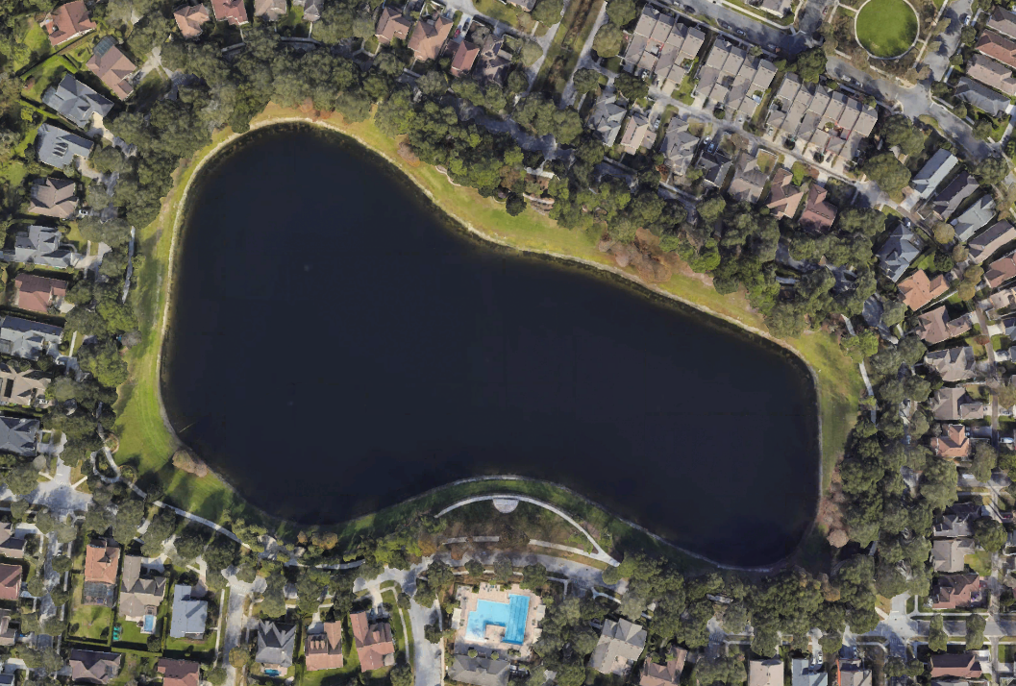
Figure 62: Lake Victoria, DeLand, FL – Stormwater treatment facility and irrigation source for Victoria Commons neighborhood
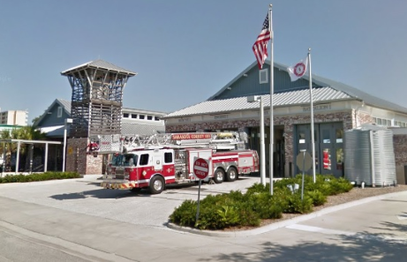
Figure 63: Cistern at fire station in Sarasota County, FL
Figure 51
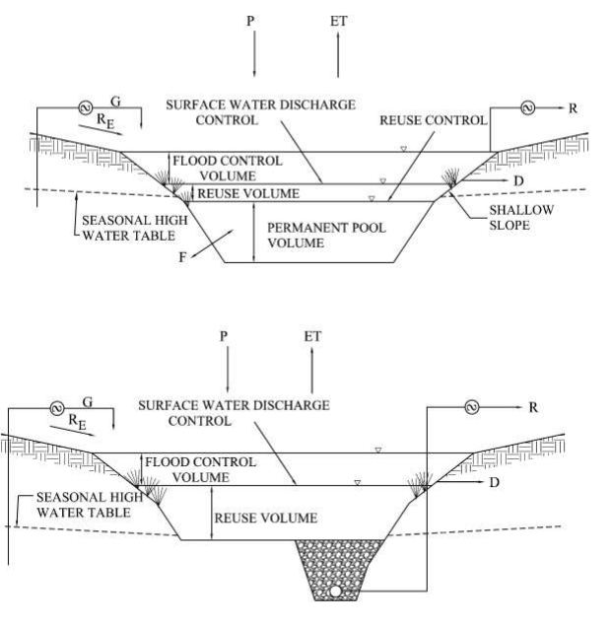
Figure 64: Stormwater pond with irrigation system equipment

Requirements to gain incentives
A stormwater harvesting method must be used on-site and may be used to meet total stormwater volume required by Division 8, of the Land development Code. This must be demonstrated in the stormwater calculations.
The proposed stormwater harvesting vessel (pond, cisterns, etc.) and all related piping, etc. and the reuse activity must be demonstrated on the Final Site Plan construction plans. This is only permitted within multifamily, commercial, and industrial zoning classifications.
Note:
      - Harvested stormwater for non-potable uses must be approved by the Florida Department of Health.
- A cistern must be designed to eliminate openings for mosquitos and protected from sunlight.
- Incentives cannot be gained by using a water harvesting park to meet minimum fire water requirements required by the Florida Fire Prevention Code, only. An additional non-potable use must be included.
Incentives
Flexible Building Setbacks, BMP Permitted within the Landscaping Buffers and Setbacks, Reduced Building Permit Fees, Reduced Land Development Fees, and Variance and/or Waiver Not Required.

4.3.2 Biological
A. Vegetated Swale
Swales have been used for conveyance of storm water along roads for decades. They are designed and constructed to properly convey and infiltrate stormwater runoff as it travels through the swale. These swales are designed to infiltrate a defined quantity of runoff (the treatment volume) through the permeable soils of the soil floor and side slopes into the shallow groundwater aquifer immediately following a storm event. A vegetated swale combines conveyance with treatment effectiveness directly related to the amount of annual stormwater volume that is infiltrated. If soil permeability is limited, a perforated underdrain and overflow grate may be required (UACDC: Low Impact Development: a design manual for urban areas).

Incorporating swales as part of a treatment train reduces the pollutant loading to the downstream treatment system, increase the pollutant efficiency of the overall stormwater management system, and reduces maintenance.

Pursuant to the Environmental Resource Permit Applicant’s Handbook Volume I Appendix O (effective 6/28/2024), the nutrient capability of these systems can be calculated in the same way as a dry retention system.

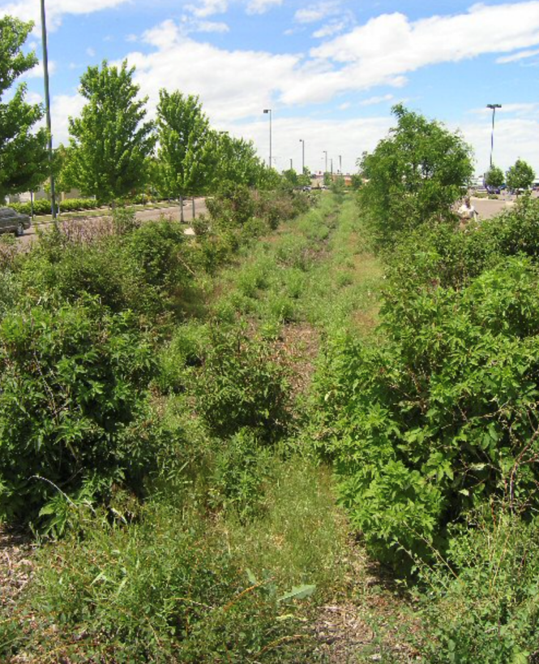
Figure 65: Planted vegetated swale between parking lot and road in Denver, CO

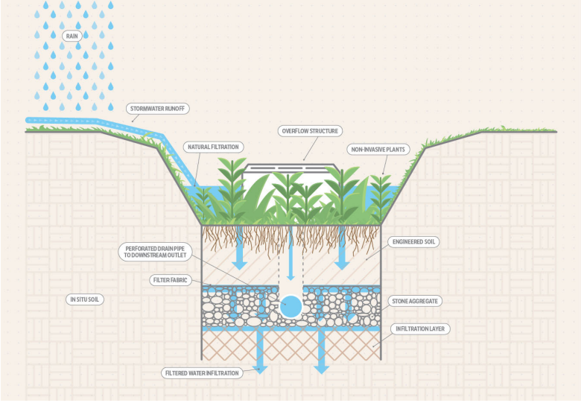
Figure 66

Requirements to gain incentives
A vegetated swale must be used on-site and may be used to meet total stormwater volume required by Division 8, of the Land development Code. This must be demonstrated in the stormwater calculations.
All vegetation must be native and identified within the civil and landscape plans.
Incentives
BMP Permitted within Landscape Buffers and Building Setbacks, BMP Permitted within Landscape Islands and Row-Ends, BMP Credited as Landscaping, Reduced Building Permit Fees, Reduced Land Development Fees, and Variance and/or Waiver Not Required.
B. Rain Gardens
Rain gardens are small retention basins that are integrated into the site’s landscaping. A rain garden is a shallow, constructed depression that is planted with deep rooted Florida native plants. They can be within parking lot islands/row ends to receive runoff from hard surfaces such as a roof, sidewalk, driveway, or parking area, or any other pervious area within a developed site. Rain gardens slow down the flow of water from impervious surfaces, hold the water for short periods of time and allow it to naturally infiltrate into the ground or evaporate. The synergy between soil, microbes, and vegetation facilitates processes such as filtration, sedimentation, absorption, ion exchange of solids and metals, as well as biological absorption and decomposition of organics and nutrients found in stormwater. They replenish the local aquifer by enhancing water filtration into the soil, diminish the flow of stormwater pollutants—like fertilizers, pesticides, and car oil—entering storm sewers or nearby water bodies, offer habitats for birds, butterflies, and beneficial insects, and elevate property value by enhancing the landscape's aesthetic appeal.
Pursuant to the Environmental Resource Permit Applicant’s Handbook Volume I Appendix O (effective 6/28/2024), the nutrient capability of these systems can be calculated in the same way as a dry retention system.
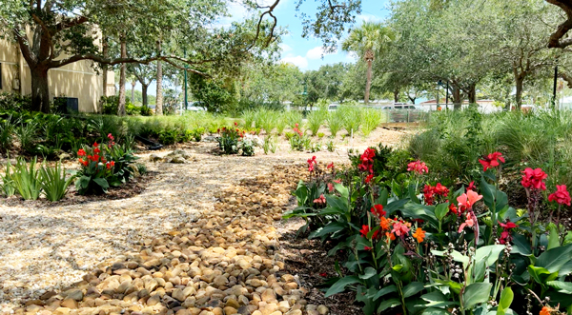
Figure 67: Rain gardens at Veterans Memorial Park, Cape Canaveral
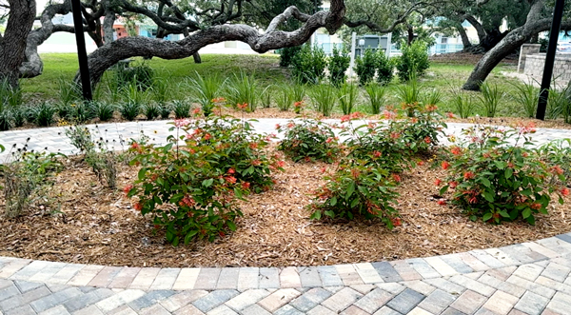
Figure 68: Rain gardens at Veterans Memorial Park, Cape Canaveral

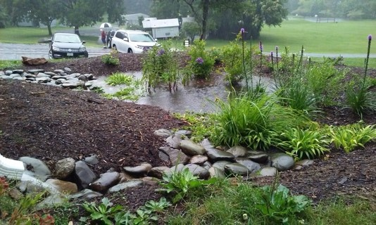Figure 69: Rain garden during storm event | 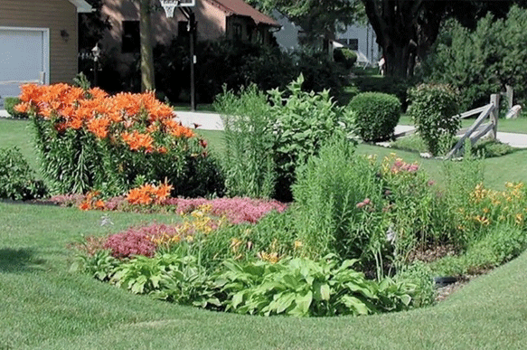Figure 70: Rain garden during clear skies
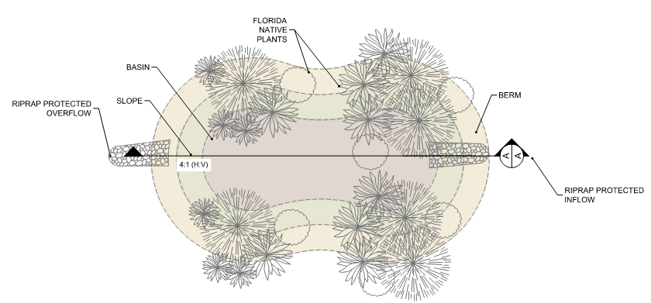
Figure 71: Example of a rain garden with a deep groundwater table.
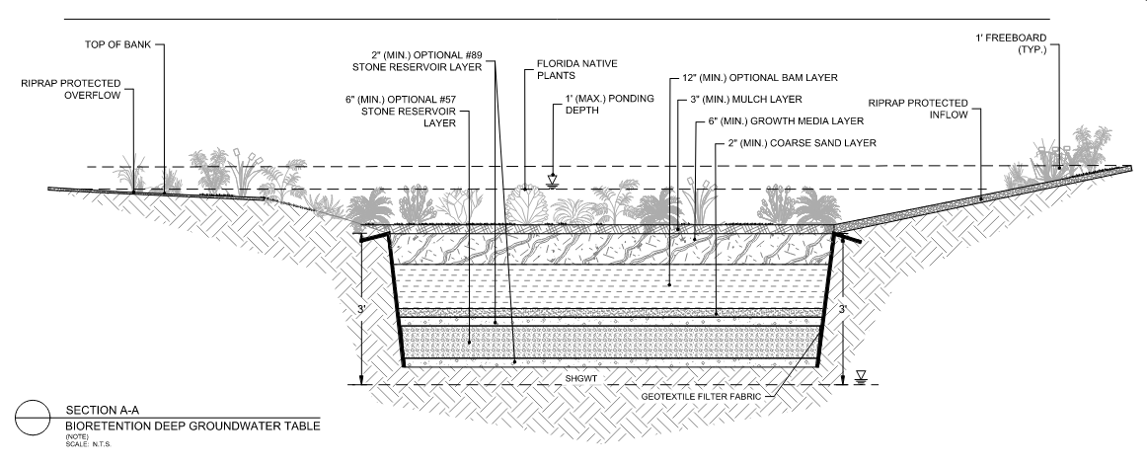
Figure 72: Example of a rain garden cross section with a deep groundwater table.
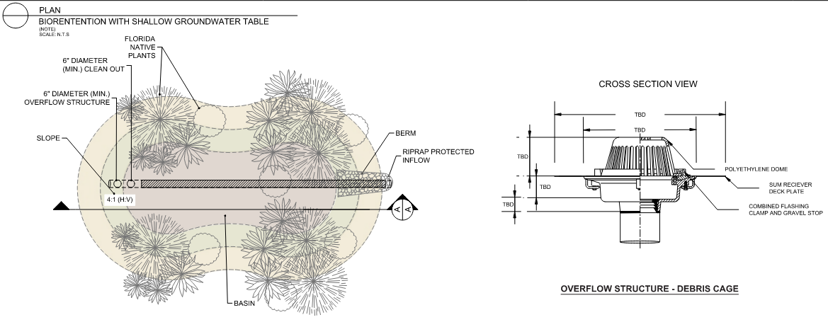
Figure 73: Example of a rain garden and overflow structure with a shallow groundwater table.
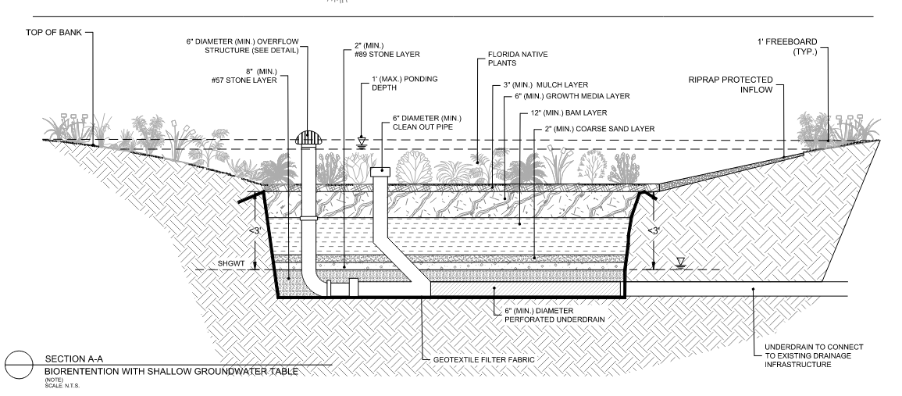
Figure 74: Example of a rain garden cross section with a deep groundwater table.
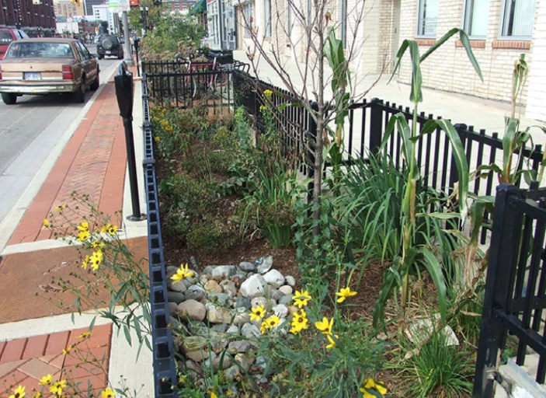
Figure 75: Planter boxes capture and treat much of the stormwater from roads and sidewalks.

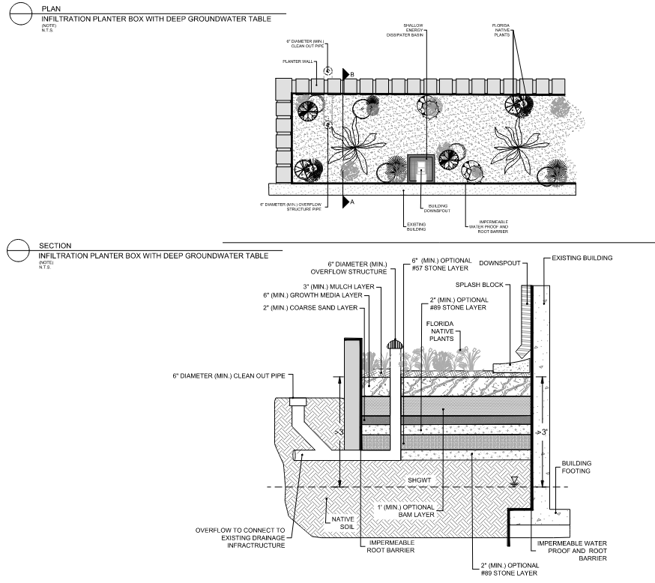
Figure 76: Example of an infiltration planter box with a deep groundwater table.
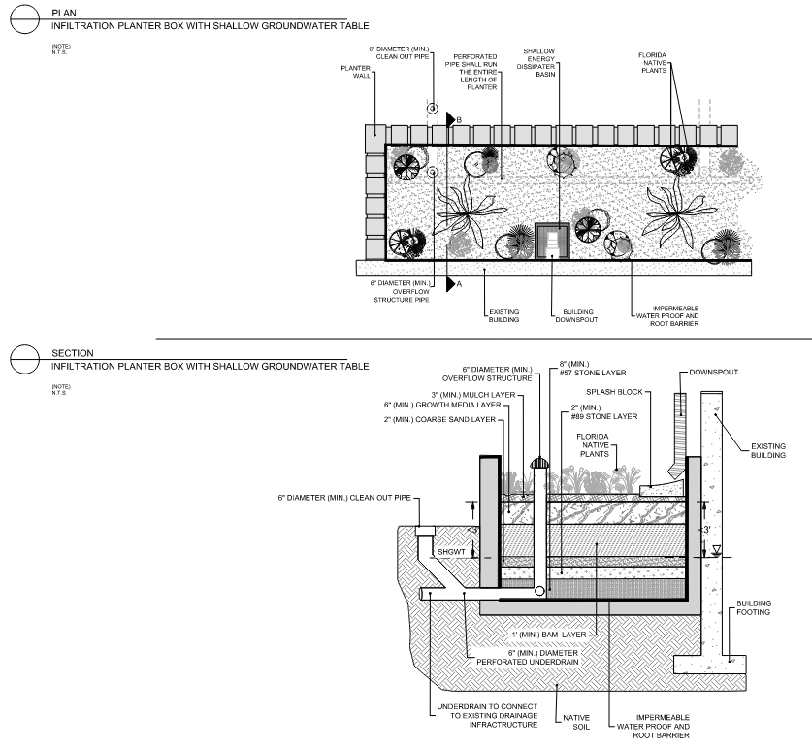
Figure 77: Example of an infiltration box with a shallow groundwater table.
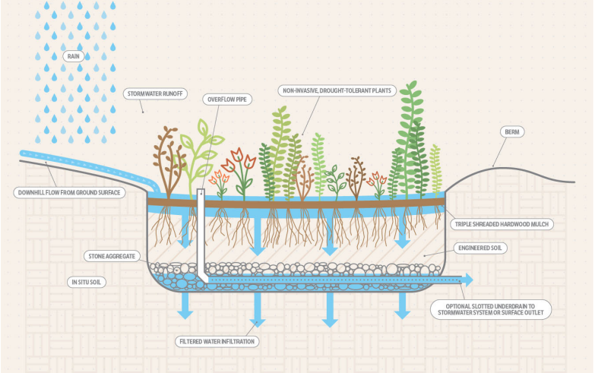
Figure 78

Requirements to gain incentives
A rain garden must be used on-site and may be used to meet total stormwater volume required by Division 8, of the Land development Code. This must be demonstrated in the stormwater calculations.
The landscape plan must depict native plant species, location, and number and any landscape rocks, etc. Species do not need to be chosen from the Zoning Landscape Plant List, as they may be aquatic in nature.
Incentives
BMP Permitted within Landscape Buffers and Building Setbacks, BMP Permitted within Landscape Islands and Row-Ends, BMP Credited as Landscaping, BMP Credited as Common Open Space, Reduced Building Permit Fees, Reduced Land Development Fees, and Variance and/or Waiver Not Required.

C. Tree Box Filters and Rainfall Interceptor Trees
A tree box filter is a tree vault containing amended soils underlain with crushed gravel media, which is connected to the overall stormwater system through perforated underdrain pipes (UACDC Low Impact Development: a design manual for urban areas). Constructing tree box filters along streets and parking areas helps to manage stormwater runoff at its source by effectively filtering and attenuating runoff during rain events. These should be used in conjunction with curb cuts (described in Section 4.2.5.B.) to facilitate the flow of stormwater into curb extensions and planted with interceptor trees.
Interceptor trees are used adjacent to impervious surfaces as part of the stormwater treatment system to reduce runoff volume and pollution from the area by intercepting and capturing rainfall before it reaches the ground. These trees are selected for their canopy structure, foliage density, and height to effectively capture precipitation and reduce stormwater runoff. The United States Forest Service states that trees planted over impervious surfaces like parking lots could reduce stormwater runoff by as much as 20 percent. Branches and stems can capture and retain as much as 15 percent of total rainfall. A large tree can capture and retain as much as 332 gallons of water (US Forest Service, 2018). By intercepting rainfall, these trees help mitigate the impact of heavy rainfall events, reduce soil erosion, and promote groundwater recharge. Additionally, they contribute to the overall sustainability of the development by improving air quality, providing shade, and enhancing aesthetic value.
Pursuant to the Environmental Resource Permit Applicant’s Handbook Volume I Appendix O (effective 6/28/2024), the nutrient capability of these systems can be calculated in the same way as a dry retention system.
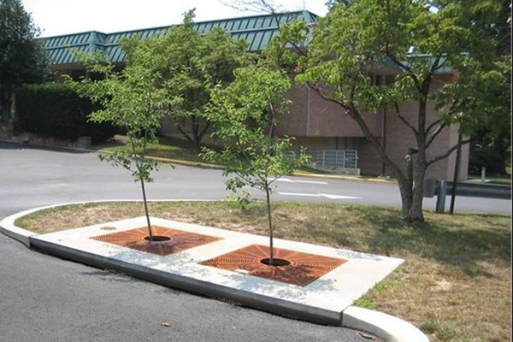
Figure 79
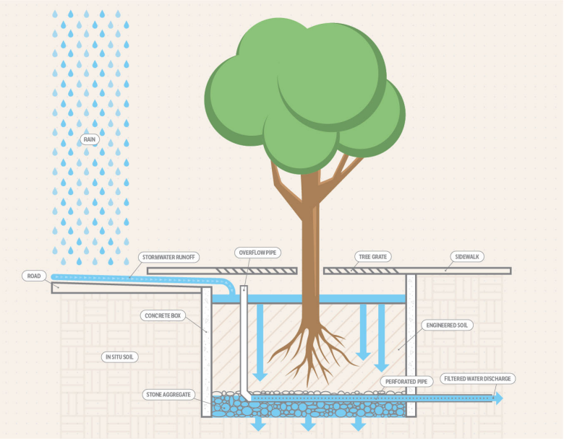
Figure 80

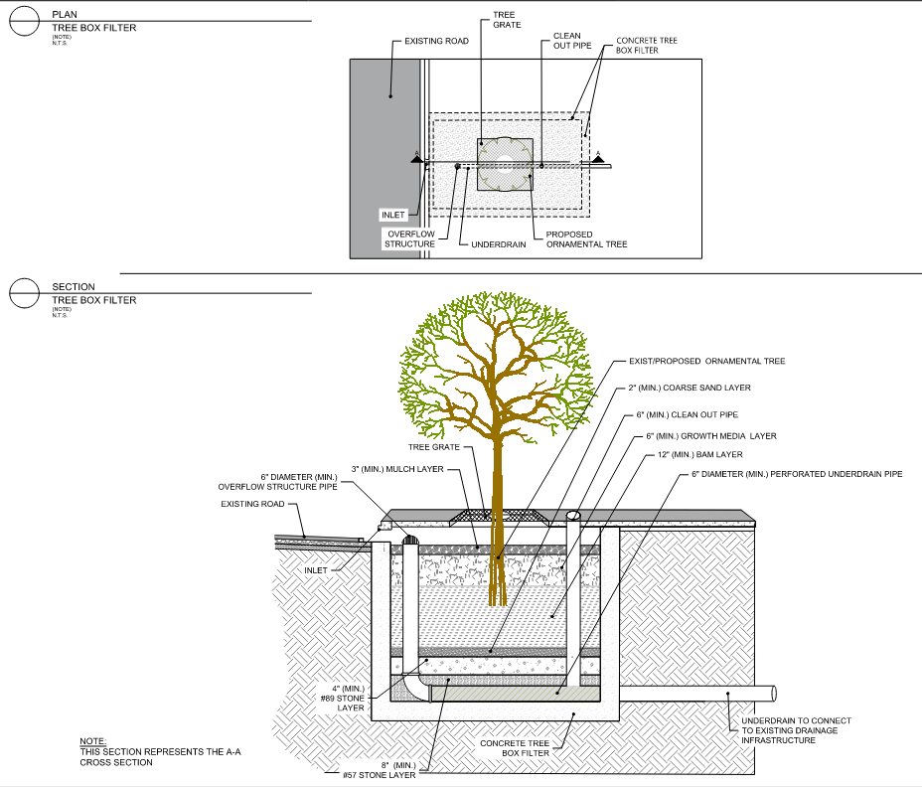
Figure 81: Example of a tree box filter.
Requirements to gain incentives
A tree box filter with a Florida native rainfall interceptor tree must be used on-site and may be used to meet total stormwater volume required by Division 8, of the Land development Code. This must be demonstrated in the stormwater calculations.
Incentives
BMP Permitted within Landscape Islands and Row-Ends, BMP Credited as Landscaping, Reduced Building Permit Fees, Reduced Land Development Fees, and Variance and/or Waiver Not Required.

D. Vegetated Roofs and Walls
Vegetated roofs are roofs with planted vegetation on a portion or the entirety of the area, filtering and controlling the flow of rainwater before it leaves a structure. By utilizing natural vegetation and soil substrates, vegetated roof systems have been shown to assist in stormwater management by attenuating hydrographs, neutralizing acid rain, reducing volume of discharge, and reducing the annual mass of pollutants discharged.
Pursuant to the Environmental Resource Permit Applicant’s Handbook Volume I Appendix O (effective 6/28/2024), the nutrient capability of a vegetated roof system can be calculated in the same way as a dry retention system.
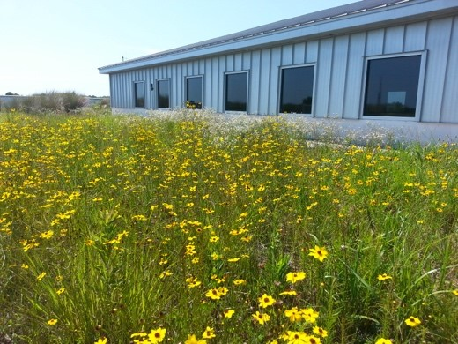  Figure 82: Escambia County Office in Pensacola, Florida | 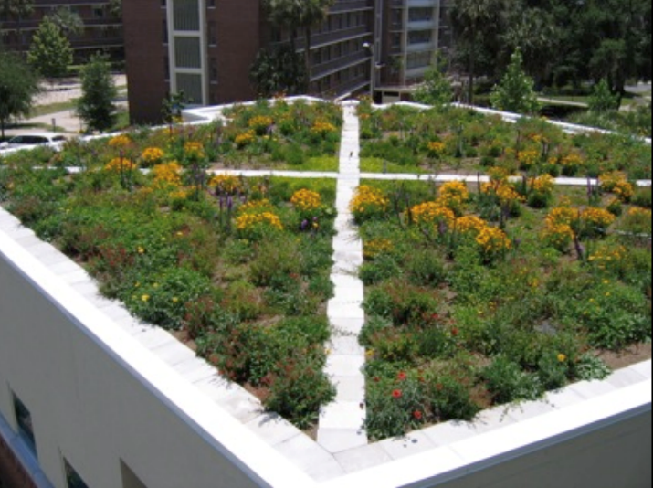Figure 83: University of Florida Perry Building

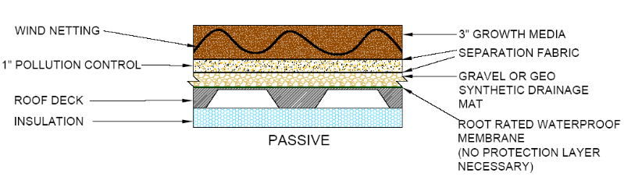
Figure 84: Extensive Green Roof Section (Passive Function)
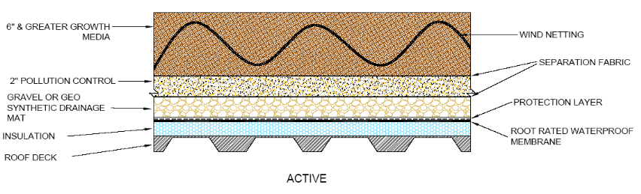
Figure 85: Intensive Green Roof Section (Active Function)

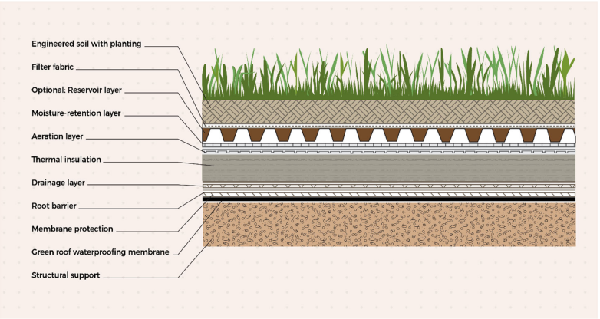
Figure 86

Vegetated walls are constructed to house plant material and engineered soil or inorganic growing medium. They can act as rainfall inceptors and provide water uptake, reducing stormwater runoff loads.

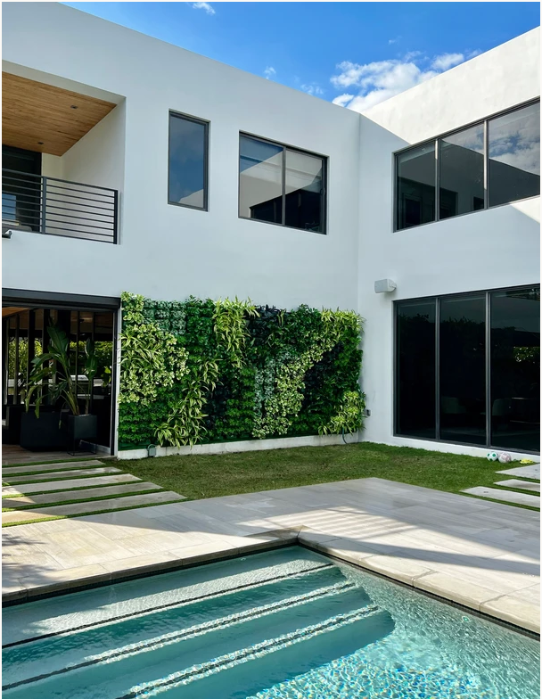
Figure 87: Vegetated wall in Coral Gables, Florida
Requirements to gain incentives
A vegetated roof or wall must be used on-site and may be used to meet total stormwater volume required by Division 8, of the Land development Code. This must be demonstrated in the stormwater calculations.
All vegetation must be native an identified within the landscape plans.
Incentives
Flexible Building Setbacks, BMP Credited as Landscaping, Reduced Building Permit Fees, Reduced Land Development Fees, and Variance and/or Waiver Not Required.

Chapter 5: Maintenance of LID Practices

5.1 Introduction
In this section, we delve into the essential practices and protocols necessary for the ongoing care and upkeep of certain LID infrastructure, beyond the typical requirements of green and gray infrastructure maintenance. It is imperative to ensure that these systems are not only effectively implemented but also properly maintained to maximize their benefits and longevity. Maintenance of LID infrastructure encompasses a spectrum of activities, ranging from routine inspections to proactive measures aimed at preserving functionality and environmental performance. Through diligent maintenance practices, we aim to uphold the integrity of LID features, mitigate potential risks, and safeguard the surrounding environment against adverse impacts.

5.2 Maintenance Responsibilities for LID Techniques in Subdivisions
In implementing Low Impact Development (LID) techniques for subdivision designs to gain incentives, it's crucial to note that maintenance responsibilities lie with individual property owners, Homeowners Associations (HOA), and Property Owners Associations (POA) within the subdivision. Section 2.1 requires submission of covenant and restriction documents and language on the Final Plat which include perpetual maintenance by a HOA or POA. While the County doesn't enforce covenant and restriction documents directly, embedding maintenance provisions within them ensures understanding of upkeep responsibilities for LID infrastructure.

5.3 Maintenance Responsibilities for LID Techniques in Site Plans
As with subdivisions, by implementing Low Impact Development (LID) techniques for site plan designs to gain incentives, individual property owners are responsible for perpetual maintenance. Section 2.1 requires a statement on the final site plan, affirming this commitment.

5.4 Site Design LID Maintenance Requirements

5.4.1 Native Landscape, Fertilizers and Irrigation
- Ensure all HOA/POA members and homeowners understand the requirement to retain the native vegetation and that removal or replacement with non-native species is not permitted.
- Regularly inspect trees for health and structural integrity, pruning as needed.
- Control invasive species to protect native plants.
- Mulch and water to retain moisture and promote healthy growth. Conduct soil testing and amend soil for optimal plant health.
- Monitor and adjust irrigation for efficient water use. Removal of the smart irrigation controllers is not permitted.

5.4.2 Habitat Management
- A long-term vegetation management plan must be prepared to maintain the conservation area in natural or vegetative condition.
- Assess habitat health through surveys and identify degradation factors.
- Establish clear restoration goals and prioritize them based on significance and feasibility.
- Implement tailored restoration techniques, emphasizing sustainability.
- Monitor progress, adapt strategies as needed, and engage stakeholders.
- Remove litter and debris for a clean landscape.
- Control invasive species to protect native plants.
- Ensure all vegetation management practices comply with wildfire urban interface standards.
- Annual reports must be submitted to the Land Development Office and reviewed by Environmental Management and Fire Rescue.

5.4.3 Alternative Surface Material
Inspect pavement regularly for settlement and structural defects. Replace broken pavers immediately to prevent structural instability. Pavers can be removed individually and replaced during utility work. Pavement sections can be cut out and replaced with permeable or conventional pavement materials. Proper maintenance is crucial to keeping any GSI system functional. Permeable pavement should be routinely inspected, and any needed maintenance performed as soon as possible. The frequency of maintenance will depend on the system size and location. In general, permeable pavement should be inspected at least monthly and after heavy rain events to identify any issues early. Use the below checklist to document system inspections and recommended maintenance practices. Keeping record of system maintenance can alert you to any potential problems before they seriously disrupt the system’s function. Types of maintenance may include:
- At least annual vacuum sweeping is recommended to remove clogging material from the pavement surface. Pressure washing is discouraged, except as a last option.
- Check drainage area for bare soil or erosion, and replant or stabilize adjacent areas as necessary.
- Check to see whether underdrains are clogged by inspecting cleanouts or observation wells and looking for extended water storage.
- For smaller areas, remove the damaged pavers, check and fill the underlying gravel.
- Repair as per manufacturer specification. Do not apply sealants to permeable pavement.
- Sweep leaf litter and sediment regularly to prevent surface clogging and ponding.
- Prevent large root systems from damaging subsurface structural components.
- Manually remove, mow, or torch weeds.
- Use an herbicide only if it is approved for use in or near water (check with your local Extension Office for suggestions).
- Replace paver pore space with aggregate per original design.

5.5 Stormwater Storage, Treatment, and Conveyance LID Maintenance Requirements

5.5.1 Wet Pond
- Routine maintenance is needed during the initial stage after the installation of plants to allow expansion of the desirable plants and control the growth of invasive species.
- Routine maintenance requirements are generally minimal after plantings become established.
- Remove weeds and invasive plants in the shoreline area. When practical remove roots of these species to prevent regrowth.
- A lake mower can be used to control aquatic vegetation by selectively cutting some lily pads and leaving others for fish habitat. Because lilies spread their roots (rhizomes) laterally, the only other method to prevent spread is planting in submerged containers.
- Selectively harvest vegetation for permanent nutrient removal before they die back. Otherwise, nutrients can return to the pond.
- Remove sediment, debris, and blockages from inlet and outlet structures. Sedimentation in the flow path can clog inlets and outlets and reduce conveyance efficiency and infiltration.
- Identify obstructions and clear them immediately.
- Identify any areas with at least 2 inches of erosion or sedimentation. Immediately remove accumulated sediment of more than 4 inches, as this may affect GSI function.
- Repair or replace broken inlet and outlet structures or components as needed. Monitor minor damage such as dents, rust, or minor cracks for indicators of when repair or replacement is required.

5.5.2 Dry Pond
- Routine maintenance is needed during the initial stage after the installation of plants to allow expansion of the desirable plants and control the growth of invasive species.
- Routine maintenance requirements are generally minimal after plantings become established.
- Remove weeds and invasive plants. When practical, remove roots of these species to prevent regrowth.
- Remove sediment, debris, and blockages from inlet and outlet structures. Sedimentation in the flow path can clog inlets and outlets and reduce conveyance efficiency and infiltration.
- Identify obstructions and clear them immediately.
- Identify any areas with at least 2 inches of erosion or sedimentation. Immediately remove accumulated sediment of more than 4 inches, as this may affect GSI function.
- Occasionally mechanically scarify the pond bottom to maintain percolation.
- Repair or replace broken inlet and outlet structures or components as needed. Monitor minor damage such as dents, rust, or minor cracks for indicators of when repair or replacement is required.

5.5.3 Underground Retention and Detention Systems
- Regular, routine inspection and maintenance is an important component of this type of underground system to ensure that it functions in a satisfactory manner. The maintenance intervals for an underground retention system are typically more frequent than standard ‘dry’ retention ponds. The performance of the underground system will be related to the effectiveness of the upgradient sediment/ trash removal devices and the frequency of inspections and maintenance activities for each of the underground retention systems components.
- Inspection frequency:
  - After a large storm event of greater than one (1) inch of rainfall: to ensure the (continued) free flow of stormwater, inspect the system and remove accumulated trash and debris from the up-gradient sediment/trash removal devices, and the inflow and outflow points of the down-gradient underground retention systems.
  - Every 6 months: perform a comprehensive inspection of the underground retention system for accumulated trash, debris, and organic matter, and remove/dispose of these contaminates to ensure unimpeded stormwater flow. As appropriate, clean the surface of the sub-grade sands by ranking, and check for accumulations in the various underground areas. If the sediment/contaminate accumulation is greater than two (2) inches a vacuum truck and/or similar equipment may be necessary for removal operations. Removed contaminants shall be taken to an approved off-site landfill.
  - Annually, during September-November: monitoring of the drawdown time of the stormwater through the sub grade sands shall be done to ensure recovery within 72 hours after the last rainfall event. Monitoring and observing the drawdown times can be done visually through the inspection ports or observation well after a storm event. the drawdown of the water quality treatment volume (RTV) must recover within 72 hours after the storm event. If appropriate, post construction hydraulic conductivity testing of the non-compacted soil floor shall be performed by the appropriate Florida licensed professional. Any post construction soil testing reports should be submitted to the county upon request.
  - drawdown times that exceed 72 hours are indicative of subgrade clogging and will likely require the removal of contaminants and ranking of the subgrade soils. actual depth of the removal can be done visually by looking at the discoloration of the entrapped fine silts, hydrocarbons (greases and oils), and organic matter. If required, replacement sub-grade soils must meet the design specifications under the original permit authorization.
  - in addition to the subgrade soils, other elements of the stormwater management system such as pipes, inlets, geotextile fabric, gravel, sediment/trash removal devices, etc. are to be inspected and repaired/replaced if needed.

5.5.4 Infiltration Trench
- Replace pea gravel and topsoil when clogged.
- Clear inlets of debris, including sediment and oil/grease monthly.
- Mow grass and remove grass clippings from filter strip areas, if applicable.
- Repair undercut and eroded areas at inflow/outflow structures.
- Inspect pretreatment devices and diversion structures for debris accumulation and structural integrity; take corrective action as needed.
- Aerate pretreatment basin bottom or de-thatch basin bottom, if applicable.
- Scrape pretreatment basin bottom to remove accumulated sediment and reseed ground cover, if applicable.
- Totally rehabilitate the trench and restore its design storage capacity upon failure.
- Excavate trench walls to expose clean soil, if applicable.

5.5.5 Exfiltration Trench
- Monitor facility for sediment accumulation in the pipe (when used) and storage volume recovery (i.e., drawdown capacity). Observation wells and inspection ports should be checked following three days minimum dry weather. Failure to percolate stored runoff to the design treatment volume level within 72 hours indicates binding of soil in the trench walls and/or clogging of geotextile wrap with fine solids. reductions in storage volume due to sediment in the distribution pipe, also reduces efficiency. Minor maintenance measures can restore infiltration rates to acceptable levels short term. Major maintenance (total rehabilitation) is required to remove accumulated sediment in most cases or to restore recovery rate when minor measures are no longer effective or cannot be performed due to design configuration.
- Inspect appurtenances such as sedimentation and oil and grit separation traps or catch basins as well as diversion devices and overflow weirs when used. Diversion facilities and overflow weirs should be free of debris and ready for service. Sedimentation and oil/grit separator should be scheduled for cleaning when depth approaches clean out level. Clean out levels should be established not less than 1 foot below the invert elevation of the chamber.
- Remove sediment from sediment or/grease traps, catch basin inlets, manholes, and other appurtenant structures and dispose of properly.
- Remove debris from the outfall or “Smart Box” (diversion device in the case of off-line facilities).
- Remove sediment and clear trench system. This process normally involves facilities with large pipes. Clean out may be performed by suction hose and tank truck and/or by high-pressure jet washing.
- Periodic clean out or rehabilitation of the system to remove any accumulated trash, sediment and other inflow debris and remediate any clogging or perforated pipes.
- Total replacement of the system. In some cases, the system may not be able to be rehabilitated sufficiently to restore the design storage and infiltration rate. In these cases, complete replacement of the system may be necessary. The applicant shall provide an estimate of the expectant life expectancy of the exfiltration trench and an estimate of the cost to replace the trench.

5.5.6 Stormwater Harvesting
- Repair any components of the Stormwater Harvesting System that are not functioning properly and restore proper flow and filtration of stormwater.
- Repair or replace any damaged components of the Stormwater Harvesting System and irrigation as needed for proper operation.

5.5.7 Vegetated Swale
Vegetated swales should be routinely inspected, and any needed maintenance performed as soon as possible. The frequency of maintenance will depend on the system size, location, and plants selected. In general, bioswales should be ideally inspected at least monthly and after heavy rain events to identify any issues early. Use the below checklist to document system inspections and recommended maintenance practices. Keeping record of system maintenance can alert you to any potential problems before they seriously disrupt the system’s function. Types of maintenance may include:
- Remove sediment and debris from catch basins, curb inlets, and pipes.
- Maintain at least 50% conveyance at all times.
- Repair or replace damaged inlet and outlet structures as needed.
- Repair or seal cracks and replace when repair is insufficient.
- Maintain or replace check dams per design specifications.
- Replant per planting plan or substitute from the approved plant list.
- Irrigate only as needed until established and maintain 2-3 inches of mulch in landscape beds.
- Irrigate and mulch as necessary.
- Maintain grass to a height of 6 to 9 inches.
- In areas where appropriate, prune to allow for sight lines and foot traffic.
- Prune to ensure inlets and outlets freely convey stormwater into and/ or out of facility
- Manually remove weeds and monitor for invasives.
- Fill in and lightly compact areas of erosion. Replant according to planting plan or substitute from the plant list. Any erosion deeper than 2 inches must be addressed. Sediment more than 4 inches deep must be removed.
- Whenever possible, attempt to identify the cause of erosion or sedimentation to address the cause rather than the effect alone.
- Ensure splash blocks or inlet gravel/rock are adequate to distribute flow and prevent erosion.
- Rake, till, or amend soil surface to restore infiltration rate as needed

5.5.8 Rain Gardens
- Repair or replace broken inlet and outlet structures as soon as possible.
- Ensure splash blocks or inlet gravel/rock are adequate by checking for nearby erosion.
- Water levels should recede below the mulched surface within 24 hours (preferably, but absolutely within 48 hours) after a rain event.
- If ponding routinely remains after 48 hours, inspect subsurface water levels in observation wells and clean outs at or greater than 96 hours to determine if subsurface soils or underdrain are extending ponding durations. If accessible, check underdrain outlet into storm drain to evaluate flow.
- If surface soils are limiting infiltration and extending ponding, till, amend, or rake soils as needed to ensure ponding water drains within 48 hours.
- Identify any obstructions to flow and clear them immediately. Remove sediment, debris, and blockages from catch basins, trench drains, curb inlets, and pipes to always maintain flow capacity.
- Manually remove weeds, invasive species, and dead plant material. Replant per original planting plan, or substitute from the plant list.
- Ideally, plant selection would avoid including plants that would need irrigation and instead populate with plants that can tolerate periodic drought conditions.
- Irrigate only as needed until established and maintain 2-3 inches of mulch in landscape beds.
- Fill in and lightly compact areas of erosion. Replant according to planting plan or substitute from the plant list. Whenever possible, attempt to identify the cause of erosion or sedimentation to address the cause, rather than the effect alone.
- Identify and note any areas with at least 2 inches of erosion or sedimentation. Immediately remove accumulated sediment of more than 6 inches as this may affect GSI function.

5.5.9 Tree Box Filters
Tree box filters should be routinely inspected, and any needed maintenance performed as soon as possible. The frequency of maintenance will depend on the system size, location, and plants selected. In general, tree box filters should be ideally inspected at least monthly and after heavy rain events to identify any issues early. Use the below checklist to document system inspections and recommended maintenance practices. Keeping record of system maintenance can alert you to any potential problems before they seriously disrupt the system’s function. Types of maintenance may include:
- Tree box filters should be checked seasonally and after major storm events to maintain optimum storage and drainage functions.
- Following storm events, tree box filters should be inspected to ensure that standing water is not present in the planter for more than 36 hours to avoid mosquito breeding and adverse effects on trees.
- Monitor and maintain the health of trees using best landscape maintenance practices. Prune and replace as necessary.
- Herbicides should not be used in or around tree boxes. Weeds and invasive plants should be removed manually.
- Remove sediment and debris from catch basins, trench drains, curb inlets, pipes, and around tree(s); maintain at least 50% conveyance at all times.
- Extend and secure liner to tree box walls above the high-water mark. The facility must be watertight if adjacent to foundations to prevent moisture from affecting a foundation.
- Replant per original planting plan or substitute from plant list. Irrigate, mulch, trim, and prune as needed.
- Check regularly for diseases.
- Repair or seal cracks in tree box structure.

5.5.10 Vegetated Roofs and Walls
Green roofs should be routinely inspected, and any needed maintenance performed as soon as possible. The frequency of maintenance will depend on the system size, location, and plants selected. In general, green roofs should be ideally inspected at least monthly and after heavy rain events to identify any issues early. Use the below checklist to document system inspections and recommended maintenance practices. Keeping record of system maintenance can alert you to any potential problems before they seriously disrupt the system’s function. Types of maintenance may include:
- Vegetation will require supplemental irrigation, at least initially, and only very hardy plants should be selected for green roof systems. Depending on the green roof, required plant maintenance will range from two to three yearly inspections to check for weeds or damage, to weekly visits for irrigation, pruning, and replanting.
- To ensure continuity in the warranty and the maintenance requirements, the building architect, structural engineer and/or owner should specify and maintain everything up to and including the waterproof membrane. The green roof designer and installer should only be responsible for those items above the waterproof membrane, including soils, drainage and plantings.
- A one-foot barrier must be maintained around the roof drain to prevent vegetation and debris from clogging the drain as well as providing easy inspection.
- When the vegetation density is less than 80%, new plants shall be added.
- Immediately after construction, property owners need to regularly monitor green roofs to ensure that vegetation is healthy. During the first season, owners may need to water green roofs periodically if precipitation is insufficient. After the first season, property owners may only need to inspect and lightly fertilize extensive green roofs approximately once per year.
- Property owners need to maintain intensive green roofs like any other landscaped area. Maintenance may involve gardening and irrigation in addition to general roof maintenance.
- Green roofs are less prone to leaking than conventional roofs. In most cases, detecting and fixing a leak under a green roof is no more difficult than doing the same for a conventional roof. Still, a qualified professional should use proper construction techniques and conduct leak testing before planting occurs. Many green roof guidance documents provide helpful descriptions of leak detection methods, including flood tests and low-voltage leak detection.
- Remove sediment and debris if necessary.
- Repair any leaks or structural deficiencies and contact the manufacturer for repair or replacement.
- Replant per original planting plan or substitute from plant list.
- Trim dry grasses and remove clippings. Irrigate or prune as needed.
- Manually remove weeds before they go to seed. Cover with plants and mulch as needed.
- Fill, hand tamp, or lightly compact and plant to disperse flow.
- Rake or amend to restore infiltration or flow
- Clear drains. Check the irrigation system for leaks.

Resources
Introduction to LID and Technical Manuals
General
Huber, J. (2010). Low impact development: A design manual for urban areas. University of Arkansas Community Design Center.
Low Impact Development. East Central Florida Regional Planning Council. (2023, May 31). https://www.ecfrpc.org/lid
Lake George Association. Protect Natural Drainage Paths and Drainage Areas | Low Impact Development. (n.d.). https://lidcertification.org/certification/protect-natural-drainage-paths-and-drainage-areas#:~:text=Design%20site%20layouts%20and%20grading,decreases%20the%20time%20of%20concentration.
City
Titusville Low Impact Development. (2022, May 11). https://titusville.com/DocumentCenter/View/3248/Exhibit-A-LID-Tech-Manual-clean-ADOPTED?bidId=
County
Alachua County Stormwater Treatment Manual. Alachua County, Florida. (2018, October). https://www.alachuacounty.us/Depts/epd/WaterResources/Documents/ADACompliant/Alachua%20County-SWM%20Manual.pdf
Low Impact Development Guidance Document. Sarasota County, Florida. (2015, May). https://www.scgov.net/government/public-works/water-quality-for-bays-estuaries/low-impact-development
Low Impact Development Manual for Michigan. Michigan Department of Environmental Quality. (2008). https://www.semcog.org/desktopmodules/SEMCOG.Publications/GetFile.ashx?filename=LowImpactDevelopmentManualforMichiganSeptember2008.pdf
Low Impact Development Implementation Guidebook. Volusia County, Florida. (2023).
https://www.volusia.org/core/fileparse.php/6149/urlt/Request-3-LID-Guidebook-attachment.pdf
Low Impact Development Retrofit Guide. Brevard County Natural Resources Management. (2022, October 30). https://lagoonloyal.com/wp-content/uploads/2020/09/LID-Manual-Final_111120.pdf
Stormwater Manual. Pinellas County. (2021, November 1). https://pinellas.gov/stormwater-manual/
State
Environmental Resource Permit Applicant’s Handbook Volume 1. State of Florida. (2024, June 28). https://www.flrules.org/Gateway/reference.asp?No=Ref-15342
Federal Agencies
Benefits of Natural Floodplains. Federal Emergency Management Agency. (2022, April 1). https://www.fema.gov/floodplain-management/wildlife-conservation/benefits-natural
Eliminating Curbs and Gutters. Environmental Protection Agency. (2021a, December). https://www.epa.gov/system/files/documents/2021-11/bmp-eliminating-curbs-and-gutters.pdf
Environmental Protection Agency. (2024, January 16). Learn About Green Streets. Environmental Protection Agency. https://www.epa.gov/G3/learn-about-green-streets
Large-volume Storms and Low Impact Development. Environmental Protection Agency. (2017, October). https://www.epa.gov/sites/default/files/2017-Regional GI/LID Manuals. Florida Department of Environmental Protection. (2024, February 6). https://gsi.floridadep.gov/resources/regional-green-infrastructure-low-impact-development-low-impact-design-manuals/
Richards, L. (2006, January). Protecting Water Resources with Higher-Density Development. Environmental Protection Agency. https://www.epa.gov/sites/default/files/2014-03/documents/protect_water_higher_density1.pdf
Space limitations and Low Impact Development. Environmental Protection Agency. (2018, August). https://www.epa.gov/sites/default/files/2018-08/documents/bbfs11space508.pdf
Stormwater Best Management Practices: Green Parking. Environmental Protection Agency. (2021b, December). https://www.epa.gov/system/files/documents/2021-11/bmp-green-parking.pdf
Stormwater Best Management: Practice Permeable Pavements. Environmental Protection Agency. (2021c, December). https://www.epa.gov/system/files/documents/2021-11/bmp-permeable-pavements.pdf
Urban Forest’s water retention, infiltration, and transpiration. United States Forest Service. (2018, January 25). https://www.fs.usda.gov/inside-fs/delivering-mission/deliver/urban-forests-water-retention-infiltration-and-transpiration#:~:text=Trees%20planted%20over%20open%2C%20impervious,as%20332%20gallons%20of%20water
Figures
Cover Page: top right – Sandra Stetson Aquatic Center, bottom left - Gary Comer Youth Center Roof Garden, bottom right – Fleet Fair Rain Barrel
Figure 1: Google Earth Image of Commercial Structure on North Woodland Boulevard, DeLand, Florida
Figure 2: City of Orlando Guide to Green Development
Figure 3: WFTV News Station: Housing developer looks to breathe new life into Volusia Mall
Figure 4: EPA: National Pollutant Discharge Elimination System Green Parking
Figure 5: Zillow: 1601 SE North Blackwell Dr, Port Saint Lucie, FL 34952
Figure 6: University of Florida: Gardening Solutions
Figure 7: Google Maps Satellite Image of Lincoln Oaks Development in DeLand, Florida
Figure 8: American Society of Landscape Architects – Improving Water Efficiency: Residential Bioswales and Bioretention Ponds
Figure 9: Discover DeLand – The Ultimate Online Guide for DeLand
Figure 10: Franklin Regional Council of Government – Green Infrastructure and Low Impact Development
Figure 11: Topographic Map Screenshot from GRM Interactive Map, Volusia County
Figure 12: Concrete-Free Slab: Foundation-to-Wall Connection - GreenBuildingAdvisor
Figure 13: Homepage - Great Rivers Greenway
Figure 14: Volusia County Integrated Floodplain Management Plan, 2018.
Figure 15: Old Dixie Highway - Tomoka State Park - Volusia County captured by Richard White
Figure 16: United States Forest Service - Branching out: Agroforestry as a climate change mitigation and adaptation tool for agriculture
Figure 17: Subdivision Construction Plan, Volusia County, FL
Figure 18: Housing in Nature: Open Space/Cluster Housing Ordinances
Figure 19: Chagrin River Watershed Partners: Conservation Development
Figure 20: Subdivision Construction Plan, Volusia County, FL
Figure 21: RDC Design/Build: Passive Park Projects
Figure 22: Multi-use Trail in Volusia County, FL
Figure 23: Florida Native Plant Society: Landscaping with Natives
Figure 24: Florida Native Plant Society: Landscape Awards
Figure 25: Florida Fish and Wildlife Conservation Commission – Restoration Projects
Figure 26: Urban Design Lab captured by Tetra Tech Inc.
Figure 27: EPA: Large Volume Storms and Low Impact Development
Figure 28: EPA: Space Limitations and Low Impact Development
Figure 29: EPA – Eliminating Curb and Gutters
Figure 30: iStock by Getty Images captured by beekeepx
Figure 31: Versatile Pro Concrete Services
Figure 32: Stormwater Partners: Permeable pavements and pavers
Figure 33: Random Acts of Green
Figure 34: Caltrans Pervious Pavement Design Guidance
Figure 35: Caltrans Pervious Pavement Design Guidance
Figure 36: Environmental Resource Permit Applicant’s Handbook Volume 1
Figure 37: GreenWorks captured by Clean Water Services Inc.
Figure 38: EPA: Revising Local Codes to Facilitate Low Impact Development captured by Tetra Tech Inc.
Figure 39: Green Infrastructure Primer (southsidegreen.com)
Figure 40: WALK LAUREL: Doing Parking Islands the right way
Figure 41: National Guard Chief Craig McKinley Building
Figure 42: EPA Green Sheets Handbook
Figure 43: Reducing Directly Connected Impervious Areas with Green Stormwater Infrastructure captured by N. Del Monaco
Figure 44: Reducing Directly Connected Impervious Areas with Green Stormwater Infrastructure captured by N. Del Monaco
Figure 45: Aerial Image of Sandra Stetson Aquatic Center
Figure 46: Point Defiance Regional Stormwater Treatment Facility - City of Tacoma
Figure 47: Point Defiance Regional Stormwater Treatment Facility - City of Tacoma
Figure 48: Point Defiance Regional Stormwater Treatment Facility - City of Tacoma
Figure 49: Clemson University: Protecting Water Quality with Vegetated Buffers
Figure 50: Clemson University: Protecting Water Quality with Vegetated Buffers
Figure 51: Orange County Stormwater Low Impact Development Manual (orangecountyfl.net)
Figure 52: Environmental Resource Permit Applicant’s Handbook Volume 1
Figure 53: Environmental Resource Permit Applicant’s Handbook Volume 1
Figure 54: Jefferson Park Jubilee: landscaping in the park | litlnemo | Flickr
Figure 55: SJRWMD Applicant’s Handbook Volume 2
Figure 56: Orange County Stormwater Low Impact Development Manual (orangecountyfl.net)
Figure 57: Dartmouth: Facilities Operations & Management
Figure 58: California Department of Transportation
Figure 59: Pacific Northwest National Laboratory
Figure 60: BMP Trains 2020 User Manual, Stormwater Management Academy, December 2021, University of Central Florida, Orlando Fl.
Figure 61: Environmental Resource Permit Applicant’s Handbook, Volume II: For use within the geographic limits of the St. Johns River Water Management District
Figure 62: Lake Victoria located in DeLand, FL. Image captured by Google Earth.
Figure 63: Image of Fire Station, Sarasota County, FL.
Figure 64: FDOT Project BD 321-03 Regional Stormwater Facilities
Figure 65: EPA: Semi-Arid Green Infrastructure Toolbox - Biofiltration Swale
Figure 66: Environmental Resource Permit Applicant’s Handbook Volume 1
Figure 67: WATCH: City of Cape Canaveral Unviels New 'Smart' Rain Garden at Veterans Memorial Park - Space Coast Daily
Figure 68: WATCH: City of Cape Canaveral Unviels New 'Smart' Rain Garden at Veterans Memorial Park - Space Coast Daily
Figure 69: Virginia Soil and Water Conservation District: Rain Gardens
Figure 70: Clackamas Soil and Water Conservation District: What is a Rain Garden and Why Do I Want One?
Figure 71: Orange County Stormwater Low Impact Development Manual (orangecountyfl.net)
Figure 72: Orange County Stormwater Low Impact Development Manual (orangecountyfl.net)
Figure 73: Orange County Stormwater Low Impact Development Manual (orangecountyfl.net)
Figure 74: Orange County Stormwater Low Impact Development Manual (orangecountyfl.net)
Figure 75: EPA: Large Volume Storms and Low Impact Development
Figure 76: Orange County Stormwater Low Impact Development Manual (orangecountyfl.net)
Figure 77: Orange County Stormwater Low Impact Development Manual (orangecountyfl.net)
Figure 78: Environmental Resource Permit Applicant’s Handbook Volume 1
Figure 79: Flickr: Department of Environmental Protection Montgomery County, MD
Figure 80: Environmental Resource Permit Applicant’s Handbook Volume 1
Figure 81: Orange County Stormwater Low Impact Development Manual (orangecountyfl.net)
Figure 82: University of Florida: Green Roofs
Figure 83: University of Florida: Florida-Friendly Landscaping Program
Figure 84: City of Doral Low Impact Development Master Plan
Figure 85: City of Doral Low Impact Development Master Plan
Figure 86: Environmental Resource Permit Applicant’s Handbook Volume 1
Figure 87: Miami Green Walls

