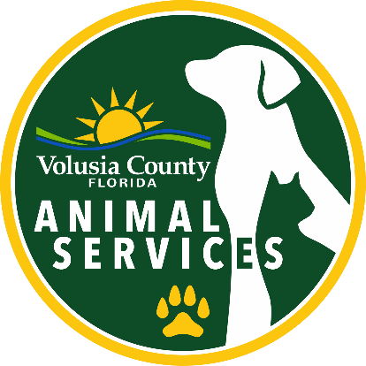
DECLARED
DANGEROUS
DOG LIST

The dogs listed on this site have been declared
dangerous by Volusia County Animal Services.

GUIDELINES USED IN DETERMINING A DANGEROUS DOG

- The dog has:
  - without provocation, aggressively bitten, attacked, or endangered a human being, or has inflicted severe injury on a human being on public or private property; or
  - Has more than once, without provocation, severely injured or killed a domestic animal while off the owner's property; or
  - Has been used primarily, or in part, for the purpose of fighting, or is a dog trained for dog fighting; or
  - Has, without provocation, chased or approached a person upon the streets, sidewalks, or any public grounds in an aggressive, menacing fashion or apparent attitude of attack, provided that such actions are attested to in a sworn statement by one or more persons, and dutifully investigated by the appropriate authority.
- A dog shall not be declared dangerous if the threat, injury, or damage was sustained by a person who, at the time, was unlawfully on the property, or while lawfully on the property, was teasing, tormenting, abusing, or assaulting the dog or its owner or a family member.
- No dog may be declared dangerous if the dog was protecting or defending a human being within the immediate vicinity of the dog from an unjustified attack or assault.

If Animal Services finds sufficient cause to declare a dog "dangerous," the owner is notified in writing. At this point the owner has three options:

- Appeal the notice of sufficient cause to Volusia County Animal Services, which will hold a hearing before the Hearing Officer and either accept or rescind the declaration. If the Hearing Officer accepts the sufficient cause findings, the owner may appeal their decision to the County Court or proceed with option 2 or 3.
- Comply with the Dangerous Dog Restrictions (listed below).
- Surrender the dog to Animal Services.

COMPLYING WITH THE DANGEROUS DOG RESTRICTIONS

To comply with the restrictions, a dog owner must obtain a certificate of registration for the dog from the Animal Services Division. The dog owner must obtain this certificate within 14 days after issuance of the final order classifying the dog as dangerous or the conclusion of any appeal that affirms such final order. The initial registration fee for the dangerous dog shall be $1,500. The owner shall be required to renew the certificate at an annual cost of $500.

To obtain a certificate of registration or a renewal thereof, the owner shall be at least 18 years old and present to the Animal Services Division sufficient evidence of:

- Current certificate of rabies vaccination for the dog

- Proper enclosure to confine a dangerous dog as defined in section 14-42(b)(3)

- Clearly visible warning sign measuring at least 8 1/2" x 11" in size conspicuously placed at all entry points that informs both children and adults of the presence of a dangerous dog on the property

- Permanent identification of the dog by implantation of a microchip

- Spay/neuter certificate from a veterinarian

- Proof of liability insurance for the premises where the dangerous dog shall be securely enclosed in an amount of at least $500,000.00 to cover damages resulting from an attack by the dangerous dog causing bodily injury to a person and provide proof of the required liability insurance coverage to the animal control authority for the area in which the dog is kept. The owner shall name the animal control authority as a certificate holder and notify the animal control authority of any cancellation, modification, expiration or termination of the liability policy required by this section.

- If applicable, a notarized statement shall be submitted to the Animal Services Division by the landlord of the dog owner's premises where the dangerous dog shall be securely enclosed, which states that the landlord is aware of the dangerous dog classification and that the tenant must adhere to additional requirements, posting regulations and insurance requirements.

For more information

For further information on Dangerous Dog laws, please refer to Section 14-42, Code of Ordinances, County of Volusia and Florida State Statute, Chapter 767

The location and appearance of these dogs is provided to inform and educate the public. View Volusia County Registered Dangerous Dogs in a larger map.

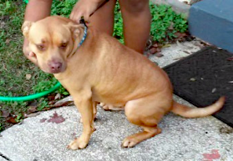 | “KILO”  206 E. Rosehill Ave.  DeLand, FL 37723  Tan  Pitbull  Neutered male  Date Deemed:  4/12/2012 | 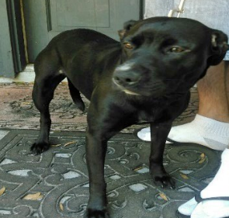 | “L.L.”  2433 Oxford Lane  DeLand, FL 32724  Black and white  Lab mix  Spayed female  Date Deemed:  4/8/2016
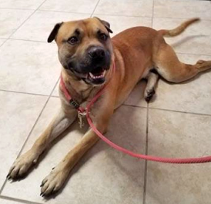 | “DRACO”  384 Center Drive  DeLand, FL 32720  Brown and black  Pitbull mix  Neutered male  Date Deemed:  12/28/2022 | 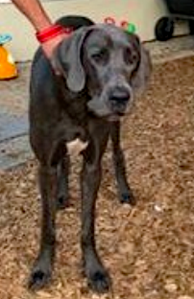 | “BENTLEY”  1073 Roberts St.  Ormond Beach, FL 32174  Blue and white  Great Dane  Neutered male  Date Deemed:  5/25/2022
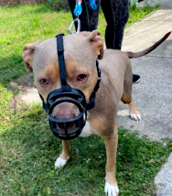 | “KRATOS”  164 Douglas ST  Edgewater, FL 32141  American Bulldog  Tricolor  Neutered male  Date Deemed:  7/11/2022 | 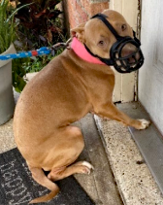 | “GYPSY”  164 Douglas St  Edgewater, FL 32141  American Bulldog  Red and white  Spayed female  Date Deemed:  7/11/2022
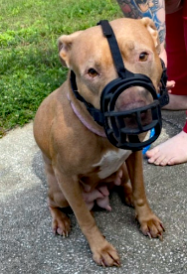 | “KARMA”  164 Douglas ST  Edgewater, Fl 32141  Pitbull mix  Tan and white  Spayed female  Date Deemed:  7/11/2022 | 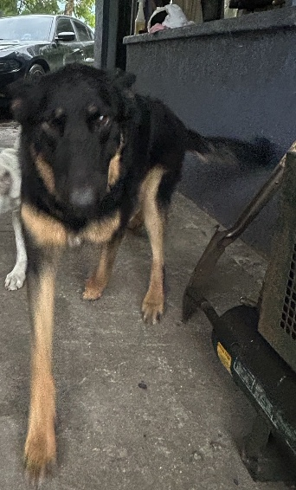 | “BROWLEY”  190 Lake George Rd  Seville, FL 32190  Black/Brown German Shepherd  Neutered Male  Date Deemed: 2/28/2025
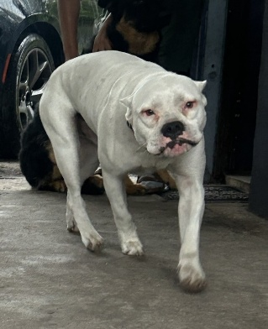 | “BLAZE”  190 Lake George Rd  Seville, FL 32190  White Pitbull  Neutered Male  Date Deemed: 2/28/2025

MISSING
If you have any information regarding the whereabouts of these dogs, please contact Volusia County Animal Services.

