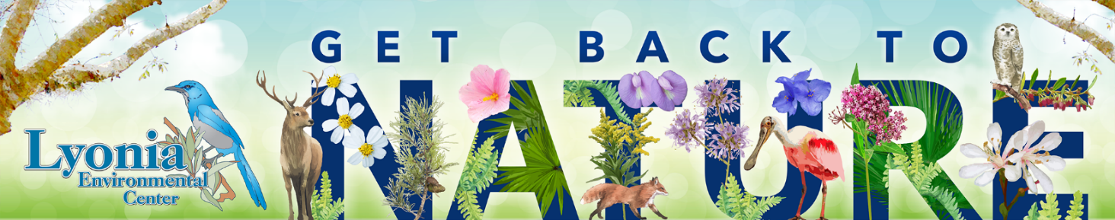

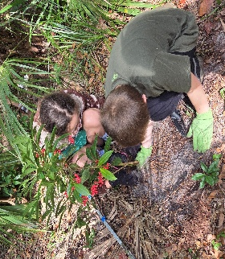
2026-2027 HOME SCHOOL PROGRAM

Join Lyonia Environmental Center
staff for a series of indoor and outdoor homeschool adventures that focus
on Volusia County’s ecosystems, native plants, and wildlife.
ON-SITE PROGRAMS Staff and guests will present these programs in the LEC classroom and Lyonia Preserve. This 360-acre preserve is home to native plants and abundant wildlife, including the Florida scrub jay and gopher tortoise. Wear closed-toe shoes, bring drinking water, and be prepared to hike on sugar sand trails.
PARENTS ARE WELCOME TO ATTEND THE PROGRAM WITH THEIR CHILD OR THEY MAY DROP THEM OFF FOR ON-SITE PROGRAMS.
OFF-SITE PROGRAMS Staff and guests will present these programs at various off-site locations in Volusia County.
PARENTS ARE REQUIRED TO STAY WITH THEIR CHILD FOR ALL OFF-SITE PROGRAMS.
PROGRAM GUIDELINES
Spots are offered on a first-come, first-served basis and are secure once payment has been made. Programs may be modified at any time as needed.
REGISTRATION AND PRE-PAYMENT ARE REQUIRED. NO WALK-INS PERMITTED.
Cost: $8 per child per program. Programs are limited to one free adult per family
Cancellation policy: Full refund with 2-week notice given.
To register or for more information call 386-789-7207, ext. #21026 or email Shari Smith, Education Program Coordinator at ssmith@volusia.gov or email Alexandra Hemme, Education Program assistant at ahemme@volusia.gov
Lyonia Environmental Center
2150 Eustace Ave.. Deltona, FL 32720
386-789-7207, ext. #21028
www.LyoniaPreserve.com

INVASIVES OUT, NATIVES IN
Grades 1-9 10:00 a.m. – noon Wed., October 7, 2026
Lake Ashby Park
4150 Boy Scout Camp Rd
New Smyrna Beach

OUTDOOR: Discover the importance of protecting local ecosystems by learning about native and invasive plants. Participants will help remove non-native invasive species and plant native vegetation, gaining hands-on experience while making a positive impact on local wildlife and habitats. This interactive program encourages environmental stewardship and teaches how small actions can make a big difference for nature. Wear closed-toed shoes, bring water, bug spray and gloves.

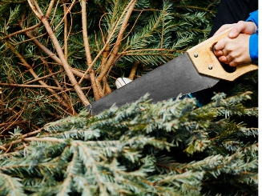
GIFTS FROM NATURE

Grades 1-9

10:00 a.m. - noon
Wed., December 2, 2026

Lyonia Environmental Center 2150 Eustace Avenue Deltona
INDOOR/OUTDOOR: Help restore Florida’s unique scrub habitat while learning why removing young sand pines benefits this threatened ecosystem. Participants will take part in a hands-on habitat restoration project by helping remove young sand pines and will have the opportunity to take a tree home. Participants will also create two unique upcycled ornaments to decorate

their tree. Wear closed-toed shoes and bring water and gloves.
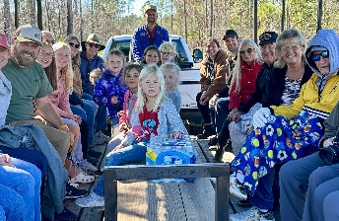

NIGHT ECO BUGGY
Grades 1-9
5:30-8:00 p.m.
Wed., January 6, 2027

Deep Creek Preserve
946 State Rte 415
New Smyrna Beach
Dropped Pin in New Smyrna Beach, FL United States - Apple Maps

OUTDOOR: Climb aboard the eco-buggy and discover what creatures lurk in the night at Deep Creek Preserve! Environmental Specialist, Tommy Nordmann will discuss the myths and facts of some of the nocturnal animals, including owls and bats, found in Volusia County. Afterwards, we’ll have s’mores by the fire at the Deep Creek campsite. Wear closed-toed shoes and bring water, bug spray, and a flashlight.

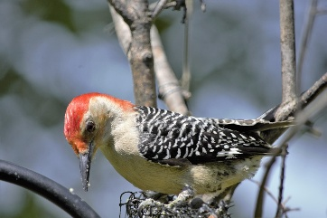

LOVE THE SCRUB

Grades 1-9

10:00 a.m. - noon
Wed., February 03, 2027

Lyonia Environmental Center 2150 Eustace Avenue Deltona

INDOOR/OUTDOOR: Discover the amazing journey of migratory birds during a guided hike through the preserve and explore the habitat these birds depend on. After the hike, participants will make their own suet bird feeder to take home. This hands-on program combines outdoor exploration, wildlife education, and a fun take-home project that encourages continued birdwatching at home. Wear closed-toed shoes and bring water.
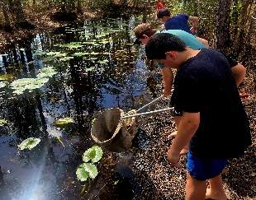
CREATURES OF THE CANAL (EcoBuggy)
Grades 1-9
10:00 a.m. - noon
Wed., April 7, 2027

Longleaf Pine Preserve
4551 Pioneer Trail
New Smyrna Beach
Dropped Pin in New Smyrna Beach, FL United States - Apple Maps

OUTDOOR: Take a ride on the eco-buggy to experience the wonders of Longleaf Pine Preserve, one of Volusia County’s conservation lands. Conservation efforts, land management practices and the agricultural history of the preserve are a few of the topics we’ll be discussing. Explore aquatic life as we use dip nets to collect and examine species found in a freshwater canal. Wear closed-toed shoes that can get wet and bring water and bug spray.

