PART II - CODE OF ORDINANCES Chapter 72 - LAND PLANNING
ARTICLE III. - LAND DEVELOPMENT REGULATIONS
DIVISION 4. DESIGN AND CONSTRUCTION STANDARDS OF IMPROVEMENTS

DIVISION 4. DESIGN AND CONSTRUCTION STANDARDS OF IMPROVEMENTS¹

Sec. 72-611. General design criteria.
- Use of natural features. The arrangement of structures, buildings, lots, blocks and traffic circulation systems and retention areas shall make the most advantageous use of topography, trees and other natural features.
- Consideration of soil and flood hazards. A development order shall not be approved unless all land intended for use as building sites can be used safely for building purposes without danger from flood or other inundation or from adverse soil or foundation conditions or from any other menace to health, safety or public welfare. Lands shall not be subdivided and/or developed until proper provisions are made for protective flood control measures and water management facilities necessary for flood-free development and flood-free vehicular access to such sites. It is the intent of this provision that no filling or grade level change will be permitted which will cause adverse drainage, or public health or public safety impacts to any surrounding area.
The "County of Volusia Soil Survey" and any supplements thereto shall be used as a guideline in identifying soil properties, and for interpretations for various uses in terms of soil limitations and soil features adversely affecting a particular use. In addition, the "soil supplement and vegetative analysis" or supplemental soil borings are to be used in interpreting the basic properties of the soils in terms of their potential for a particular use.
- Finished floor elevation, utility lines and special considerations. No development shall be approved that does not contain a suitable building site of sufficient elevation to permit construction utilizing a first floor elevation based upon the following:
  - At least one foot above the 100-year flood-prone elevation, as determined by the CDE based upon the best available data. Where the floodplain of any stream or river is defined, development shall be approved only if all parts of the platted lots located within the floodway are expressly limited to open space uses. On-site drainage storage capacity shall be in conformance with division 8.
  - Provided that building lots are a reasonable level or slope toward a street, road or right-of-way, the minimum finished floor elevation of any structure shall not be less than 12 inches above the lowest crown of that portion of any adjacent street, road or right-of-way. On lots which slope away from a street or road with continuous slope toward a lake, stream or water collection area and where positive drainage exists, the finished floor elevation of any structure, including garage areas, shall not be less than 12 inches above finished site grade measured at the highest contour that abuts the building

¹Editor's note(s)—Section XXVIII of Ord. No. 96-32, adopted Dec. 19, 1996, repealed art. IV in its entirety. Formerly, art. IV pertained to design and construction standards of improvement and derived from § I of Ord. No. 89- 26, adopted June 1, 1989; §§ II—V of Ord. No. 90-4, adopted Jan. 18, 1990; §§ XXIV—XXVI, XXXVII—XL, XLI, XLII, XLIII—XLVI, XLVII and XLVIII of Ord. No. 90-33, adopted Sept. 27, 1990; §§ 47—60 of Ord. No. 94-2,
adopted April 7, 1994. Section XXVIII also added a new art. IV as herein set out, which has been renamed div. 4 by Ord. No. 2008-25, § III, adopted Dec. 4, 2008.
Code references—Fire prevention and protection, ch. 54; roads and bridges, ch. 94; utilities, ch. 122.
Special acts reference—Roads and bridges, ch. 222.

unless specifically approved by the CDE and the DRC. Where necessary, swales shall be constructed to divert runoff water around any structure so as to not adversely impact adjacent property owners.
  - Driveways or other areas of access to a building or structure shall be sloped so as to prevent the runoff of surface water into any building or structure, including garage and carport areas.
  - Utility lines including, but not limited to, electric power and light, telephone and telegraph, cable television, water, sewer and gas, shall be constructed and installed beneath the surface of the ground unless it is determined by the DRC that soil, topographical or any other compelling conditions make the underground installation of such utility lines unreasonable and impracticable. The underground installation of bulk electric power supply lines, including but not limited to, transmission lines and primary distribution feeder lines, shall not be required.
  - Special considerations shall be given in the layout of streets, lots, blocks, buildings and easements to the preservation of large and specimen individual trees; to preserving natural drainage methods and natural topography and landscape; and to providing screening, buffers or berms where developments abut noncompatible land uses.
- Monuments. Permanent survey reference monuments shall be installed in all subdivisions and condominium plats in accordance with F.S. ch. 177, as amended. Additional monuments such as along rear lot lines which do not abut the subdivision boundary may be required by the county registered land surveyor.
  - At least one corner of a development shall be designated by course and distance (tie) from a readily discernible reference marker such as a U.S. Government marker, section corner, or quarter-section corner. When such a monument or corner is not available, the tie shall be made to some permanent and readily recognizable landmark or identifiable point, physical object or structure, excluding trees.
  - At least two monuments shall be installed as control corners within each block within the plat. The surveyor shall install additional monuments, if required by the county registered land surveyor, prior to final plat approval. All monuments shall be constructed of concrete and shall be at least four inches in diameter or square, and not less than two feet in length. Each monument shall have imbedded in its top or attached by a suitable means a metal plate of noncorrosive material marked plainly with the point, the surveyor's registration number, and the words "Permanent Reference Monument" or the initials "P.R.M." Monuments shall be set in the ground so that the top is flush with the finish grade.
  - Property markers shall be installed in accordance with F.S. ch. 177, as amended.
- Impervious area and stormwater runoff.
  - The area covered by structures and impervious surface shall not exceed 80 percent for any lot.
    - Pervious areas may be used to satisfy requirements for landscaping and setbacks, buffer strips, drain fields, passive recreation areas, or any other purpose that does not require covering with a material that prevents infiltration of water into the ground.
    - In the case of the use of an impervious material which does not cover all the surface to which it is applied, credit towards the computation of the pervious area shall be given according to the amount of percolation that is permitted.
    - Parking areas, whether paved with impervious material or not, shall be onsidered impervious. (Ord. No. 96-32, § XXVIII, 12-19-96; Ord. No. 2008-25, § III, 12-4-08)

Sec. 72-612. Streets.
- General requirements for paved and unpaved streets. All proposed lots or developments, except as provided in section 72-547 (Conservation subdivisions), and 72-548 (Unpaved road subdivisions), or for utilities such as cable substations, communication towers, etc., shall front on a paved street. Primary access to a subdivision or development shall be from a street paved to the standards of this section. This street, if not already paved, shall be paved by the developer from the entrance of the development to the nearest public paved street. The character, width, grade and location of all streets shall conform to the standards in this section and shall be considered in their relation to existing and planned streets, to topographical conditions, to public convenience and safety, and in their appropriate relation to the proposed uses of the land to be served by such streets. Construction and material specifications for streets shall conform to "FDOT Standard Specifications for Road and Bridge Construction," except as otherwise may be stated herein or depicted below:

TYPICAL ROADWAY SECTIONS
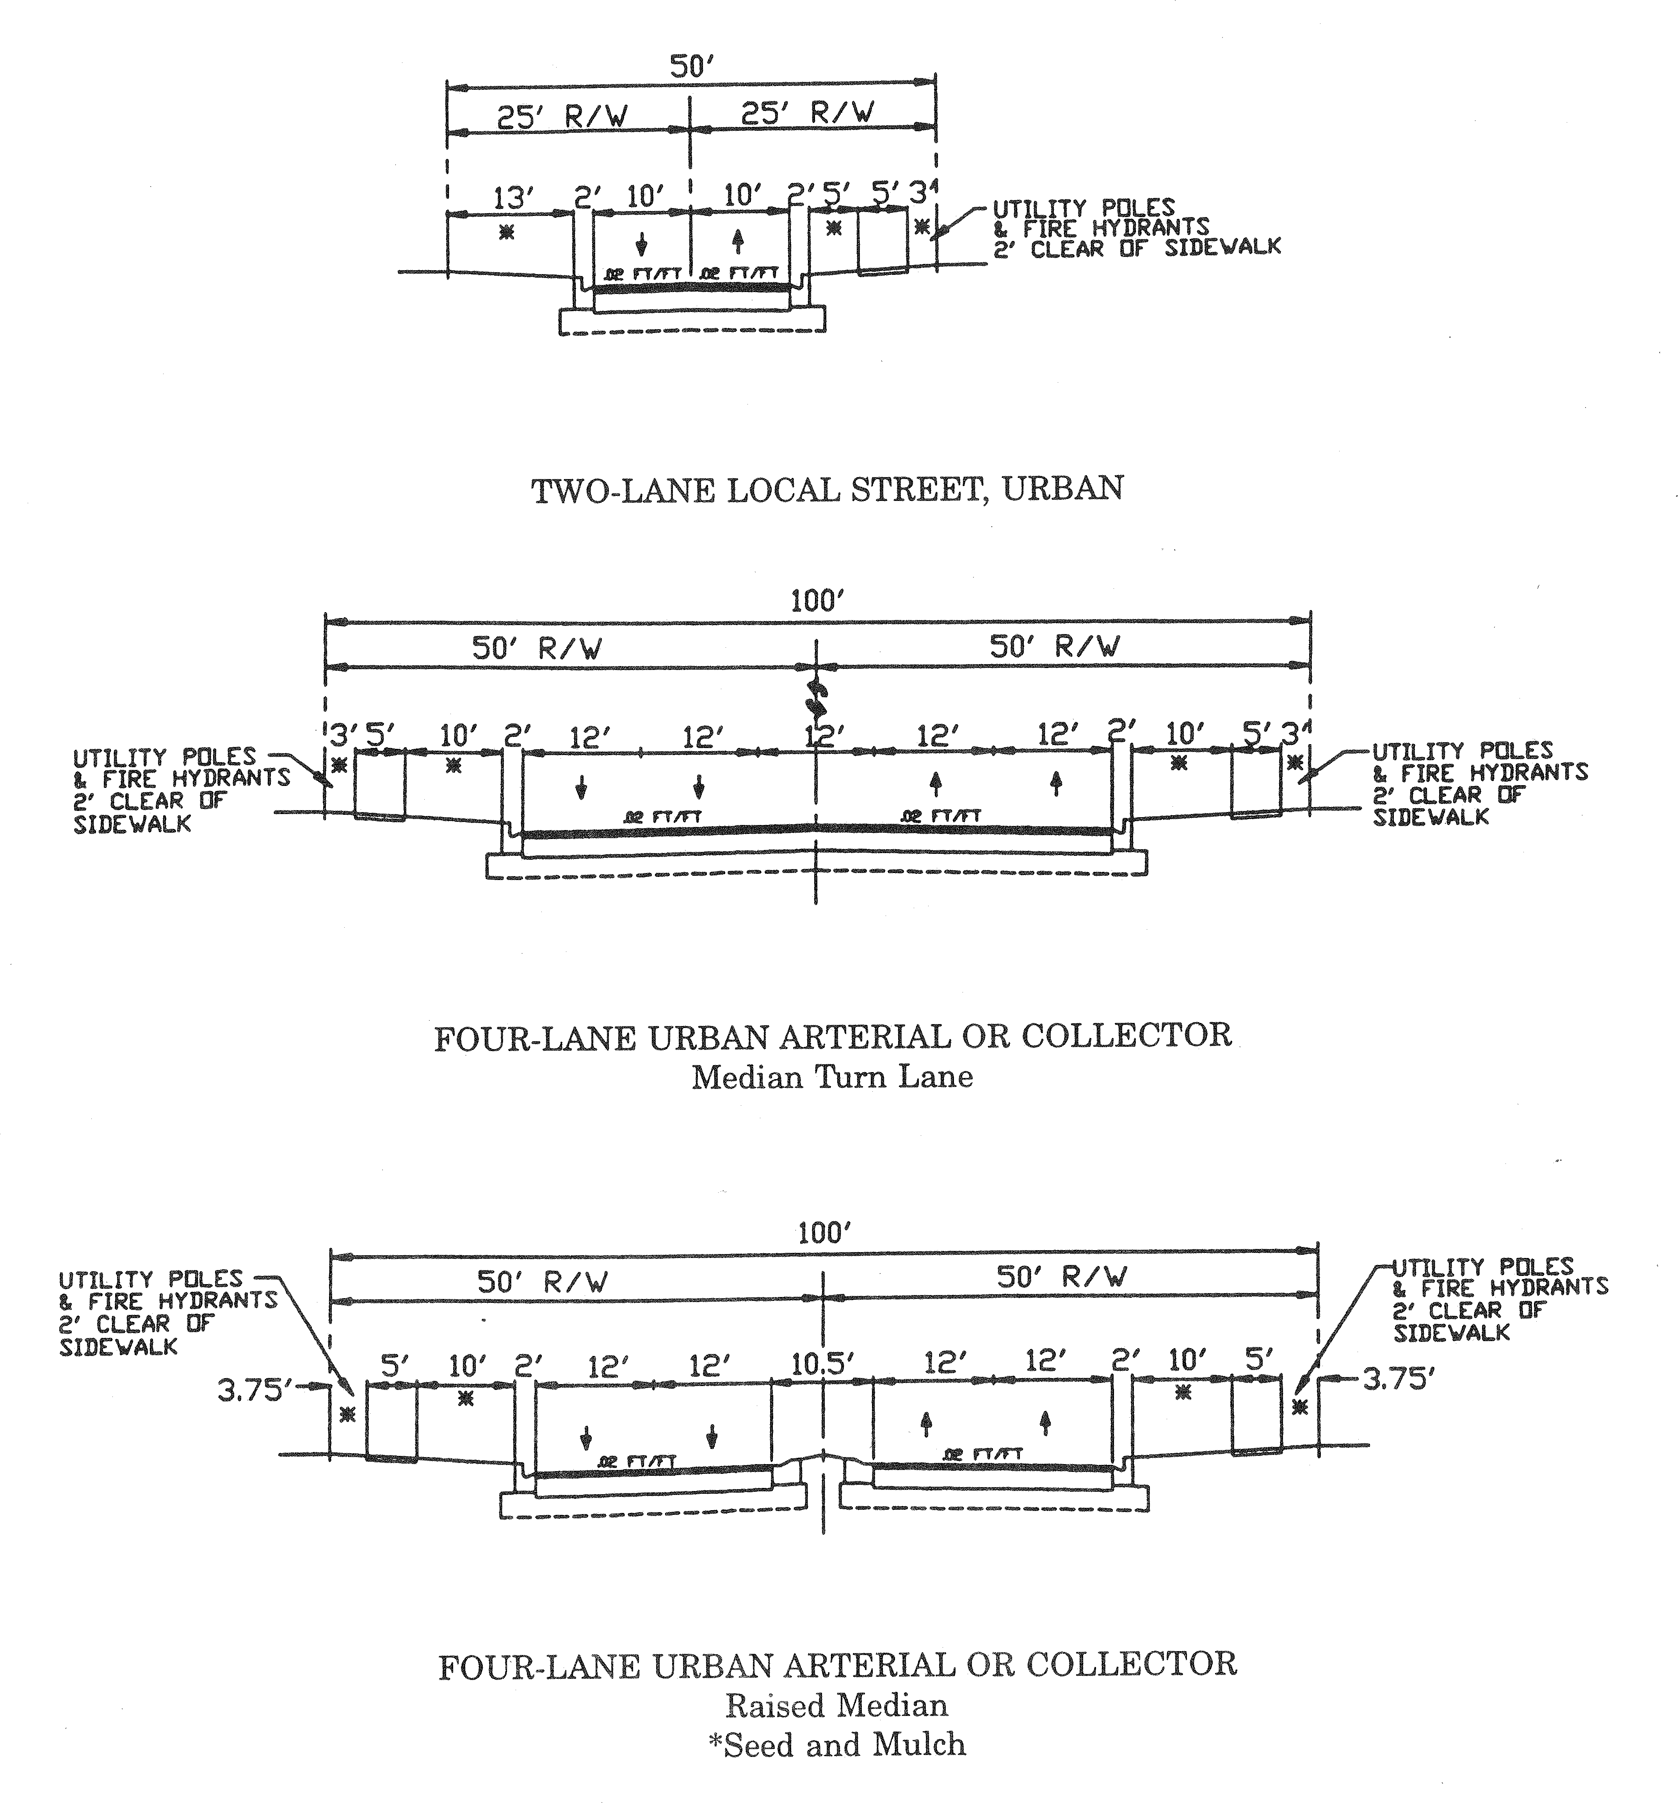

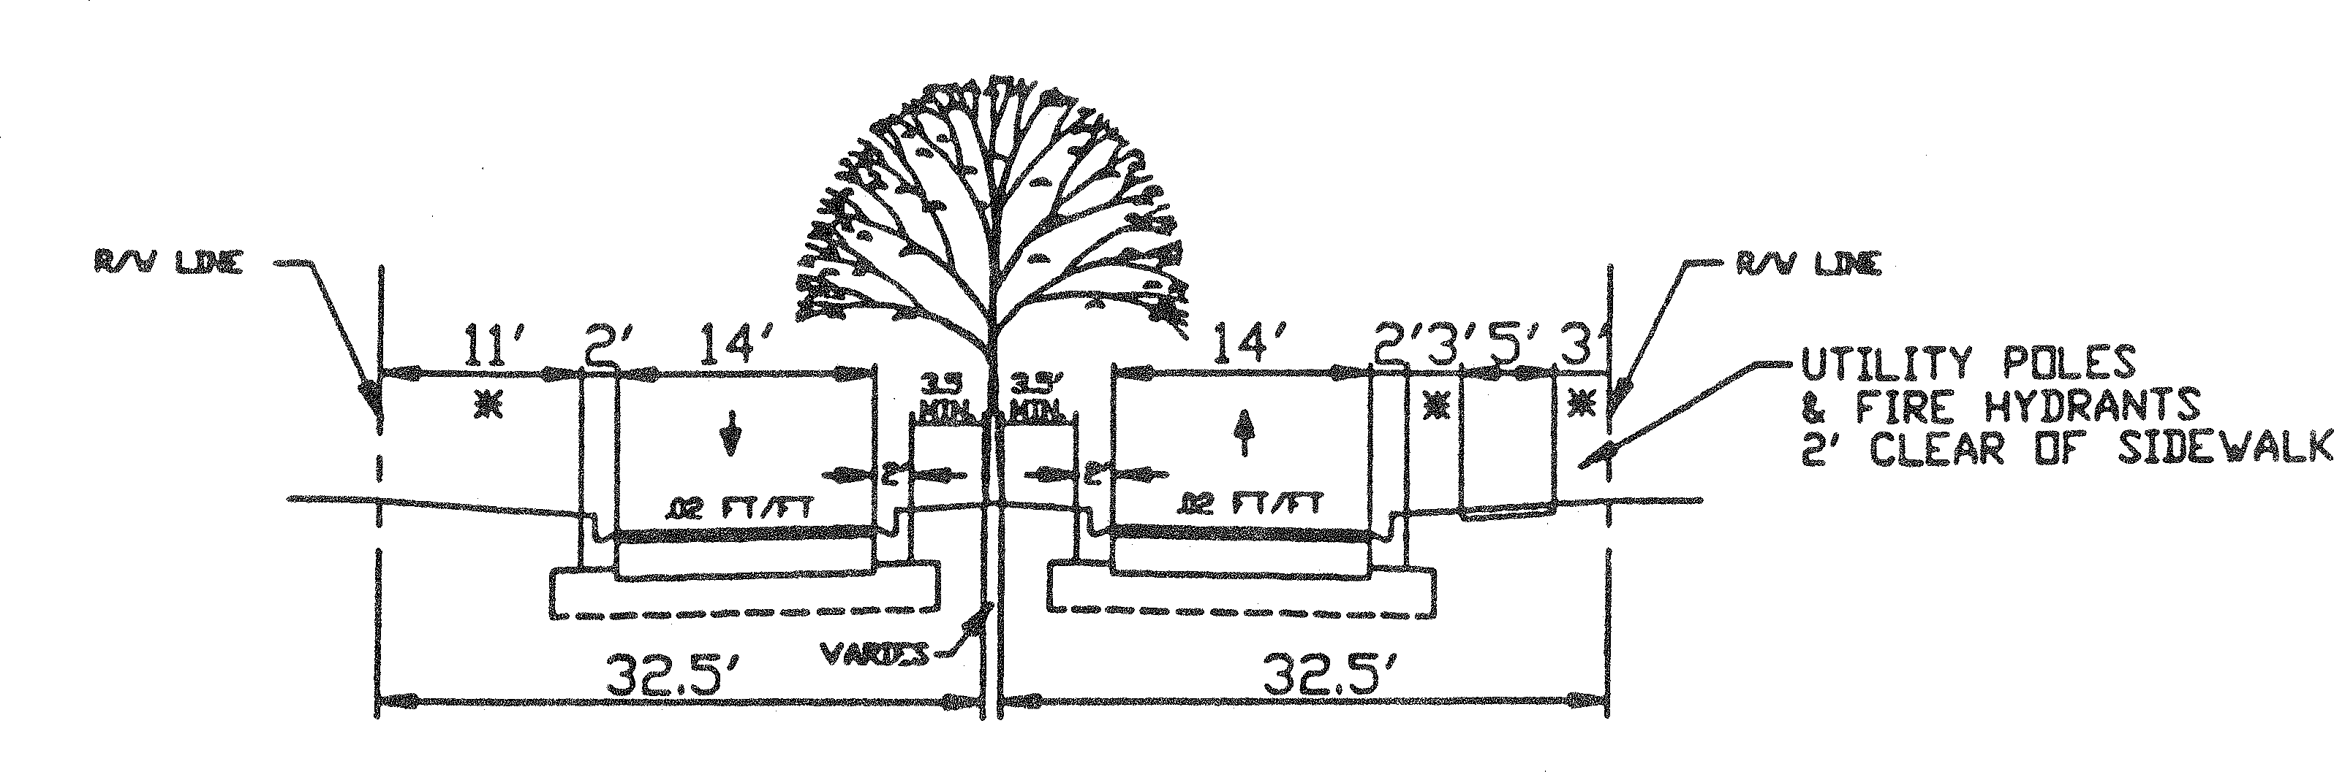

TWO LANE LOCAL STREET URBAN, WITH ISLAND SEPARATOR
Note: Minimum width of island is 4′ without obstructions [such as posts & trees, etc.]
*Seed and Mulch

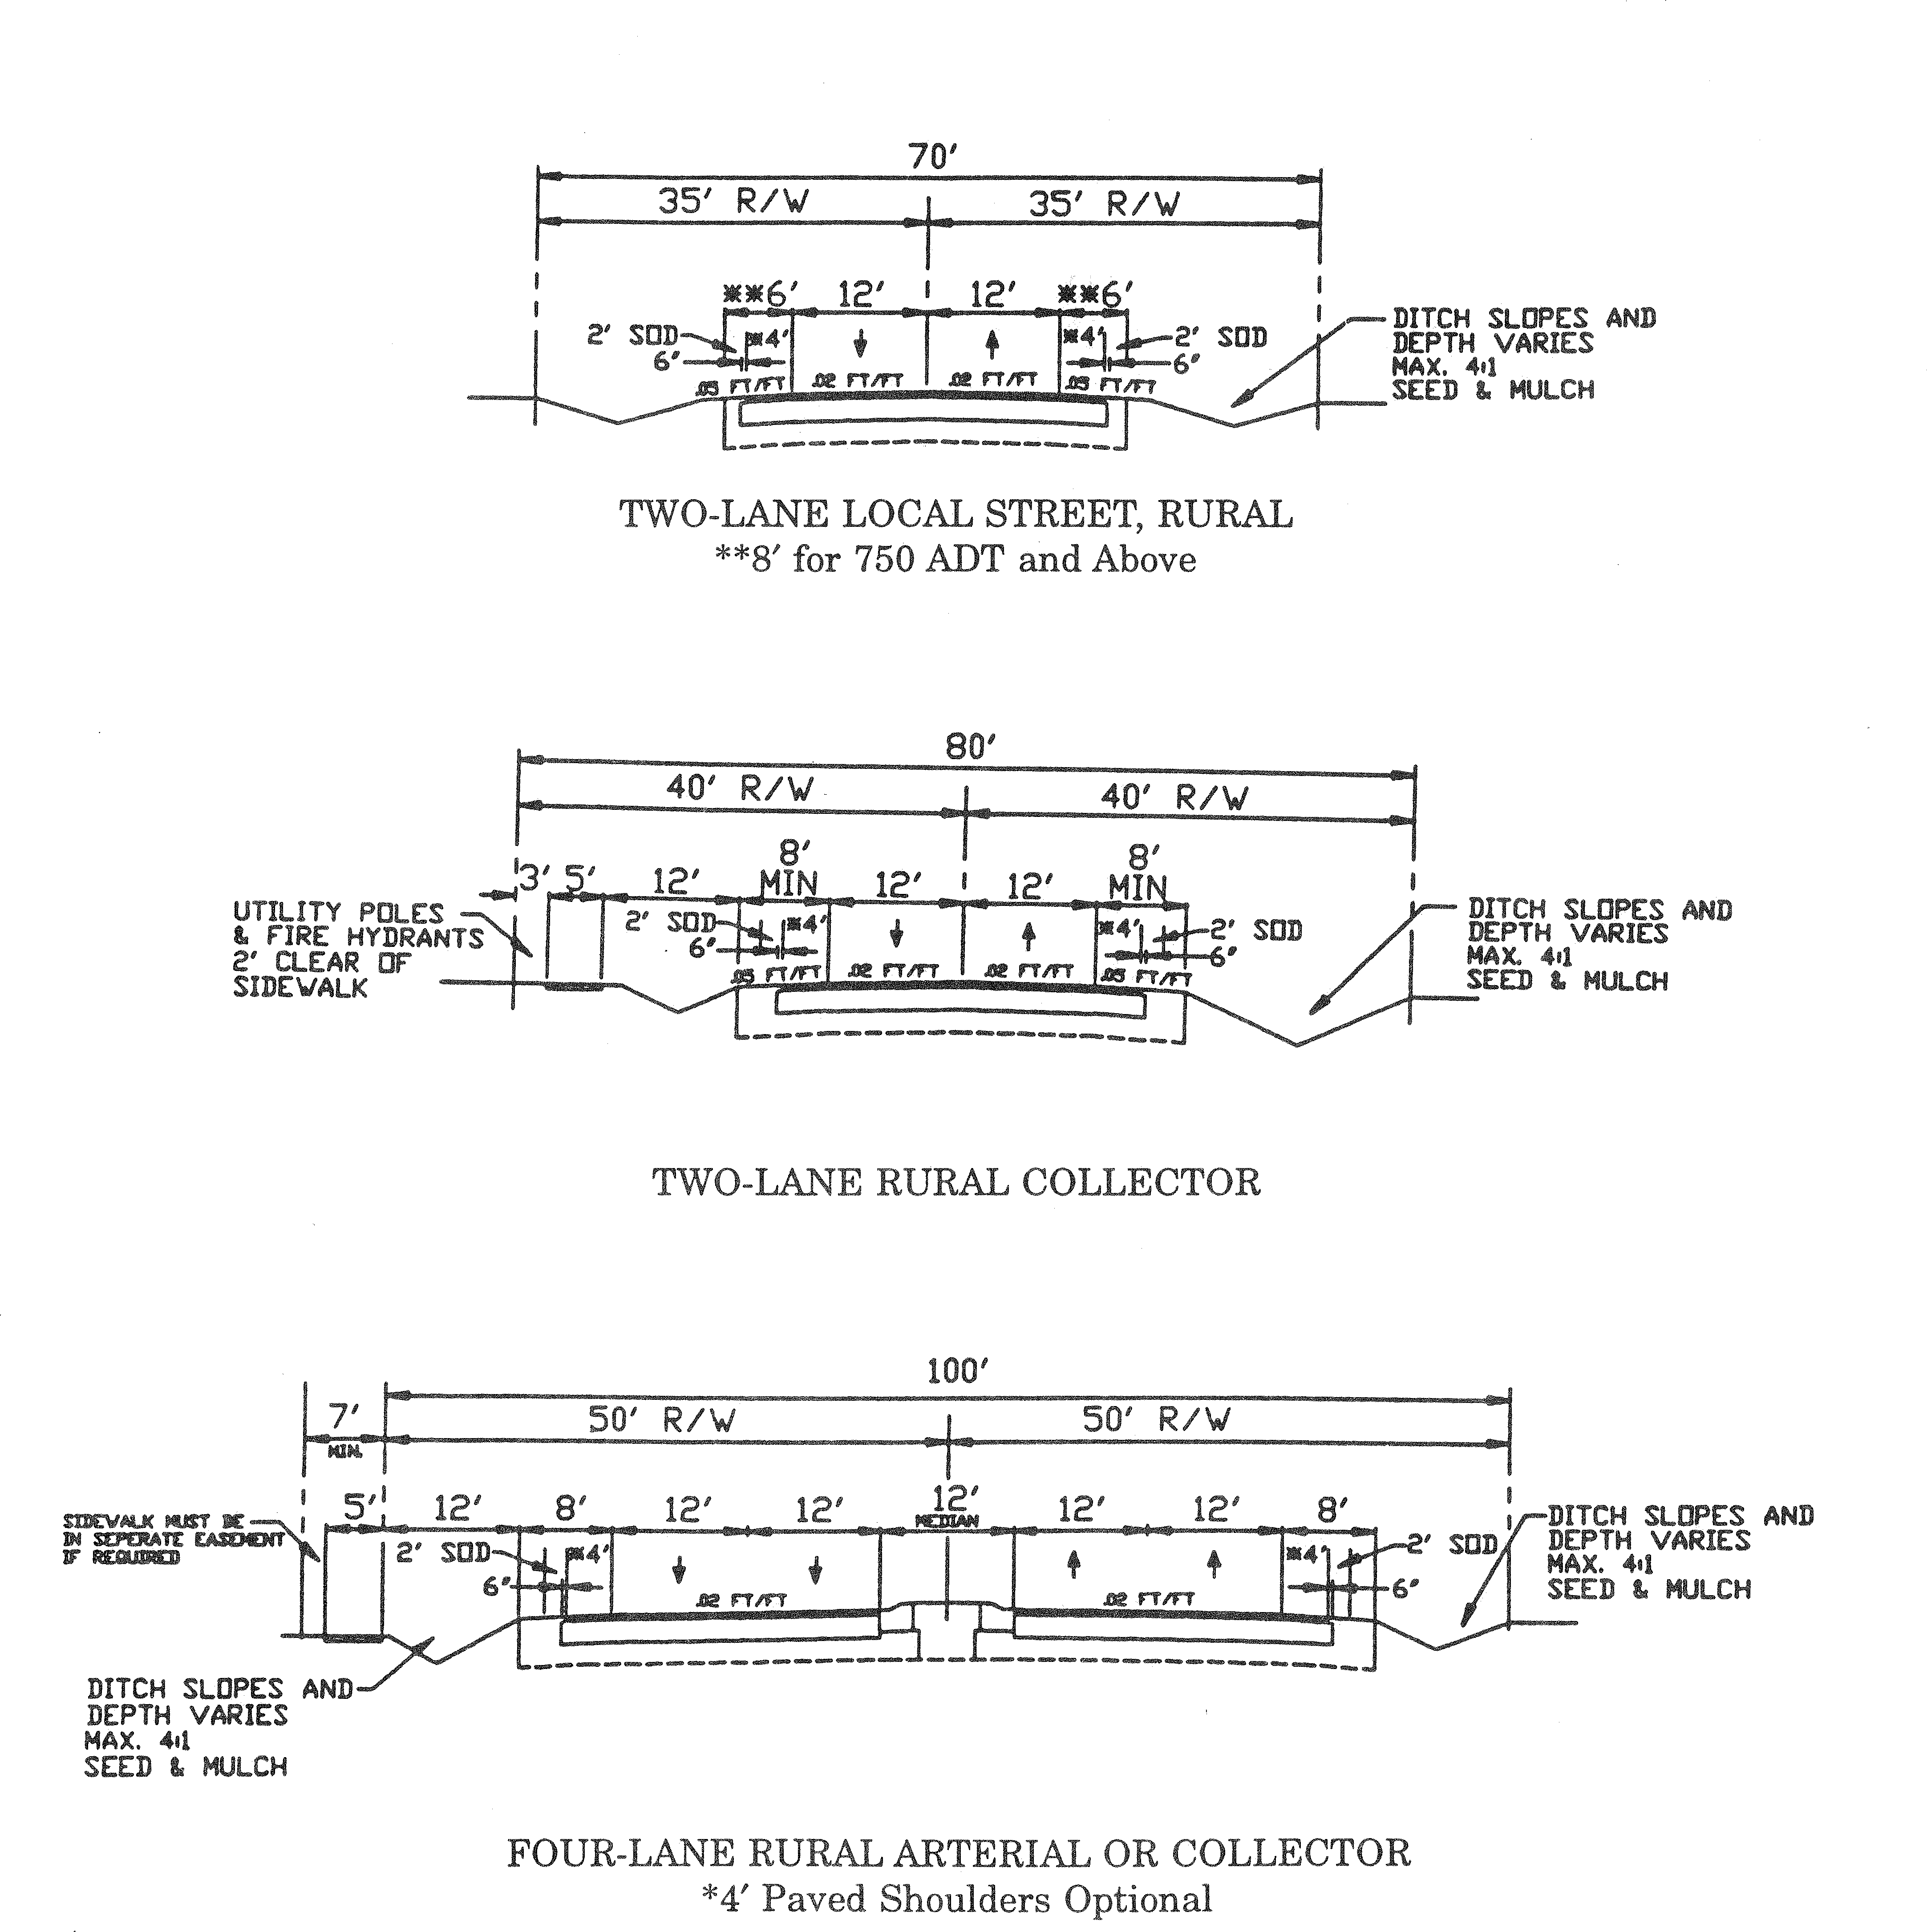
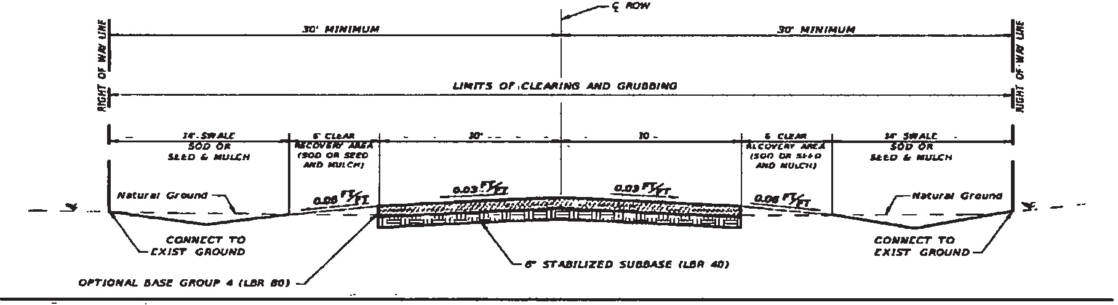

Notes:
UNPAVED PRIVATE ROAD TYPICAL SECTION
Design Speed 30 MPH

Optional base group 4 (LBR 80)
6" Stabilized subbase (LBR 40)
(FDOT Design Standards latest edition or base approved by CDE)
Optional base group 4
4" Type B 12.5 Reclaimed asphalt pavement 6" Graded aggregate including gravel and rock 9" Sand clay mix
6" Cemented coquina
6" Limerock - including #57 stone
The stabilized subbase may be replaced by a 2-inch increase in the depth of the base. The road elevation shall be a minimum of one foot above the 100-year floodplain.
  - Thoroughfares in developments should be planned in conformity with chapter 2, the traffic circulation element of the comprehensive plan.
  - All newly platted streets intended to serve residential uses shall be public except for private unpaved roads approved under section 72-547 (Conservation subdivisions) or section 72-548 (Unpaved road subdivisions). The DRC may also recommend and the county council may approve private streets for security purposes only, provided all such streets meet all design and construction criteria of this article, a permanent security post or posts are provided, and a condominium or homeowners association is created with all duties and powers necessary to ensure perpetual maintenance of such private streets. All streets shall be constructed to the exterior property lines of the development unless they are permanently terminated by a cul-de-sac or an intersection with another street.
  - Newly platted streets intended to serve business or industrial uses may be private if approved by the DRC. In such cases, all streets shall meet the design and construction criteria of this article unless overriding conditions, such as sharing entrances or parking areas, require different design criteria.
  - Design and construction standards:
    - Street capacities shall be determined by the standards established by the "Transportation Research Board Highway Capacity Manual".
    - The geometric design of streets shall conform to the minimum standards established by the "FDOT Minimum Standards for Streets and Highways", except where changes are specified herein.
    - The construction of streets and work in the public right-of-way shall conform to the "FDOT Standard Specifications for Road and Bridge Construction", except where changes are specified herein.
    - The determination of traffic generation rates for a particular development shall conform to the latest edition of the "ITE Trip Generation Manual", unless otherwise approved by the county traffic engineer (CTE).
    - Obstruction to visibility. At the intersection of any streets, no obstruction of any kind shall block the visibility of motorists between 30 inches and ten feet above the centerline grades of those intersecting streets within a triangular area of horizontal configuration as depicted in the "FDOT Roadway and Traffic Designs Standards Index No. 546", or as amended.
- Traffic impact analysis. Unless waived by the DRC, the developer at his/her expense shall have a registered professional engineer qualified in traffic engineering prepare and provide the county with a traffic impact

analysis when trip ends generated by the proposed development equal or exceed 1,000 trip ends per day, as determined from the "ITE Trip Generation Manual", or when determined to be necessary by the DRC, if less than 1,000 trip ends per day. The traffic impact analysis shall be submitted at the time of ODP or FSP review, and shall provide the following findings and appropriate methodologies utilized in determining the findings:
  - Total projected average daily trip ends for the proposed development;
  - Design capacity of the accessed street(s);
  - Average projected peak-hour trip ends generated by the development;
  - Analysis of projected on- and off-site traffic patterns and turning movements;
  - Projected percentage of truck and bus traffic;
  - Other related information as required by the DRC.
- Arrangement of streets. The arrangement of streets in a development shall:
  - Provide efficient and orderly hierarchy of streets;
  - Conform with official plans and maps of County of Volusia;
  - Be integrated with the existing and planned street system of the surrounding area in a manner which is not detrimental to existing neighborhoods;
  - Be such that the use of local streets by through or commercial traffic is discouraged;
  - When necessary, as determined by the DRC, provide at least two separate and remote entrances to a development, unless other provisions, such as easements, are made for emergency ingress and egress, and provided that such entrances will not adversely affect the overall street system;
  - Facilitate and coordinate with the desirable future development of adjoining property of a similar character and provide for local circulation and convenient access to neighborhood facilities;
  - Local streets shall be patterned in such a way that continuous traffic from one collector to another collector is discouraged.
- Intersections. Street intersections shall be laid out as follows:
  - Streets shall intersect at an angle of 90 degrees, unless circumstances acceptable to the DRC indicate a need for a lesser angle of intersection.
  - Spacing of street intersections.
    - A collector may intersect an arterial, but only if aligned with and extending an existing collector which intersects the arterial, or at a minimum distance of 1,320 feet from the intersection of an existing collector and the arterial.
    - A local street shall not intersect an arterial unless unavoidable, in which case the local street may intersect an arterial, but only if aligned with and extending an existing local street which intersects the arterial, or at a minimum distance of 660 feet from any other intersection of the arterial.
    - A collector may intersect another collector, but only if aligned with and extending an existing collector, or at a minimum distance of 660 feet from any other intersection.
    - A local street may intersect a collector if spaced at a minimum distance of 660 feet from any other intersection or, in the case of a T-type intersection, at a minimum distance of 330 feet from any other intersection.

    - The minimum spacing requirements of this section may be reduced upon a finding by the DRC that, given the particular conditions of the proposed development, such reduction will not compromise operational and safety standards or cause undo hardship.
  - Property lines at street intersections shall be rounded with a minimum radius of 25 feet. A greater radius shall be required for angles of intersections less than 90 degrees.
  - If required by the CDE, the right-of-way width and pavement width shall be increased by at least ten feet on each side of an arterial street for a minimum distance of 150 feet from its intersection with another arterial street or thoroughfare, to permit proper intersection design.
- Minimum right-of-way and pavement widths. New street minimum rights-of-way and pavement widths shall be as set forth in Tables II and III.
- Additional right-of-way and/or pavement widths.
  - Additional right-of-way shall be required for public safety and convenience, or to assure adequate access, circulation, parking and to provide turn lanes on any public road. Further, additional right-of- way may be required on existing or proposed thoroughfares if such thoroughfares are within the capital improvements element of the comprehensive plan.
  - The thoroughfares shown on the thoroughfare system maps in chapter 2 of the traffic circulation element of the Comprehensive Plan of Volusia County or the jurisdiction in which the roads are located, which are either located within or provide primary access as provided in subsection (f)(1) above, shall be conveyed or dedicated to the public by deed, or if acceptable to the county or other appropriate jurisdiction, by grant of easement.
  - Half streets shall be prohibited. Where a previously dedicated half street, paved or unpaved, abuts or is within a tract to be developed, the second half of the street shall be dedicated to the county and the full width shall be paved by the developer where the subject street is necessary for the development of the subdivision or overall traffic circulation.
  - Additional right-of-way required at intersections. For the installation of traffic-control equipment, a chord based on a 30-foot radius curve at the intersection of the right-of-way lines, shall be provided at each thoroughfare intersection, and the area between the chord and the tangents of the intersecting streets shall be dedicated or, if acceptable to the county, granted by easement.
- Access to development.
  - Every lot or parcel shall have access from a publicly dedicated street, except as otherwise provided in subsection (a) of this section.
  - Where development borders on or contains a right-of-way for a railroad, expressway, interstate highway, drainage canal or waterway, a street may be required approximately parallel to and on each side of such right-of-way, at a distance suitable for the appropriate use of the intervening land and in compliance with all provisions of this article.
  - Reserve strips controlling access to streets shall be prohibited, unless dedicated to the public.
  - Median openings. To assure traffic safety, capacity and control, median openings located on a thoroughfare shall be spaced the maximum distance apart that will allow safe and adequate traffic circulation.
    - Location.
      - No median opening shall be spaced at a distance less than 660 feet from any other median opening unless specifically approved by the CTE on a finding that, given the particular

conditions of the proposed development, such determination will not compromise traffic operational and safety standards.
      - Dedicated public streets are given priority consideration for median openings.
    - Design criteria.
      - All median openings shall include at least 105 feet storage with 50 feet transition, unless otherwise acceptable by the CTE. Increased storage and transition lengths may be required to eliminate disruption of through-traffic flow.
      - Final design of median openings shall be approved by the CTE.
- Street jogs. Street jogs or centerline offsets between streets shall be no less than 150 feet.
- Culs-de-sac. Cul-de-sac length shall be determined in the following manner: Twenty × typical lot width, with a maximum of 2,000 feet. Paved turnarounds shall be provided. In the center of the turnaround, an unpaved island, surrounded by a curb, improved with grass and landscaping that will not interfere with sight distance, may be provided. Center islands shall have a diameter of 17 feet.
- Street grade. Minimum centerline grade for all streets with curb and gutter shall be 0.2 of one percent. Maximum centerline grades for streets range from three to eight percent depending on type and design speed and shall meet the recommended maximum grades in the FDOT "Green Book". The centerline may be flat for all swale sections provided the swale grade is a minimum of 0.2 of one percent.
- Minimum street elevation. New streets shall be designed flood-free so as not to submerge, based on foreseeable flood stages. Generally, the minimum street centerline elevation shall be one foot above known or estimated flood stages of natural or manmade water bodies. Where flood stage recovery is expected to occur in less than one day (such as water sheds with positive outfall or tidal flood areas), the lowest edge of pavement elevation may be at the flood stage.
- Street names. Proposed streets which are obviously in alignment with other existing or approved named streets shall have the same name as the existing or approved streets. In no other case shall the name of a proposed street duplicate or be phonetically similar to existing or approved street names, irrespective of the use of alternative suffixes, such as "street", "avenue", "boulevard", "drive", "place", "court", etc. Circle or loop streets shall bear the same name throughout. All street names shall require the approval of the department.
- Streetlights. All proposed urban development shall provide for street lighting installation. A petition for creation of a special assessment district for street lighting shall be submitted in accordance with the provisions of chapter 110, article II, Code of Ordinances.
  - Installation of street lighting.
Arterials. Lighting units of 22,000 lumen along arterials must be spaced 100 feet to 150 feet on alternate sides of the street. All intersections must be provided with street lighting.
Collectors. Lighting units of 16,000 lumen along collectors must be spaced 200 feet to 250 feet on alternate sides of the roadway. All intersections must be provided with street lighting.
Locals. New streetlights of 9,500 lumen on local streets must be provided at intersections or at points along the street such as sharp curves or existing overlength culs-de-sac where streetlights would decrease the potential for accidents.
  - Installation procedures. Proposed street lighting along all public rights-of-way must be coordinated through the county. Streetlight installation orders are issued by the county department of public works to initiate the process and must be requested by the developer through the county as soon as street

construction plans are complete. All costs for new street lighting on public streets must be paid for by the developer.
- Curbs and gutters:
  - General. Except for rural developments, all streets shall be drained utilizing curb-and-gutter construction unless otherwise waived by the CDE.
  - Width and permitted types. The width of curb and gutter shall be a minimum of 24 inches and shall be either Florida State DOT-type or Miami curb and gutter, depending upon the flow to be handled. Environmental curb or a minimum 18-inch wide curb surrounding medians may be permitted by the DRC in developments where soil types and/or topography indicate this method to be preferable. All curbs designed to handle water shall incorporate an approved gutter design. There shall be a stabilized subgrade beneath all curbs and one foot beyond the back of curbs. No water valve boxes, meters, portions of manholes, or other appurtenances of any kind relating to any underground utilities shall be located in any portion of a curb and gutter section.
  - Minimum grades. The minimum allowable flow line grade of curbs and gutters shall be 0.2 of one percent, except in intersections where flatter grades shall be allowable. The tolerance for ponded water in curb construction is one-fourth-inch maximum.
  - Other requirements.
    - Plastering shall not be permitted on the face of the curb.
    - Joints shall be provided at intervals of ten feet, except where shorter intervals are required for closures, but in no case less than four feet.
    - No raised portion of any type of curb shall be constructed closer than 12 feet from the pavement edge of an intersecting road without curbs. After concrete has set sufficiently, but in no case later than three days after construction, the curbs shall be backfilled.
    - All cross-street valley gutters shall be constructed of concrete.
- Street construction specifications.
  - Clearing and grubbing of rights-of-way. The developer shall clear all traveled ways and recovery areas according to the "FDOT Standard Specifications for Road and Bridge Construction". Trees may be selectively cleared outside of the recovery area to accommodate the installation of the drainage, water and sewer systems, or any other utilities. Any such tree removal shall be in accordance with the requirements of division 10. All debris shall be removed by the developer from rights-of-way after construction.
  - Paving.
    - All paving shall be done in accordance with "FDOT Standard Specifications for Road and Bridge Construction" and "FDOT Roadway and Traffic Design Standards", except where changes are specified herein.
    - All unstable materials such as muck, peat, plastic clays or marls shall be removed from roadbed areas. The areas then shall be backfilled with suitable material, and the subgrade stabilized to a depth below the base as shown in Table I. Stabilization shall be to 75 pounds per square inch, Florida bearing value, for soils stabilized with clay, marl or other plastic-type materials and to 40 percent limerock bearing ratio for soils stabilized with shell, concrete screenings or other granular materials. The materials to be added for stabilization, if needed, shall be either high- bearing soil, sand clay, ground lime rock, or any other suitable material. (Muck shall not be used.) For rural sections, subgrade shall be stabilized to include the entire width of both shoulders to a depth of six inches. Where curb and gutter is utilized, subgrade shall be stabilized underneath

curb to a depth of six inches and for a distance of four feet beyond the back edge of curbs where Miami or environmental curbs are used. For raised curbs, refer to stabilization requirements as used in "FDOT Standard Specifications for Road and Bridge Construction" and "FDOT Roadway and Traffic Design Standards".
    - Written test results, provided by a competent testing laboratory, shall be submitted giving Florida bearing value sufficient to obtain uniform results for each and every type of soil appearing in the roadbed at or random locations designated by the county.
    - After the subgrade is mixed, brought to grade, and ready for base course construction, it shall be showing not less than 98 percent modified maximum density for samples taken not more than every 250 feet apart, alternating from side to center, thence to opposite side and back to center, etc., or, in addition, whenever the county may require, prior to commencing. Separate test results will be required if stabilization is performed under curb areas separately from stabilization of the roadbed, showing not less than 98 percent modified maximum density for samples taken not more than every 250 feet apart, alternating from side to center, thence to opposite side and back to center, etc., or, in addition, whenever the county may require, prior to commencing. Separate test results will be required if stabilization is performed under curb areas separately from stabilization of the roadbed.
  - Base courses.
    - Base course type and thickness shall be determined from Table I. All base courses shall be constructed in accordance with "FDOT Standard Specifications for Road and Bridge Construction" and "FDOT Roadway and Traffic Design Standards".
TABLE I. ROAD DESIGN STANDARDS

 |  | Arterial or over  10,000 ADT* | Collector or 2,000 to  10,000 ADT | Local 1,000  to 2,000  ADT | Local 0 to  1,000 ADT
I. | Asphalt:
 | A. Surface¹ :
 | 1. Friction  course² | 1″ | 1″ | — | —
 | 2. Structural course³ | 2″ | 1½″ | 1½″ | 1″⁴
 | B. Base:
 | Limerock or | 10″ | 8″ | 6″⁴ | 6″⁴
 | Soil cement  or | 10″ | 8″ | 6″⁴ | 6″⁴
 | Asphalt | 8″ | 6″ | 5″⁴ | 5″⁴
 | C. Subbase stabilizing | 12″ | 10″ | 8″ | 6″
II. | Concrete:
 | A. Pavement | 9″ | 6″ | 6″ | 5″
 | B. Subbase | Florida Department of Transportation Embankment Standards to be used for all concrete road construction. Top 12″ layer shall be A-1, A-3 or A-2-4 AASHTO Classification, stabilized to LBR 40 or FBV 75, as recommended by the CDE.  *Average daily traffic.

¹ No recycled asphalt material shall be used in surface course asphalt.
² DOT Type FC1 or FC4 only shall be used for friction course.
³ Type I asphaltic concrete or any current DOT structural course may be used.
⁴ Minimum thickness. Standard DOT tolerance below dimension not acceptable.
    - Following compaction, for limerock base courses, written test results shall be submitted showing not less than 98 percent modified maximum density for samples taken not more than every 250 feet apart, alternating from side to center, etc., or wherever the county may require.
    - Tests shall be required for each layer if construction is in two layers. The contractor shall make borings in areas designated by the county inspector to enable measurement of thickness.
    - Finished lime rock base courses shall be primed without delay and continuously maintained free of damage until the wearing surface is applied. The wearing surface shall be applied immediately upon completion, but, in no case, later than 15 days.
  - Wearing surface.
    - The material used for the wearing surface shall be a Florida DOT asphaltic concrete mix of types S-1, S-3 or FC, or Florida DOT modifications. The surface shall have a compacted nominal thickness in accordance with Table I.
    - On all streets in commercial or industrial subdivisions, the wearing surface shall be constructed no less than one and three-fourth inches thick in any place.
    - A certified copy of the design mix shall be approved by the CDE before being placed. Any deviation from this design requirement will be considered only after review and documentation of the special circumstances by the county. The maintenance of the completed road system shall be guaranteed for a period of one year.
  - Concrete streets. Concrete streets may be permitted. Refer to Table I for specifications. Construction shall be in accordance with "FDOT Standard Specifications for Road and Bridge Construction" and "FDOT Roadway and Traffic Design Standards".
  - Unpaved roads. Unpaved roads may be constructed in conservation subdivisions or unpaved road subdivisions subject to the following criteria and Table II Rural Development Requirements:
    - New unpaved roads are permitted in conservation subdivisions or unpaved road subdivisions, provided the roads are designated as private roads, the unpaved private roads shall be set aside for common ownership and maintenance, which shall be borne by the lot owners using the unpaved private roads for access, and a "notice to future land owners" is recorded with the Clerk of the Circuit Court for Volusia County, as set forth in sections 72-547 and 72-548. The unpaved roads shall comply with the unpaved private road typical section as set forth in this section, and meet the unpaved roads standards in Table II Rural Development Requirements as set forth in this section.
    - New unpaved private roads shall connect to a publicly maintained right-of-way or a privately maintained right-of-way that meets the design and construction standards in this division. The DRC may waive the design and construction standards for connections to existing unpaved roads upon finding:
      - The existing unpaved road base can bear the weight of a fire engine and ambulance without failing, as certified by a Florida registered professional engineer.
      - The existing unpaved road base can bear the weight of the additional residential trips generated by the proposed development, without failing, as certified by a Florida registered professional engineer.

- Street name signs, regulatory signs, pavement markings, reflective pavement markers, traffic signals and pedestrian crosswalks.
  - General. Required signs must be in place prior to county acceptance of the street. All signing and pavement marking shall be in accordance with the "USDOT Manual on Uniform Traffic Control Devices" and shall be approved by the CTE. Traffic control signs shall be fabricated using 3M brand "Scotchlite" sheeting (engineer grade) on minimum 0.080 gauge 5052-H38 aluminum blanks "U" channel posts, may be used for all signs smaller than 36-inch × 48-inch. All warning signs shall be 30-inch × 30-inch. If, at any time prior to final acceptance, an unforeseen need becomes apparent for signing or pavement markings that were not shown on the approved plans, the county reserves the right to require the additional sign(s) or markings in the interest of public safety and as a condition of county acceptance. Alternative materials for sign mounting may be approved by the CTE.
  - Street name signs.
    - Street name signs shall be a minimum of nine inches in height with lettering five inches in height on 3M brand "Scotchlite" sheeting (engineer grade) 0.080 gauge 5052-H38 aluminum; silver/white reflective upper and lower case lettering with green Scotchlite reflective background sheeting or equivalent with a minimum 30-inch length. Street name sign poles shall include a two-inch by 12-foot galvanized-type round support set in concrete, or a 2-1/2>-inch × 12-inch - three lbs. per foot galvanized "U" channel post. Street name signs may be placed on the same pole above a "STOP" sign. Alternative materials for sign mounting may be approved by the CTE.
    - Thoroughfare intersections shall be provided with at least two street name signs on diagonally opposite corners.
  - Regulatory signs. Thirty-inch high intensity octagon "STOP" signs on 12-foot long, three lbs/ft. "U" channel posts (rail steel only) or three-inch diameter 12-foot long round aluminum posts shall be provided at every street intersection as a condition for acceptance of development paving and drainage improvements and shall be in place prior to final inspection. The developer shall furnish and erect regulatory signs as required by the CTE. Regulatory signs must conform to the specifications in the "USDOT Manual on Uniform Traffic Control Devices", and locations of signs shall be subject to approval by the CTE.
  - Pavement markings. All pavement markings and striping within public rights-of-way shall be thermoplastic and shall be installed in accordance with FDOT Standard Index #17346.
  - Reflective pavement markers (RPM's). RMP's shall be provided for all construction within public rights- of-way of all thoroughfares and shall be installed in accordance with FDOT Standard Index #17352.
  - Traffic signals. Traffic signals and other control devices shall be installed at locations determined by the DRC, where warranted, pursuant to any submitted traffic studies in accordance with "USDOT Manual on Uniform Traffic Control Devices". Signal design plans prepared by a qualified traffic engineer shall be provided for all new and existing signal modifications. The plans shall include appropriate intersection details at a one inch = 20 foot scale with signal head details, movement diagram, signal timing and system timing, pole calculations and a tabulation of quantities based on FDOT standard pay item numbers. Signals on State Roads shall meet FDOT requirements and shall be approved by the FDOT Traffic Operations.
  - Pedestrian crosswalks. Pedestrian crosswalk signing and marking, where used, shall be in accordance with the "USDOT Manual on Uniform Traffic Control Devices".
- Alleys.
  - One-way alleys may be provided to serve residential, business, commercial and industrial areas and shall be a minimum of 30 feet in right-of-way width with 12 feet of pavement.

  - Changes in direction of the alignment of an alley shall be made on a centerline radius of not less than 50 feet.
  - Dead-end alleys shall be prohibited.
- Bridges. Bridges shall be constructed to the width of the connecting roadway pavement, or such additional width as required by the CDE, with an additional allowance on each side for a pedestrian walk. Bridges extending over waterways shall have a center span and a vertical clearance as required by the CDE. Bridges shall be designed by a professional engineer and conform to AASHTO and ASTM specifications, which are incorporated herein by reference and made a part hereof, and any applicable federal and state requirements.

TABLE II. RURAL DEVELOPMENT REQUIREMENTS

 | ARTERIAL | COLLECTOR |  | LOCAL STREETS
 | Two or  Four Lanes | Four-Lane  Collector | Two-Lane  Collector | Local | Local/  Cul-de-Sac | Unpaved Roads
Volume | 10,000—50,000  ADT | 5,000—10,000  ADT | 2,000—5,000 ADT | 300(a)—2,000 ADT | 0—300(a) ADT | 0—250 ADT  251—500 ADT  with alt emerg access
Access | Yes | Yes | Yes | Yes | Yes | Yes
Minimum design  speed | 50 mph(l) | 45 mph(l) | 40 mph(l) | 30 mph(g)(l) | 30 mph(g)(l) | 30 mph(g)(l)
Intersection  space minimum | 660 ft.(b) | 660 ft.(b) | 330 ft.(b) | 250 ft.(e) | 250 ft.(e) | 250 ft.(e)
Lanes | 2—4 | 4 | 2 | 2 | 2 | 2
Minimum  improved surface width | 24 or 48 ft.(j) | 48 ft.(j) | 24 ft.(j) | 24 ft.(j) | 24 ft.(j)/43 ft. | 20 ft.(j)(l)/43 ft.
Improved  surfaced(l) radii | 40—50 ft. | 40—50 ft. | 40—50 ft. | 30—40 ft. | 30—40 ft. | 30—40 ft.
Pavement  mark/signing | Yes(d) | Yes(d) | Yes(d) | Yes(d) | Yes(d) | N/A/Yes(d)
Parking on street | Prohibited | Prohibited | Prohibited | Prohibited | Prohibited | Prohibited
Median | Yes(c) | Yes(c) | No | No | No | No
*Turn lanes | As required(f) | As required(f) | As required(f) | No | No | No
Traffic signal | As warranted | As warranted | As warranted | No | No | No
Pedestrian  crossing | At signalized  crossings | At signalized  crossings | Intersection only | Yes(d) | Yes(d) | N/A
*Approach
widening
(Expand  intersection) | Yes | Yes | Yes | No | No | No

*ROW | 100 ft. | 80 ft. | 80 ft. | 70 ft. | 70 ft./68 ft. radius | 60 ft./63 ft.
Design vehicle  (geom.) | WB 60 & SU | WB 60 & SU | WB 60 & SU | WB 40 & SU | WB 40 & SU | WB 40 & SU
Corners of ROW | 30-ft chord | 30-ft chord | 30-ft chord | 30-ft chord or 25  ft. radius(k) | 30 ft. chord or 25  ft. radius(k) | 25 ft. radius
*Sidewalks | As required(h) | As required(h) | As required(h) | No | No | No

Table Notes:

(a) | Over 300 ADT may be allowed if an alternate emergency access is provided.
(b) | Or alternate approved by the development review committee based upon land planning and traffic analysis. A minimum 1,320 feet spacing will be required between two signalized intersections.
(c) | Refer to section 72-612.
(d) | As delineated in the "USDOT Manual on Uniform Traffic Control Devices."
(e) | Or 150 feet for opposing offset T-type intersection.
(f) | Refer to subsection 72-619(e)(5).
(g) | Design speeds lower than 30 mph may be used for local, subdivision type roads and streets. Streets with a design speed less than 30 mph shall be posted with appropriate legal speed limit signs.
(h) | Refer to subsection 72-620(b).
(i) | See the Manual of Uniform Standards for Design Construction and Maintenance for Streets and Highways (Green Book).
(j) | See FDOT Standard Specifications for Road and Bridge Construction and Table I for the structural section.
(k) | Refer to subsection 72-612(d)(3) and subsection 72-612(f)(4).
(l) | Pavement is not required. 20 ft. refers to the stabilized surface width; see unpaved private road typical section.
* | Further explanation in provisions of this section
N/A | = Not Applicable
TABLE III. URBAN DEVELOPMENT REQUIREMENTS

 | Arterial | Collector |  | Local Streets
 | Two or  Four Lanes | Four-Lane  Collector | Two-Lane  Collector | Local | Local/  Cul-de-Sac

Volume | 10,000—36,000  ADT | 5,000—10,000  ADT | 2,000—5,000 ADT | 300^{(a)} —2,000  ADT | 0—300^{(a)} ADT
Access | Prohibited^{(b)} | Prohibited^{(b)} | Prohibited^{(b)} | Yes | Yes
Minimum design speed | 45 mph^{(m)} | 45 mph^{(m)} | 40 mph^{(m)} | 20 mph(g)(m) | 20 mph(g)(m)
Intersection space minimum | 660 ft.^{(c)} | 600 ft.^{(c)} | 330 ft.^{(c)} | 250 ft.^{(h)} | 250 ft.^{(h)}
Lanes | 2 or 4 | 4 | 2 | 2 | 2
Minimum pavement width | 24 or 48 ft.^{(n)} | 48 ft.^{(n)} | 24 ft.^{(n)} | 20 ft.^{(n)} | 20 ft.^{(n)} /43 ft.  radius
Pavement radii | 40—50 ft. | 40—50 ft. | 40—50 ft. | 30—40 ft. | 30—40 ft.
Pavement mark/signing | Yes(e) | Yes(e) | Yes(e) | Yes(e) | Yes(e)
Parking on street | Prohibited | Prohibited | Prohibited | Prohibited | Prohibited
Median | Yes(d) | Yes(d) | No | No | No
Turn lanes | As required^{(f)} | As required^{(f)} | As required^{(f)} | No | No
Traffic signal | As warranted | As warranted | As warranted | No | No
Pedestrian crossing markings | At signalized  crossings | At signalized  crossings | Intersections only | As required by  CTE | As required by  CTE
Approach widening (expand  intersection) | Yes | Yes | No | No | No
ROW | 100 | 80 ft. | 80 ft.^{(p)} | 50 ft.^{(i)} | 50 ft.^{(i)} /54 ft.  radius
Design vehicle (geom) | WB 60 & SU | WB 60 & SU | WB 60 & SU | WB 40 & SU | WB 40 & SU
Corners | 30-ft. chord | 30-ft. chord | 30-ft. chord | 30 ft. chord or  25 ft. radius^{(o)} | 30 ft. chord or  25-ft. radius^{(o)}
Sidewalks | Yes | Yes | Yes | Yes | As required^{(j)}
Streetlights | Yes | Yes | Yes | Yes | As required^{(k)}

Table Notes:
(a)
Over 300 ADT may be allowed if an alternate emergency access is provided.

(b)
Unless the spacing requirements of Table V-C are met.
(c)
Or approved alternate by the development review committee based upon land planning and traffic analysis. A minimum 1,320 ft. spacing will be required between two signalized intersections.
(d)
Refer to section 72-612.
(e)
As delineated in the "USDOT Manual on Uniform Traffic Control Devices" and as required by the CTE.
(f)
Refer to subsection 72-619(e)(5).
(g)
Design speeds lower than 30 m.p.h. may be used for local, subdivision type roads and streets. Streets with a design speed less than 30 m.p.h. shall be posted with appropriate legal speed limit signs.
(h)
Or 150 feet for opposing offset T-type intersection.
(i)
A 40-foot right-of-way width may be approved by the DRC provided a six-inch minimum vertical curb is used and upon a showing that all required improvements can be contained within the proposed 40-foot right-of-way or adjacent easements. Setbacks for structures shall be sufficient to permit a minimum of 25 feet of driveway depth from the closest side of the sidewalk to the structure.
(j)
Refer to subsection 72-620(b).
(k)
Refer to subsection 72-612(l).
(l)
[Reserved.]
(m)
See the Manual of Uniform Standards for Design, Construction and Maintenance for Streets and Highways (Green Book).
(n)
See FDOT Standard Specifications for Road and Bridge Construction and Table I for the structural section.

(o)
Refer to subsection 72-612(d)(3) and subsection 72-612(f)(4).
(p)
An internal subdivision functional collector may have a 60-foot right-of-way.
(Ord. No. 96-32, §§ XXVIII, LXXVII, 12-19-96; Ord. No. 2008-25, § III, 12-4-08; Ord. No. 2012-05, § V, 4-19-12; Ord. No. 2015-03, § II, 6-11-15; Ord. No. 2018-05, §
XVIII, 1-18-18)

Sec. 72-613. Blocks.
General. The length, width and shape of blocks shall be determined with regard to:
- Provision of adequate building sites suitable to the special needs of the type of use contemplated;
- Needs for convenient access, circulation, control and safety of street and pedestrian traffic and fire protection;
- Blocks may be permitted in accordance with F.S. ch. 177. (Ord. No. 96-32, § XXVIII, 12-19-96; Ord. No. 2008-25, § III, 12-4-08)

Sec. 72-614. Lots.
- General. All lots shall be consistent with the requirements of the zoning ordinance [article II, Code of Ordinances]. In addition, the following requirements shall apply:
  - Width. All lots fronting on a cul-de-sac shall have a minimum width at the right-of-way line of not less than 35 feet, measured at the chord.
  - Orientation. Every lot shall abut on a street which has a minimum right-of-way as set forth in Tables II and III.
- Dimensions. Lots shall meet the minimum dimensional requirements of the Zoning Ordinance No. 80-8, as amended [article II of this chapter] and shall be determined by the particular land use and building size proposed provided that minimum dimensions for lots utilizing individual wells and/or septic tanks shall be in accordance with section 72-617.
  - Corner lots. Corner lots shall have a 15 percent greater width and area than that required by the applicable zoning classification to accommodate setbacks from both streets, except where all lots have an area of one-half acre or larger.
  - Street access. The development of land shall provide, by means of a street or accessway, each lot with satisfactory and permanent access to an existing paved street. Backing onto streets shall not be permitted except in single-family and duplex developments. In addition, where automobiles backing onto adjacent streets from single-family or duplex driveways are anticipated to present a potential traffic flow or safety problem, the DRC may require provisions, such as turnaround areas or horseshoe driveways, or other access control measures as deemed necessary.
- Double-frontage lots. Double-frontage lots shall be permitted only where necessary to separate a development from thoroughfares, to overcome disadvantage of topography and orientation, or to limit individual driveway access where necessary to preserve the carrying capacity of streets. Where double- frontage lots are created, they shall all front in the same direction. The rear of the lots shall be screened from the abutting street by a wall of brick or masonry construction, erected on-site, six feet in height. The DRC may require landscaping of suitable height or permit a fence other than masonry. Access rights along the portion of the lots abutting a thoroughfare shall be dedicated to the County of Volusia by means of a note stating, "Vehicular Access Rights Dedicated to County of Volusia as a Nonvehicular Easement", lettered on the final plat along the right-of-way line adjacent to the lots affected.
(Ord. No. 96-32, § XXVIII, 12-19-96; Ord. No. 2008-25, § III, 12-4-08)

Sec. 72-615. Easements.
- Utility easements.
  - Utility easements shall be granted where necessary to accommodate all required utilities. Easements shall be centered on rear or side lot lines, unless otherwise approved by the DRC. Where required, rear lot line easements shall have a minimum width of 7.5 feet per lot (15 feet total) and side lot line easements shall have a minimum width of five feet per lot (ten feet total). A minimum total width of 15 feet must be provided, where necessary, for storm or sanitary sewers. In all cases, easements shall be granted to the perpetual use of the public for the purpose shown therein.
  - The term "utility easement" shall allow, but not be limited to, the installation of sanitary and storm sewers, water lines, gas lines, electrical lines, telephone and telegraph lines and cable television lines.
- Water and wastewater easements. Water and wastewater lines shall be installed within a granted easement or a dedicated right-of-way, which meets the following standards:
  - A lot line easement shall be a minimum of 15 feet in total width.
  - A maintenance easement in which both water and wastewater lines are to be installed shall be wide enough to allow for a ten-foot separation between lines, unless the wastewater lines are entirely encased in concrete.
  - The width of an easement immediately adjacent to a building or structure shall be determined by the following factors: Type of pipeline (water, wastewater or force main), size and elevation of line, damage to buildings or structures in the case of failure and accessibility to utility maintenance equipment.
- Drainage and maintenance easements. Drainage easements of a width required for handling and maintaining an adequate storm drainage system shall be provided. In addition, drainage and maintenance easements shall be a minimum of ten feet wide on a 10:1 or flatter slope surrounding all retention areas, and 20 feet wide to and along drainage pipes and structures to permit periodic access and maintenance by machinery, unless otherwise approved by the CDE.
- Pedestrian and bicycle easements. Pedestrian and bicycle easements or walkways may be provided on-site. Pedestrian and bicycle easements shall be at least two feet beyond the edge of the facility.
- No county expense. All easements shall be granted at no expense to the county. (Ord. No. 96-32, § XXVIII, 12-19-96; Ord. No. 2008-25, § III, 12-4-08)

Sec. 72-616. Phased development.
Each phase of any development shall be capable of standing on its own, in the event that subsequent phases are not developed.
(Ord. No. 96-32, § XXVIII, 12-19-96; Ord. No. 2008-25, § III, 12-4-08)

Sec. 72-617. Water and sewer.
- General. Water and sewer facilities shall be designed in compliance with all applicable regulations by a Florida registered engineer. All water and sewer facilities shall be approved by county utilities, the CDE, as appropriate, the Volusia County Health Department, the Florida Department of Environmental Regulation,

and the St. John's River Water Management District, as appropriate. The cost of designing and installing water and sewer systems shall be borne by the developer.
- Water facilities.
  - All proposed urban developments shall provide potable water production, treatment and distribution facilities, in accordance with chapter 7, the potable water subelement of the comprehensive plan and [chapter 122, article II, Code of Ordinances], and other applicable regulations.
  - Developments with lot sizes equal to or greater than one acre may utilize individual wells provided that provisions are made to meet fire flow requirements in accordance with section 72-622 of this article and, further, provided the development is designated rural in the comprehensive plan.
  - Development of water facilities shall be consistent with the comprehensive plan.
  - All proposed urban development located within one-quarter mile of an existing potable water facility with available capacity, as provided in division 14, to serve the proposed development, shall connect to said existing facility or alternate facility approved by Volusia County Utilities. The proposed development shall be designed to provide adequate areas and easements necessary for the installation and maintenance of a potable water distribution system which meets the requirements of the potable water subelement of the comprehensive plan, of this article, [chapter 122, article II, Code of Ordinances], chapter 17-6 and chapter 10D-6, Florida Administrative Code, and the most current ANSI/ASTM standards.
  - All proposed urban development within one-quarter mile of an existing potable water facility, which lacks capacity to serve the proposed development, shall be approved subject to the existing or approved alternate potable water facility being made available as provided in division 14.
  - Where joint participation agreements have not been approved, the county may operate and maintain potable water production, treatment and distribution systems in the unincorporated area of the county. Developments that construct or guarantee construction of their own potable water facilities shall convey such potable water facilities to the county.
- Sewer facilities.
  - All proposed urban development shall provide for central sewer collection, treatment and disposal facilities in accordance with chapter 8, the sanitary sewer subelement of the comprehensive plan, [chapter 122, article II, Code of Ordinances], division 14 of this article, and other applicable regulations.
  - Where approved for use, all septic tanks shall be located in yards abutting sewer facility easements. Where connection to a central wastewater system is not required, individual wastewater disposal treatment and discharge systems which include septic tanks shall be provided.
  - Where joint participation agreements have not been approved, the county may operate and maintain wastewater collection, treatment and disposal systems in the unincorporated area of the county. Developments that construct or guarantee construction of their own sewer collection, treatment and disposal facilities shall convey the sewer facilities to the county at no expense to the county.
  - Development of sewer facilities shall be consistent with the comprehensive plan. A finding that wastewater collection, treatment and disposal services is available must be based upon a demonstration that the existing facilities have sufficient capacity to provide for the needs of the proposed development and for all other developments in the service area which are occupied, available for occupancy, for which building permits are in effect, or for which wastewater treatment or disposal capacity has been reserved. If existing wastewater services are unavailable, but will be made available, any development order shall be conditioned upon such availability. A finding that wastewater services will be made available must be based upon a demonstration that there is a feasible plan to construct or expand a wastewater system which will have sufficient capacity to provide

for the collection, treatment and disposal needs of the proposed development and for all other developments in the service area which are occupied, available for occupancy, for which building permits are in effect, or for which wastewater collection, treatment or disposal capacity has been reserved. The granting of a development order shall not be construed to effect a reservation of wastewater capacity.
  - Whenever any pressure or force mains are located underneath pavement or curbs with cover of less than 36 inches, the mains shall be encased or shall be constructed of ductile iron for pipe diameter of four inches or more, and galvanized iron for pipe diameter under four inches or shall be made of appropriate material.
  - Where central sanitary sewer facilities are provided, all new development approved pursuant to division 2, shall install facilities where feasible for connection and use of recovered wastewater for irrigation and other nonpotable water uses. Upon being made available, such development shall connect to and use recovered wastewater.
(Ord. No. 96-32, § XXVIII, 12-19-96; Ord. No. 2008-25, § III, 12-4-08)

Sec. 72-618. Off-street circulation, parking and loading facilities.
- Functional elements of off-street circulation system. Parking spaces, drive aisles, driveways and reservoir areas are the basic functional elements of the off-street circulation system. Additional elements, including but not limited to, service roads, loading areas, bicycle parking areas, and mass transit loading (bus stop) areas within the proposed development, and left-turn lanes, right-turn lanes, traffic signals and marginal- access roads immediately adjacent to the proposed development, may also be required.
  - Vehicular circulation must be completely contained within the property, and vehicles located within one portion of the development must have access to all other portions without using the adjacent street system.
  - Parking stalls and aisles.
    - The minimum size (in feet) of a parking space shall be as follows:
9′ × 19′ - standard space
9′ × 22′ - parallel space
12′ × 20′ with a five-foot-wide adjacent ingress/egress aisle - handicap space
Parking and maneuvering areas shall be designed in accordance with the diagram and table below. A maximum of two feet of the length of any parking space may be grassed with use of raised curb or wheel stops.

PARKING DIMENSIONS

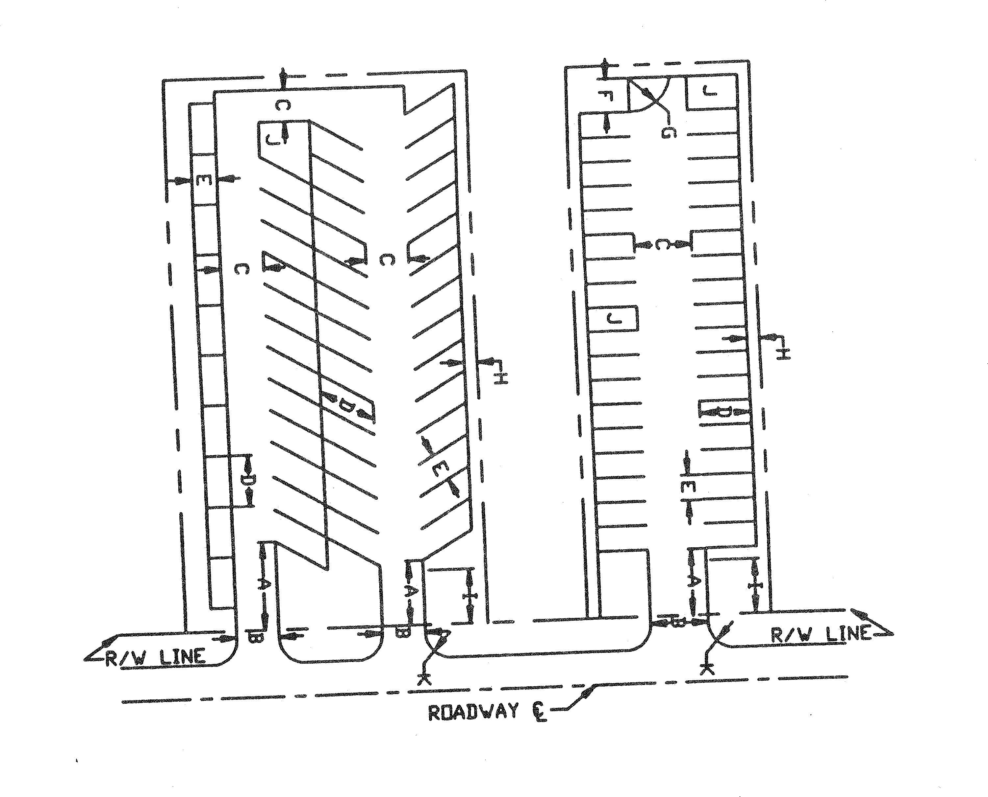

1 | - | Reservoir Area - Refer to subsections 409.01 and 409.04 of this Code.
2 | - | Driveway Width - Refer to subsections 409.01 and 409.04 of this Code.
All dimensions set out in 3 through 8 below are minimum dimensions.
Dimensions of aisles and spaces for the following parking space angles are as follows:
Parking Space Angles - (DEGREES) 45 50 55 60 90 180
3 | - | Drive Aisle - 13′ 15′ 16′ 18′ 24′ 15′
4 | - | Parking Space Depth - 18′ 18′ 18′ 19′ 19′ 22′
5 | - | Parking Space Width (Measured perpendicularly to the striping) - 9′ 9′ 9′ 9′ 9′ 9′
6 | - | Row End Backup Area Depth - 15′
7 | - | Row End Backup Area Radius - 15′
8 | - | Distance to Property Line or Building - 5′ or as required by section 808, Volusia County Zoning  Ordinance, 80-8, as amended.
9 | - | Landscaped Buffer Area - As required by section 808, Volusia County Zoning Ordinance, 80-8, as  amended.
10 | - | Landscaped Island/Row End - As required by section 808, Volusia County Zoning Ordinance, 80-8, as amended.
11 | - | 30′ Radiums Minimum.

    - Any required off-street parking and loading area shall be surfaced with brick, asphalt, bituminous concrete, packed shell, or marl material, and maintained in a smooth, well-graded condition. Stabilized grass or other alternate materials may be approved by the LDM.
    - All required parking stalls shall have direct and unobstructed access from a parking aisle.

    - No parking stall shall directly abut a driveway.
    - Access for emergency fire vehicles shall be in accordance with NFPA standards.
    - All off-street parking areas shall be so arranged and marked as to provide for orderly safe loading, unloading, parking and storage of vehicles with individual parking stalls clearly defined, and with directional arrows and traffic signs provided as necessary for traffic control. All signs and pavement markings shall be in accordance with the "USDOT Manual on Uniform Traffic Control Devices".
    - Acceptable plans must illustrate that proper consideration has been given to the surrounding street plan, traffic volumes, proposed street improvements, vehicular street capacities, pedestrian movements and safety.
  - Driveways.
    - All parking aisles shall connect to a driveway.
    - A parking lot which exceeds 60 parking stalls shall be designed with at least one, two-way directional driveway loop system connecting the point of entry of the parking lot to the parking stalls and the principal building.
    - The minimum distance from a driveway to a structure or property line shall be five feet.
    - Single-lane driveways shall be a minimum of 14 feet wide. Two-lane driveways shall be a minimum of 24 feet wide. Required widths shall be increased according to vehicle type or if the number of parking stalls connected or the number of trips generated justifies such increase.
    - Any off-street parking facility shall have either driveway approaches of sufficient width to allow for two-way traffic, or one-way driveways connected to aisles, parking areas or maneuvering areas in such a manner as to permit traffic to simultaneously enter and leave the property, facing forward at the same time. A driveway which is only wide enough for one-way traffic shall be signed for one-way operation.
  - Parking and loading areas to be curbed. Except for one- and two-family dwellings, all parking and loading areas shall be constructed with a six-inch raised curb or wheel stops located a minimum distance of seven feet behind the street right-of-way line and other property lines along sidewalks, safety islands, driveways, sight distance triangles, and other places as determined by the CTE. The raised curb shall be constructed in such a manner as to prevent vehicles from crossing sidewalks or other pedestrian walkways, other than by means of an approved driveway approach.
- Additional functional elements.
  - Off-street loading spaces.
    - Off-street loading spaces shall be designed to accommodate both the parking of and maneuvering of the design vehicle exclusive of those areas designated for aisles, driveways or parking stalls. Backing from or onto public right-of-way shall not be permitted. Off-street loading spaces shall be directly accessible from a street without crossing or entering any other loading space and may not extend into any street.
    - Off-street loading space dimensional requirements. Each required off-street loading space shall have a minimum dimension of 12 feet by 40 feet and a minimum overhead clearance of 14 feet above the paving grade.
  - Handicapped parking spaces.
    - All handicapped parking spaces shall be accessible by a curb cut or curb ramp. Handicapped spaces and access aisles shall be paved and located at the closest practical point to the use or

structure on the premises and so that it will not be necessary for individuals to access the space from behind other nonhandicapped spaces.
    - Each handicapped parking space, regardless of the angle of design, shall have a minimum width of 12 feet, a minimum 20 feet in length with an adjacent five and parallel five-foot wide access aisle and shall comply with the standards specified in the Florida Accessibility Code for Building Construction, latest edition, published by the Florida Department of Community Affairs and F.S. § 316.1955.
    - Each handicapped space shall be prominently posted with a permanent sign of a design specified in "Roadway and Traffic Design Standards", latest edition, published by the Florida Department of Transportation.
  - Off-street truck maneuvering. Where a proposed development includes a truck loading operation and has access to a thoroughfare, adequate space shall be provided such that all truck maneuvering is performed off-street.
- Vehicular reservoir areas. Adequate reservoir capacity shall be required for both inbound and outbound vehicles to facilitate the safe and efficient movement between the public right-of-way and the development. An inbound reservoir shall be of sufficient size to ensure that vehicles will not obstruct the adjacent roadway, the sidewalk, and the circulation within the facility. An outbound reservoir shall be required to eliminate backup and delay of vehicles within the development.
  - Design. A reservoir area shall be designed to include a space of 12 feet wide by 25 feet long for each vehicle to be accommodated within the reservoir area and so that vehicles within the reservoir area do not block parking stalls, parking aisles or driveways of off-street parking facilities.
  - Adjacent to thoroughfare. The minimum number of vehicles required to be accommodated within a reservoir area of a parking lot adjacent to a thoroughfare shall be in conformance with Table IV.
  - Adjacent to nonthoroughfare street. The minimum number of vehicles required to be accommodated within a reservoir area adjacent to a nonthoroughfare shall accommodate at least one percent of the number of parking stalls served by the driveway. For parking lots with fewer than 100 cars, the reservoir area shall be able to accommodate at least one car.
TABLE IV. VEHICLE RESERVOIR AREA REQUIREMENTS
Adjacent to Thoroughfare

 | Reservoir Area
Type of Facility | Inbound Vehicles | Outbound Vehicles
Vehicle-oriented services:
Drive-in bank | 6 spaces per service position | 1 space per service position
Drive-in beverage, food sales,  and laundry pickup | 3 spaces per service position | 1 space per service position
Drive-thru restaurant service | 8 spaces per service position | 1 space per service position
Automatic car wash | 10 spaces on approach to wash  line | 6 spaces between end of wash  line and right-of-way of street
Self-service car wash | 3 spaces on approach to wash line | 1 space between end of wash line and right-of-way of street
Hospital | 5 spaces or 1% of the total  parking capacity (use the greater figure) | None
Service station | 4 spaces per service position | 1 space per service position

Residential:
Gatehouse | 5 spaces | 1 space
Nonresidential:
Attendant parking | 10% of the total parking  capacity of the facility | None
Self-parking | 5 spaces or 1% of the total parking capacity (use the  greater figure) | None
Ticket gate (ticket-dispensing  machine) | 4 spaces minimum | 1 space
Cashier booth (tickets  dispensed manually) | 6 spaces minimum | 1 space
Gatehouse (commercial) | 5 spaces or 1% of the total parking capacity (use the  greater figure) | 2 spaces
Note: 1 reservoir space is 12 ft. × 25 ft.

- Accessibility to structures for vehicles other than automobiles.
  - Structures intended for principal uses shall be made accessible to the following type of vehicles: Residential uses, other than single-family or duplex: Single-unit truck (SU);
Commercial and institutional uses: Single-unit truck and semitrailer (WB-40) combination, intermediate;
Industrial use: Single-unit truck (SU) and semitrailer - full trailer combination (WB-60).
Definitions of, as well as, required specifications for the above vehicle types shall be those found in the "AASHTO Geometric Design of Highways and Streets".
  - All buildings other than single-family or duplex residences shall be accessible to fire apparatus from two sides. Fire engines shall be considered as a WB-40 as defined by the "AASHTO Geometric Design of Highways and Streets". The area required to meet the AASHTO design standards shall be paved or treated to ensure support to a 16-ton weight vehicle. This area shall be maintained free of trees and bushes and shall be clearly designated for this purpose. Access from one side may be accepted by the DRC where access from two sides is not possible.
  - Fire lanes shall be provided for all buildings which are set back more than 150 feet from a public road, or which exceed 30 feet in height and are set back more than 50 feet from a public road, and may be required for other buildings. Fire lanes shall be at least 20 feet in width with a minimum of five feet provided between the fire lane and any adjacent building. No parking shall be permitted between the fire lane and the building.
  - Required parking spaces, parking aisles and driveways shall not be used as loading or parking areas for any type of vehicle including emergency vehicles other than automobiles.
- Interconnected parking areas. Nonresidential and multifamily developments fronting county or city collector, arterial, or state roads shall provide driveway improvements and driveway stub outs to property lines to facilitate existing and future interconnection of parking areas to adjacent sites.
  - Parking lot access driveways and driving aisles shall be designed and located to connect to adjacent properties or access roadways that serve the subject site and adjacent properties. All access points and

interconnecting driveways shall be designed and constructed to accommodate safe and efficient vehicle travel between adjacent sites, as approved by the DRC.
  - All connecting driveway improvements shall be paved according to the applicable standards, including proper driveway widths, construction specifications and treatment of transition grades.
  - Pursuant to subsection 72-501(b)(3)c., the DRC may modify the interconnected parking area requirements at terminal points where nonresidential development abuts a residential development, or in circumstances where mixing different types of traffic (e.g., automobile versus truck) is undesirable; where separation of traffic is necessary for traffic safety; or where physical design constraints preclude interconnection of adjacent sites.
(Ord. No. 96-32, §§ XXVIII, LXXIX, 12-19-96; Ord. No. 2008-25, § III, 12-4-08; Ord. No. 2012-05, § VI, 4-19-12; Ord. No. 2012-10, § III, 6-7-12)

Sec. 72-619. Commercial, industrial and multifamily residential driveways.
- In order to provide the maximum safety with the least interference to the traffic flow on public streets, and to provide ease and convenience and ingress and egress to private property, the number and location of the types of driveways regulated pursuant to this section shall be designed relative to the intensity of use or size of the property served and the nature of the adjacent roadway. Such existing driveway approaches shall not be relocated, altered or reconstructed without prior approval. When the use of any driveway approach is changed by the owner/developer, making any portion or all of the driveway approach unnecessary, the developer of the property shall obtain a permit to abandon the driveway approach and shall, at his/her expense, replace all necessary curbs, gutters and sidewalks.
  - Access shall be provided as follows:
    - There shall be the minimum number of access points to adequately serve the development.
    - In order to provide ease and convenience in ingress and egress to private property and the maximum safety with the least interference to the traffic flow on thoroughfares, the number and location of driveways shall be regulated by the dedication of access rights to the county, and in accordance with subsection (b)(2), below and Table V of this article.
- Commercial, industrial and multifamily residential driveway design on a nonthoroughfare street. The following requirements apply to driveways connecting development to a nonthoroughfare street:
  - General.
    - The driveway entrance shall be sufficient to allow access to the parking area without interference among vehicles entering and/or leaving and vehicles circulating in the parking lot.
    - No driveway shall be constructed in the radius return of an intersection or within 50 feet of the tangent point of the radius return for an unsignalized intersection.
    - If the closest intersection is or is likely to be signalized, then traffic movements to and from any driveway within 250 feet of an intersection with a collector or an arterial shall be limited to right turns only.
    - The driveway design shall be in accordance with subsection (e)(2) of this section.
    - Typical rural two-way commercial and multifamily driveway within minimum three-foot deep ditch:

TYPICAL RURAL TWO-WAY COMMERCIAL AND MULTIFAMILY
DRIVEWAY WITHIN MINIMUM 3′ DEEP DITCH

SCALE: 1″ = 20′
Notes:
- Refer to FDOT Standard Index #273 for mitered end section and sod detail also Index #515 (turnouts) for overall detail.
- Sod all disturbed right-of-way.
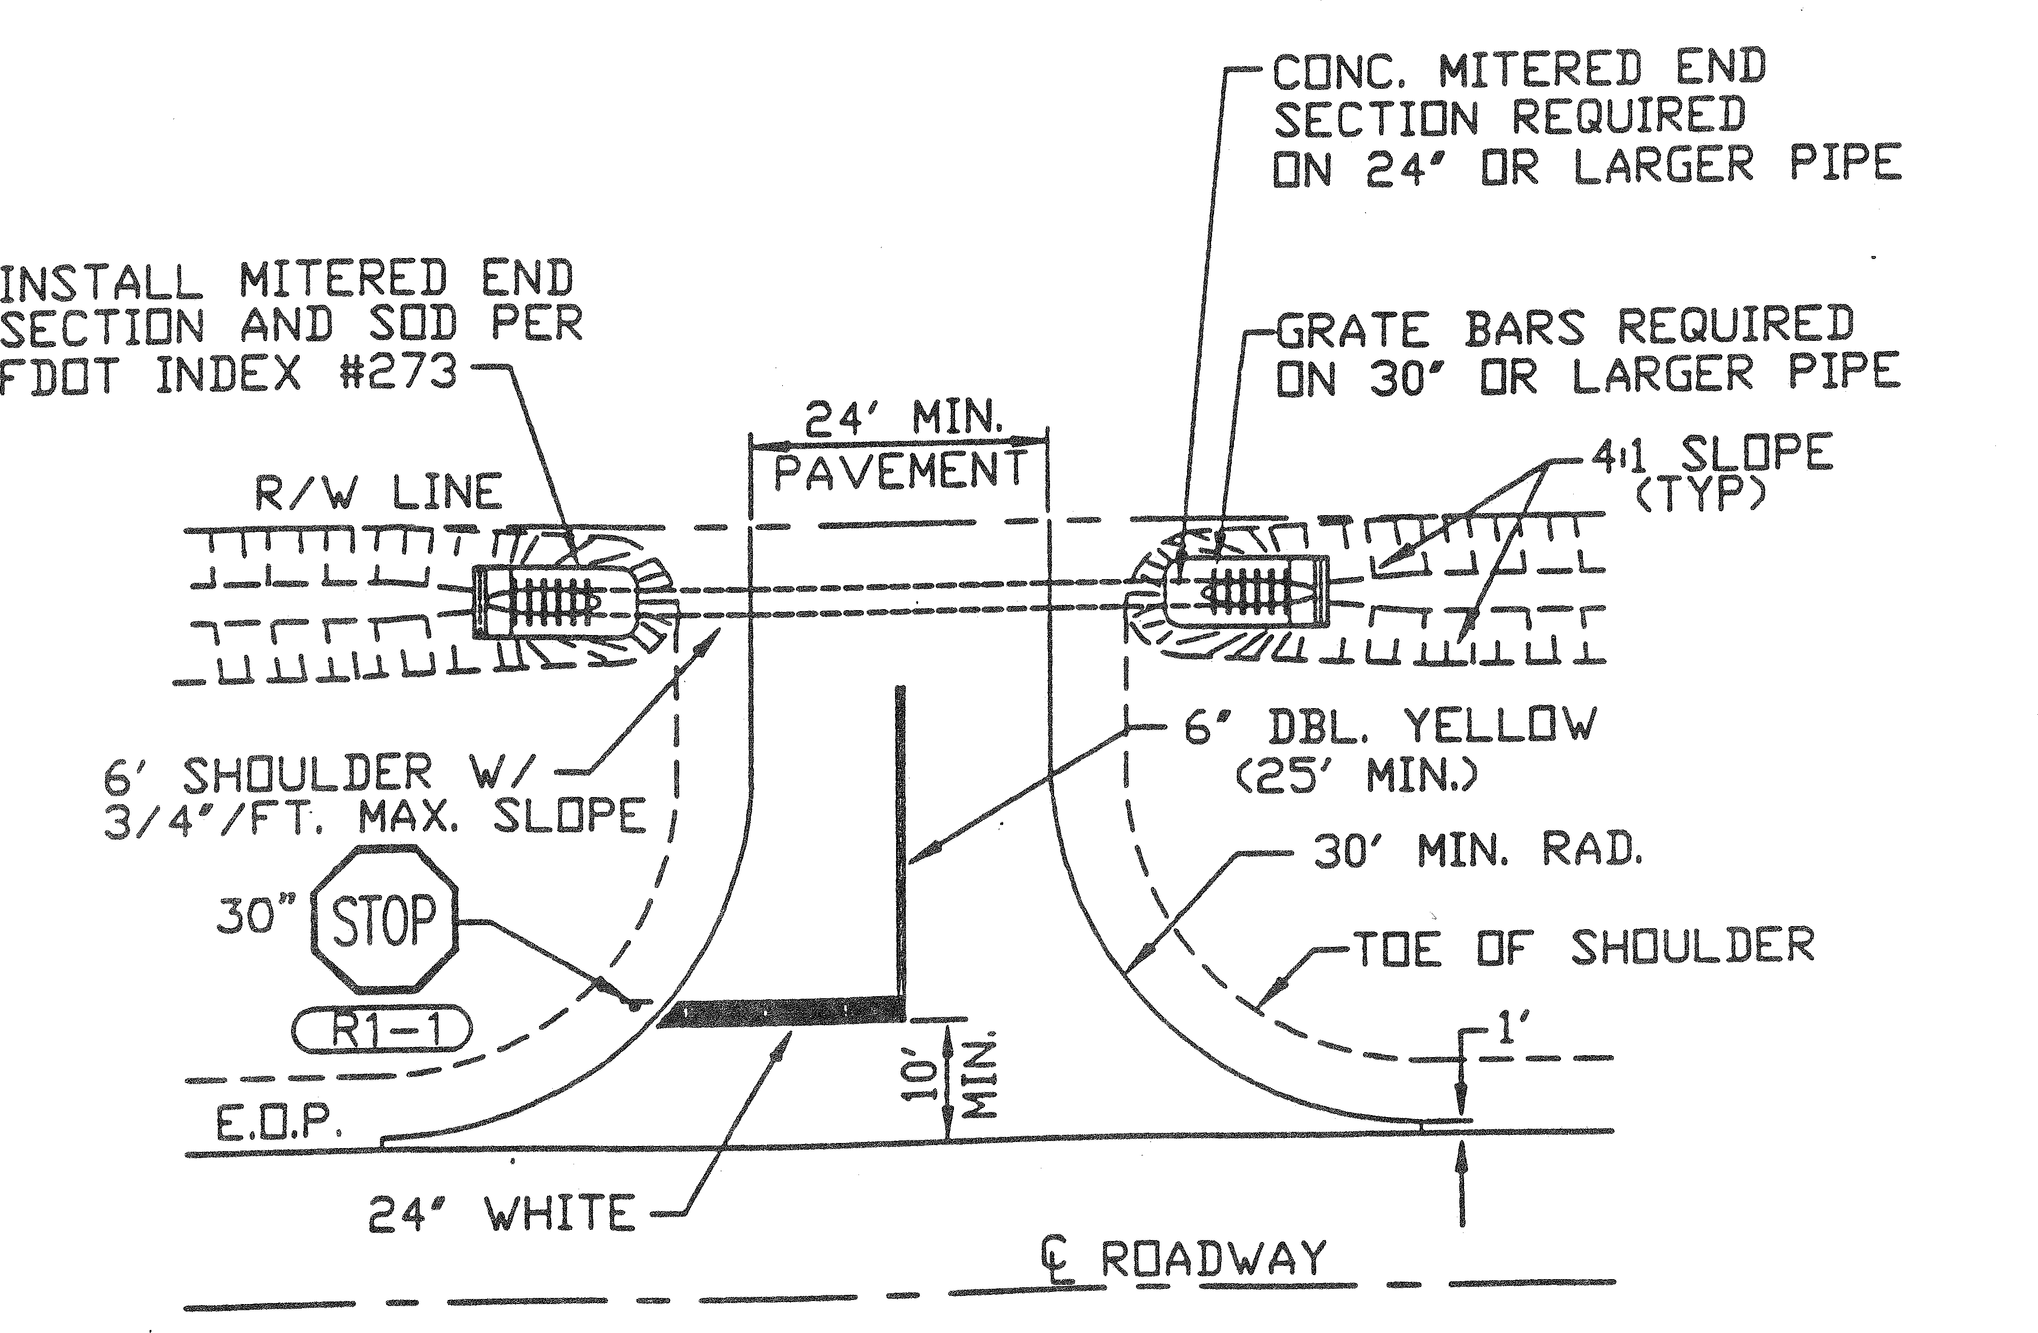

  - Number and location of driveway entrances. In order to provide the maximum safety with the least interference to the traffic flow on public streets, and to provide ease and convenience in ingress and egress to private property, the number and location of driveways shall be regulated relative to the intensity of use or size of the property served and the amount of frontage which that property has on a given street, as follows:
    - One driveway shall be permitted for ingress and egress purposes to a single property or development.
    - Two driveways entering on a particular street from a single property or development may be permitted if all other requirements of this section are met and if the minimum distance between the two driveways equals or exceeds 100 feet.
    - Three driveways entering on a particular street from a single property or development may be permitted if all other requirements of this section are met and if the minimum distance between adjacent driveways equals or exceeds 150 feet.
    - Not more than three driveways will be permitted from a single property or development. However, in the case of extensive property development (property exceeding ten acres in total land area) and/or containing more than 1,000 parking stalls, additional driveways may be

permitted provided all other requirements of this section are met and the minimum distance between adjacent driveways equals or exceeds 300 feet.
- Sight distance.
  - Cross-visibility requirements at the intersection of driveways and public right-of-way. If a driveway intersects a public right-of-way, there shall be no sight obstruction within a triangular area of property on both sides of a driveway formed by the intersection of each side of the driveway and the public right-of-way line with two sides of each triangle being ten feet in length from the point of intersection and the third side being a line connecting the ends of the two other sides.
  - Cross-visibility requirements at pedestrian crosswalks and other areas of pedestrian concentration. If a crosswalk intersects a vehicular access aisle, driveway or public right-of-way, there shall be no sight obstruction within a triangular area of property on both sides of a crosswalk or walkway formed by the intersection of each side of the walkway and the public right-of-way or aisle with two sides of each triangle being ten feet in length from the point of intersection and the third side being a line connecting the ends of the two sides.
  - Sight triangles.
    - Within the triangular areas described above, it shall not be permissible to install, set out or maintain, or to allow the installation, setting out or maintenance of, either temporarily or permanently, any vehicular parking space, sign, wall, hedge, shrubbery, tree, earth mound, natural growth or other obstruction of any kind which obstructs cross-visibility at a level between 30 inches and ten feet above the level of the driveway. Any wall or fence within the sight triangle must be constructed in such a manner as to provide adequate cross-visibility over or through the structure between 30 inches and ten feet in height above the driving surface.
    - The following will be permitted within the triangular area described above:
      - Limbs of trees and foliage trimmed in such a manner that no limbs or foliage extend into the area between 30 inches and ten feet above the level of the center of the adjacent intersection. Landscaping, except required grass or ground cover, shall not be located closer than five feet from the edge of any roadway pavement, and three feet from the edge of any alley or driveway pavement.
      - Fire hydrants and street signs.
      - If there is no public right-of-way, the sight distance requirement shall be determined by the DRC.
- Access limitations to thoroughfares.
  - There shall be no access to a thoroughfare from an existing lot with less than 300 feet of width, unless one of the following conditions is met:
    - Access to the lot is not available to streets (exclusive of alleys) other than that thoroughfare; provided, however, that commercial developments shall not be given access on local residential streets.
    - Access to the lot is not provided jointly with other lots of an adjoining development such that minimum driveway spacing and corner clearance requirements of subsection (e)(3) of this section are satisfied by the combination of lots served by the existing or relocated joint access driveway.
  - No new single-family or duplex residential lot which is under one acre in size and has less than 300 feet of frontage shall front on a thoroughfare unless access to such lot is provided from a street other than that thoroughfare. Such lot shall have access to a local street or service drive. Service drives outside the required public right-of-way may be granted by easements.

- Vehicular access to a thoroughfare. Vehicular access to a thoroughfare shall conform to the following standards:
  - General. The area within the development to which the driveway provides access shall be of sufficient size to allow all necessary functions for loading, unloading and parking maneuvers to be carried out on private property and completely off the street right-of-way.
  - Type of driveway required.
    - Minor driveway entrance. This driveway type shall be provided for a maximum daily trip end volume of 500 vehicles and/or a maximum average peak hour volume of 50 vehicles. The minimum distance from the street right-of-way line at any ingress or egress minor driveway to the outer edge of any interior service drive or parking space with direct access to such driveway shall be 25 feet, measured perpendicularly from the street. A minor driveway entrance radii shall be 30 feet, and a minimum width shall be 24 feet. A 100-foot long 12-foot wide right turn taper shall be required for a driveway adjacent to a thoroughfare with a 40 m.p.h. posted speed limit. A right turn taper will not be required for a driveway abutting a thoroughfare with four or more through lanes.
    - Intermediate driveway entrance. This driveway type shall provide for a maximum average daily trip end volume of 1,500 vehicles and/or a maximum average peak hour volume of 150 vehicles. The minimum distance from the street right-of-way line at any ingress or egress intermediate driveway to the outer edge of an interior service drive or parking space with direct access to such driveway shall be 50 feet, measured perpendicularly from the street. A right turn lane will not be required for a driveway abutting a thoroughfare with four or more lanes. Refer to subsection (e)(5) for turn lane requirements. A minimum of two egress lanes, 12 feet in width each with one, 14-foot wide ingress lane shall be provided. An intermediate driveway radii shall be 35 feet.
    - Major driveway entrance. This driveway type shall provide for a maximum average daily trip end volume of 5,000 vehicles and/or maximum average peak hour volume of 500 vehicles. The minimum distance from the street right-of-way line at any ingress or egress major driveway to the outer edge of any interior service drive or parking space with direct access to such driveway shall be 100 feet, measured perpendicularly from the street. Refer to subsection (e)(5) for turn lane requirements. A minimum of two egress lanes 12 feet each in width and one, 14-foot wide ingress lane shall be provided. A major driveway radii shall be 40 feet.
    - Major driveway - signalized. Any major driveway requiring a traffic signal shall conform to those warrants specified in the "USDOT Manual on Uniform Traffic Control Devices" in addition to the following minimum requirements:
      - The installation of any traffic signal shall be subject to the approval of the CTE.
      - Refer to subsection (e)(5) for turn lane requirements.
  - Number and location of driveways. The number and location of driveways shall be determined as follows:
    - Spacing of driveways.
      - The minimum distance for a driveway from an unsignalized intersection shall be in accordance with spacing criteria of Table V., Driveways that do not meet the spacing criteria of Table V, shall be limited to right turns only.
      - If the closest intersection is or is likely to be signalized, then traffic movements to and from any driveway within 370 feet of an intersection with a collector or an arterial shall be limited to right turns only.

      - Only one driveway shall be permitted for ingress and egress purposes to a single property or development, provided:
        - Two driveways entering a particular thoroughfare from a single property or development may be permitted if all other requirements of this section are met and if the minimum distance between the adjacent driveways conforms to the minimum spacing requirements of Table V.
        - Three driveways entering a particular thoroughfare from a single property or development may be permitted if all other requirements of these regulations are met and if the minimum distance between adjacent driveways conforms to the minimum spacing requirements of Table V.
        - A joint access driveway will be considered as adequate access for any two adjacent developments. For a development where additional driveways are being requested and where those driveways do not meet the spacing requirements, the applicant shall be required to submit a brief traffic report justifying the need, describing the internal circulation and parking system, and identifying the impact of the development and its proposed access facilities on the operation of the thoroughfare.
TABLE V. DRIVEWAY CENTERLINE SPACING REQUIREMENTS ON A THOROUGHFARE
The minimum distance between centerlines of two-way driveways shall conform to Table V. For those driveways with left turn movements, median opening spacing requirements shall have precedence.
TABLE V-A

Speed Limit (mph) | Minimum Centerline Distance  (feet)
25 | 155
30 | 175

If the speed limit of the thoroughfare is 35 miles per hour or greater, or the volume of right turn movements requires the construction of a right-turn lane(s), the minimum distance between centerlines of two-way driveways shall conform to Table V-B.
TABLE V-B
(Centerline Spacing in Feet)

 | Minor DW | Intermediate DW | Major DW | Major DW Signalized, 4  Lanes or More
Minor DW* | 335 | 350 | 355 | 370
Intermediate  DW | 350 | 360 | 365 | 380
Major DW | 355 | 365 | 370 | 385
Signalized, 4 lanes or  more | 370 | 380 | 385 | 1320*

DW = Driveway
Minor DW = Maximum ADT of 500 or a maximum peak hour volume of 50 Intermediate DW = Maximum ADT of 1,500 or maximum peak hour volume of 150 Major DW = Maximum ADT of 5,000 or maximum peak hour volume of 500
*Desirable spacing.
Driveway centerline spacing may be increased if the required turn lane storage or transition is increased by any governmental agency. Minimum driveway centerline spacing may be decreased if one-way driveways are utilized and accepted by the DRC.
  - Special driveway requirements. In the case of a land use with special driveway needs, an applicant may submit a traffic engineering study requesting deviations from the requirements of this section. If deviations from driveway requirements are permitted, substitute requirements which deviate no more than necessary to serve the special land use needs may be applied to the development in order to minimize the impact on the adjacent street.
  - Turn lanes requirements.
    - Turn lane requirements immediately adjacent to the development.
      - A left-turn lane of 12 feet in width, conforming to Table VI, shall be provided at each driveway when the average daily trip ends of the driveway is 1,000 vehicles or more and/or the average peak hour inbound left-turn volume is 25 vehicles or more. Increased queue lengths (waiting vehicle storage) may be required by the CTE to provide for additional storage, based upon a peak hour entering volume greater than 75 vehicles in the peak hour. No queue length is required if the peak hour entering volume is 75 vehicles in the peak hour or less.
      - A right-turn lane of 12 feet in width, conforming to Table VI shall be provided at each driveway when the speed limit equals or exceeds 35 miles per hour or if the development will generate 100 or more right-turn movements during the peak hour. Increased storage and transition queue lengths (waiting vehicle storage) may be required by the CTE to provide for additional storage, based upon a peak hour entering volume greater than 150 vehicles in the peak hour. No queue length is required if the peak hour entering volume is 150 vehicles in the peak hour or less.
    - Additional improvements immediately adjacent to the development. At intersections, with a thoroughfare which abut the development, the following improvements shall be provided:
      - A right-turn lane of 12 feet in width, conforming to subsection (e)(5) and Table VI, shall be provided if the development will generate 100 or more right turns during the peak hour.
      - A left-turn lane of 12 feet in width conforming to subsection (e)(5) and Table VI, shall be provided if the street's speed limit is 35 miles per hour or greater and if the development will generate 25 or more left turns during the peak hour.
    - Through lane pavement transition tapers. A through lane pavement transition taper shall be provided on all streets and roadways where the through lane is offset to provide for right turn lanes, left turn lanes, lane width changes and an increase or reduction in the number of through lanes. The through lane pavement transition taper length shall be based upon FDOT Standard Index #526 and 17346, and calculated using the following formulas:
For design speeds less than or equal to 40 m.p.h. use:

L = WS² 60
For design speeds greater than or equal to 45 m.p.h. use:

L | = | WS
L | = | the pavement transition taper length in feet.
W | = | the width of the through lane lateral transition in feet (offset).
S | = | the design speed (must be at least five m.p.h. greater  than the posted speed limit.)

TABLE VI. TURN LANE DIMENSIONAL REQUIREMENTS

Speed Limit (mph) | Urban Section Deceleration Length  (feet)* | Rural Section Deceleration Length  (feet)*
30 | 145 | 145
35 | 155 | 155
40 | 185 | 185
45 | 240 | 320
50 | N/A** | 385
55 | N/A** | 455

* Includes minimum 50 feet bay taper in accordance with FDOT Standard Index #301 and 526.
** Curbing is not permitted for these speed limits, use rural section.
    - Modifications. Required storage and transition lengths may be modified where conditions warrant and such modifications are acceptable to the DRC.
(Ord. No. 96-32, §§ XXVIII, LXXX, 12-19-96; Ord. No. 2008-25, § III, 12-4-08; Ord. No. 2012-05, § VII, 4-19-12)

Sec. 72-620. Sidewalks.
- Pedestrian access. Neighborhood and community commercial facilities shall have an efficient and direct pedestrian way connection to the residential areas the facilities are intended to serve. The design of local commercial facilities shall allow pedestrians direct access from adjacent neighborhood areas, with due consideration to the elimination of points of conflict between pedestrians and vehicles.
- Sidewalks.
  - Paved sidewalks, a minimum of five feet in width, shall be installed on one side of all local streets within a new development, except in a subdivision classified single-family or duplex where the minimum lot sizes are one acre or larger, in which case sidewalks shall not be required. Provided, however, said sidewalks shall be installed on both sides of all streets within a new development that

intersect with a thoroughfare. Alternative path systems within a new development may be approved by the DRC instead of sidewalks. Specifications for materials and design of sidewalks or alternative path systems shall be approved by the CDE. Maintenance and replacement of the sidewalks or alternative path systems within a development will be the responsibility of the abutting property owner. No sidewalks shall be required for cul-de-sac streets less than 300 feet in length.
  - Sidewalks along thoroughfares. Paved sidewalks a minimum of five feet in width shall be installed along the abutting side of all existing and proposed thoroughfares which abut a new development and along both sides of all thoroughfares which are required to be constructed within a new development where the property is designated as any urban category in the comprehensive plan. Provided, however, that if the development is within two miles of an existing or proposed school site, then a sidewalk will be required regardless of the designation in the comprehensive plan, except when the DRC waives the sidewalk requirement on one or both sides of the street for one or more of the following reasons:
    - A single-family or duplex subdivision with a density of less than three units per acre will require a sidewalk on only one side of the thoroughfare; provided, however, that within one mile of existing or planned schools, commercial centers or community centers, sidewalks shall be installed along both sides of the thoroughfare.
    - A single-family or duplex subdivision with a density one unit or less per acre shall not require a sidewalk on either side of the thoroughfare; provided, however, that within one mile of existing or planned schools, commercial centers or community centers, sidewalks shall be installed along both sides of the thoroughfare.
  - Location. Sidewalks shall be located in the right-of-way or adjacent easements of said street(s) within and abutting the development, but not closer than one foot to the abutting property line. Sufficient distance from obstacles such as fire hydrants, drainage inlets, manholes, utility structures and trees shall be maintained for the safety of the sidewalk users. No sidewalk shall be located within the appropriate recovery area of the traveled way of said street. Where the sidewalk is curved, there shall be no unsafe curves or sudden elevation changes in the sidewalk which would present a hazard to the users.
  - Pedestrian barriers. The DRC may require fences, hedges, berms, other landscaping, or other barriers in order to discourage pedestrians from crossing hazardous streets at unsafe points or at numerous points. When possible, developments shall be designed so as to promote pedestrian street crossings only at traffic-control signals, crosswalks or intersections.
(Ord. No. 96-32, § XXVIII, 12-19-96; Ord. No. 2008-25, § III, 12-4-08)

Sec. 72-621. Erosion control.
Seeding, mulching, sodding and/or other acceptable methods shall be performed as required to prevent undue erosion during all construction activities. During construction and through the developer maintenance period, the developer shall be required to keep accumulations of sand and earth out of the curb and gutter. Temporary siltation basins may be required during construction. Maintenance shall be provided by the developer for the one-year period of the road guarantee and for each lot, until final inspection is passed.
(Ord. No. 96-32, § XXVIII, 12-19-96; Ord. No. 2008-25, § III, 12-4-08)

Sec. 72-622. Fire protection systems.
The fire protection system of the proposed development shall be based upon the following requirements:

- Water supply. The fire protection water supply for the proposed development shall meet the following fire flow requirements:
  - In the case of a single-family or duplex residential development of less than ten dwelling units with lot sizes of less than one acre, or in the case of a single-family or duplex residential development of ten or more dwelling units, but less than 200 dwelling units with lot sizes of one acre or more, fire wells may be utilized.
  - In the case of a single-family or duplex residential development with lot sizes of one acre or more totaling 200 or more units, a central water system shall be utilized for fire protection water supply which meets the water flow requirements of fire services. (Refer to Table VII as a reference.)
  - In the case of a single-family or duplex residential development with lot sizes of less than one acre, the fire protection water supply shall be provided by a central potable or nonpotable water supply or a combination of central water supply, auxiliary supply of fire wells, which will produce the water flows contained in Table VII. In no case shall the central water supply for fire protection be less than 50 percent of the required fire flow. Auxiliary water supply may be provided by a combination of tank trucks, ground tanks, cisterns, elevated storage, drafting stations on canals or reservoirs, or other methods subject to approval by the department of fire services.
  - In the case of a multifamily residential development; a business or industrial development; or a place of assembly, the fire protection water supply shall be as defined in the most current edition of NFPA 1231 - "Standard on Water Supplies for Suburban and Rural Fire Fighting". In all cases the minimum fire flows shall not be less than required for dwellings in Table VII.
  - A single water supply system may be used for both potable and fire protection supply provided the requirements of Table VII and/or NFPA 1231 are maintained, as applicable.
  - The minimum time duration for required fire flows shall be in accordance with Table VIII.
TABLE VII. FIRE FLOWS FOR GROUPS OF DWELLINGS

Exposure Distances  (feet) | Required Fire Flow*  (gallons per minute)
Over 100 | 500
31 to 100 | 750—1,000
11 to 30 | 1,000—1,500
10 or less | 1,500—2,000

*Add 500 GPM where wood shingles would contribute to fire spread.
†Use 2,500 GPM minimum if buildings are continuous.
TABLE VIII

Minimum Flow at  Source of Supply (GPM) | Minimum Duration  (hours)
1,000 or less | 2
1,250 | 2
1,500 | 2

1,750 | 2
2,000 | 2
2,250 | 2
2,500 | 2
3,000 | 3
3,500 | 3
4,000 | 4
4,500 | 4
5,000 | 5
5,500 | 5
6,000 | 6
7,000 | 7
8,000 | 8
9,000 | 9
10,000 | 10
11,000 | 10
13,000 | 10

The calculations of required fire flows in gallons per minute (GPM) considers the construction, occupancy, exposure and communication as outlined in the NFPA Fire Protection Handbook (latest edition).
- Fire hydrants. Fire hydrants shall be installed according to the following requirements, with distances measured along street rights-of-way. No distance shall be measured across thoroughfares:
  - In the case of a single-family or duplex residential development; one- or two-story motels, hotels, or multifamily dwellings, or mobile home parks, hydrants shall be installed at intervals not to exceed 500 feet with a minimum main size of six inches.
  - In the case of a business or industrial development, excluding developments in a. above, hydrants shall be installed at intervals not to exceed 300 feet with a minimum main size of eight inches.
  - In the case of a building which will provide standpipe and/or sprinkler systems, a fire hydrant shall be installed within 150 feet of the exterior fire department connection with a minimum main size of eight inches.
  - In the case of the development of a high-hazard area including, without limitations, a large shopping center, a storage facility for flammable chemical or compressed gases or a manufacturing plant, the spacing and main sizes of hydrants shall be determined after computing the required fire flow, subject to review and approval by the department of fire services.
  - All fire hydrants shall deliver the required gallonage with a residual pressure of 20 p.s.i.
  - Uniform marking of fire hydrants. Color coding of fire hydrants is of substantial value to water and fire departments and is based on water flow available from them. Fire hydrant bonnets and nozzle caps shall be painted according to the following chart which shall be used to classify fire hydrants according to flow:

Class | Flow | Color of Bonnets  and Nozzle Caps
A | 1,500 GPM or greater | Blue
B | 1,001 GPM or 1,499 | Green
C | 500 GPM to 1,000 GPM | Orange
D | Less than 500 GPM | Red

- Fire wells.
  - Fire wells may be utilized where permitted by subsection (1) of this section, providing they have a separate power source and meet one of the following criteria:
    - The minimum size of a designated fire well shall not be less than six inches in diameter. A pump shall be attached capable of providing a minimum fire flow of 250 GPM; or
    - A fire well four inches in diameter may be utilized provided that it has been tested and certified by an engineer that the fire well can produce a minimum fire flow of 250 GPM.
  - Fire wells shall be located adjacent to rights-of-way, unless otherwise approved by the department of fire services and the DRC.
  - Fire wells of sufficient capacity to serve adjacent development may be provided and, when so provided, may be included in a public services and facilities agreement pursuant to subsection 72-501(f).
  - Fire wells shall be considered as public improvements subject to all provisions of division 5 of this article.
(Ord. No. 96-32, § XXVIII, 12-19-96; Ord. No. 2008-25, § III, 12-4-08)

Sec. 72-623. Illumination standards.
- Scope. The provisions of this section are intended to promote development within the unincorporated Volusia County that will:
  - Minimize light pollution;
  - Foster practical site lighting practices that utilize adequate and energy efficient lighting techniques and mechanisms; and
  - Provide illumination in a manner that will not be detrimental to either humans or wildlife.
Nothing in this section shall be interpreted to preempt chapter 72, article 3, division 12 of this code pertaining to Sea Turtle Protection. In the event of a conflict with this section, the provisions of division 12, as amended, shall apply to the extent of such conflict.
Nothing in this section shall be interpreted to preempt residential illumination standards in section 50-480, of this code.
- Definitions. The definitions below shall only apply when used in this section:
  - Cutoff. A type of luminaire which restricts illumination above horizontal and meets the Illuminating Engineering Society of North America (IESNA) definition for cutoff.
  - Flashing light. A light or lights that turn on and off, vary in intensity, change color, or otherwise do not produce a solid, continuous light more than once per eight seconds, unless required by the FAA or other governmental agency.

  - Full cutoff. A type of luminaire which completely restricts illumination above horizontal and meets the IESNA definition for full cutoff.
- Applicability. All new site lighting shall be installed in accordance with the requirements of this section unless otherwise authorized by a separate development order specifically waiving these requirements. Existing site lighting shall be allowed to remain in its current nonconforming state except that a site shall be required to fully comply with this section should any of the following occur:
  - Building addition or additions which cumulative increase the building square footage on site by more than 25 percent.
  - The cumulative replacement of 25 percent or more of the total amount of outdoor lighting fixtures.
  - A cumulative increase in off-street parking of 25 percent or more.
- Exceptions. The following types of lighting shall not be subject to this Section:
  - Lighting regulated by section 50-480;
  - Lighting regulated by chapter 72, article III, division 12, Sea Turtle Protection;
  - Emergency lighting and emergency wall packs;
  - Temporary security lighting;
  - Temporary lighting for authorized special events;
  - Seasonal decorative lighting;
  - Street lighting within a public road right-of way or private road;
  - Traffic control signals and devices;
  - Lighting used for a detention facility;
  - Lighting used for a public airport, as authorized by the FAA;
  - Lighting used to identify towers and masts for aviation purposes;
  - Up-lighting or landscape lighting not exceeding 1800 lumens per fixture and do not direct light towards an adjacent property.
- Prohibited lighting. The following types of lighting are prohibited:
  - Searchlights, beacons, spotlight and laser lights;
  - Non-shielded up-lighting or landscape lighting in excess of 100 watts or 1800 lumens;
  - Flashing lights, strobe lights or lights that flicker, blink, gyrate, change intensity or change color, except for seasonal decorative lighting;
  - Any other fixture not classified as either cutoff or full cutoff by IESNA guidelines, as amended.
- General requirements. The following general requirements apply to all properties subject to this division:
  - Lighting plan. A lighting plan shall be submitted with the final site plan application and prior to the installation or replacement of a lighting system. The plan shall, at a minimum:
    - Indicate initial foot-candle levels in 10-foot by 10-foot grids at grade to a distance of 30 feet on either side of a lot line;
    - Include type and location of all luminaires;

    - Be certified by a professional engineer, landscape architect, or professional architect registered in the State of Florida.
  - Lighting shall follow the below requirements:
    - In no case shall illumination from the property exceed one-half foot candles as measured from the property lines;
    - Illumination shall not exceed 70,000 lumens per acre;
    - All luminaires shall be cutoff or full cutoff as classified by the Illuminating Engineering Society of North America (IESNA);
    - The height of luminaires shall not exceed the height of the adjacent structure, or 25 feet, whichever is less;
    - All external lighting shall be reduced by 50 percent between 11:00 p.m., or one hour after close of business, whichever is later, and sunrise, unless a greater level of illumination is required by chapter 26, article II of this Code for late night businesses.
(Ord. No. 2021-5, § II, 3-2-21)

Secs. 72-624—72-655. Reserved.

